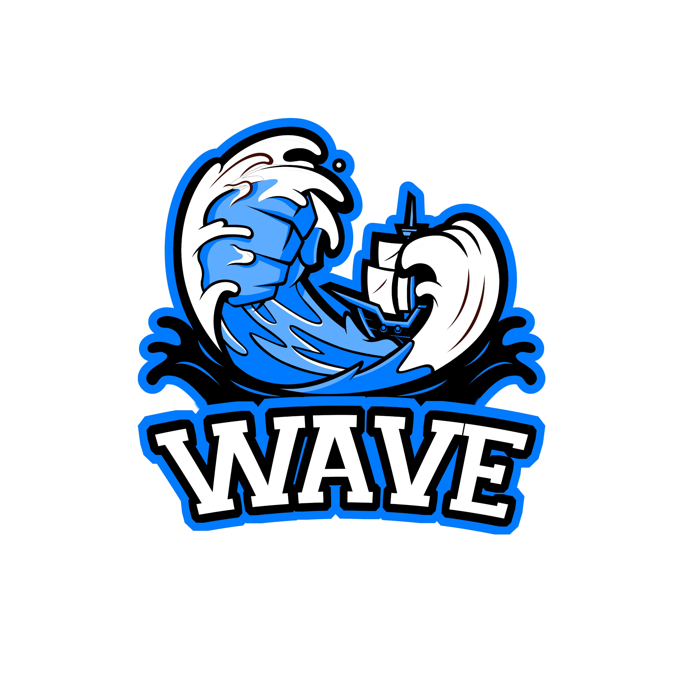
PORT COLBORNE GIRLS HOCKEY ASSOCIATION INC.
Refund Policy

Refunds will only be granted once a written application has been received and reviewed by the Executive.

If approved the following refund applies:
Received up to September - 90%
Received in the month of October - 70%
Received in the month of November - 50%
Received in the month of December - 30%
No refund after December 31.

- After the first practice if a player leaves to play at a different OWHA Association there will not be a refund. This is seen as breaking a contract with Port Colborne Girls Hockey Association.

- All players who leave the Port Colborne Girls Hockey Association before the end of the season due to residential relocation may apply in writing for a return of fees. The amount of the refund will be governed by the date on which the written request is received and shall be calculated in accordance with above percentages.

- Any player, who becomes medically unfit or receives an injury that prevents him/her from participating in hockey for the rest of the season, shall be calculated in accordance with above percentages to determine entitled refund. The amount of the refund will be governed by the date on which the injury occurred or medical condition was noted by a physician. The player shall provide medical certification by a licensed medical practitioner in support of a refund request made on medical grounds.

- In no event shall any player who is suspended or expelled from playing be entitled to a refund.

09/2023 Revised

