Emergency Action Plan (EAP)
This document should be printed and always available along with the printed Team Roster (contact information & medical information & NCP numbers optional). Nominate a member of staff as the person in charge who will deal first hand with the injured person (this person should have first aid training). Nominate another member of staff or parent as the call person.
Phone Numbers
Team/Event ______________________________________________
Emergency Site ______________________________________________
Ambulance 911
Person in Charge ______________________________________________
Police 911
Call Person ______________________________________________
Fire Department 911
Hospital (Janeway) 777-6300
(Health Science Center) 777-6335
Facility Dianne Whalen Memorial Soccer Complex
McNamara Drive
or Peter Barry Duff Memorial Park
272 Topsail Pond Road
Or OTHER.
please enter facility name & address
_ ________________________________________________________
Details of DWMSC (to be read over the telephone to emergency dispatcher)
Dianne Whalen Soccer Complex, located off of McNamara Drive on a dirt road. The Carpenters and Millwright College, located at 2-89 McNamara Drive, is next to the road for the complex. The dirt road is on your right, AFTER the Millwright College if you are travelling toward Topsail Road from Kenmount Road extension. The dirt road is on your left, right after the Double Ice Complex, and right before the Millwright College, if you are traveling from Sobeys towards the Double Ice.
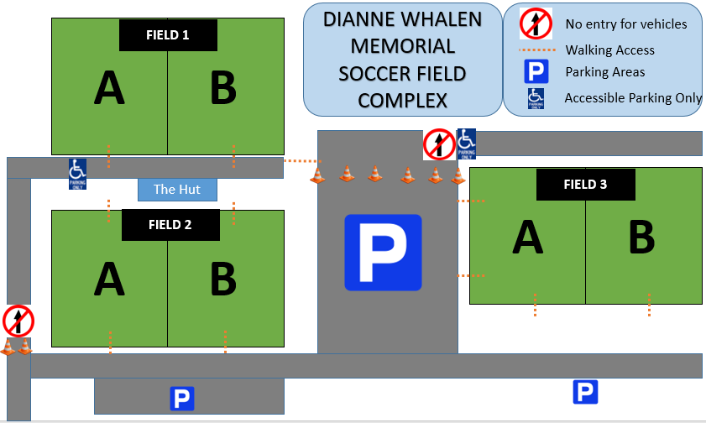

Details of PBD (to be read over the telephone to emergency dispatcher)
The Peter Barry Duff Memorial Park Clubhouse is located at 272 Topsail Pond Road.

GOAL SAFETY
It is the responsibility of Team Staff to educate your players/parents on goal safety. Always supervise and monitor your group for best practices when using goals (see below). Do not allow players to hang on goals.

Mitigation

The risk of movable soccer goals tipping can be mitigated through proper construction and anchoring. Goals can either be counterweighted at the back, or anchored to the ground. There are different types of anchors that can be used.
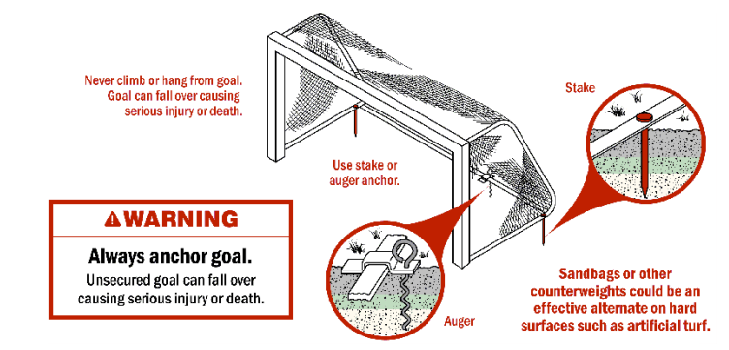

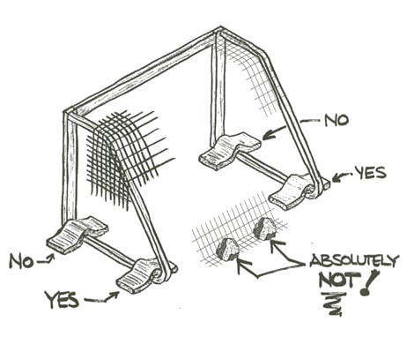

Conclusions and Safety Tips

- Securely anchor or counterweight movable soccer goals at ALL TIMES
- Anchor or chain one goal to another, to itself in a folded down position, or to a nearby fence post, dugout, or any other similarly sturdy fixture when not in use. If this is not practical, store movable soccer goals in a place where children cannot have access to them
- Remove nets when the goals are not in use
- Check for structural integrity and proper connecting hardware before every use
- Replace damaged or missing parts/fasteners immediately
- NEVER allow anyone to climb on the net or goal framework
- Ensure safety/warning labels are clearly visible (UNDER the crossbar, on sides of posts AT EYE LEVEL)
- Fully disassemble goals for seasonal storage
- Always exercise extreme caution when moving goals and allow adequate manpower to move goals of varied sizes and weights
- Movable goals should ONLY be moved by AUTHORIZED AND TRAINED PERSONNEL
- ALWAYS instruct players on safe handling of and potential dangers associated with movable soccer goals
- Movable soccer goals should ONLY be used on LEVEL fields of play
