Red Deer Ringette
Working Instruction: Evaluations and Team Builds
Location: |  | Owner | RDR Evaluations Committee
Date of Issue | 2018.AUG.31 | Revision Cycle | Annually

Revision | Content | Approved By | Date
0 | 2018/2019 Season Initial Issue | RDR Executive | 2018.AUG.21
1 | 2019/2020 Season Revision | RDR Executive | 2019.AUG.31

Introduction:
Welcome to the 2019-2020ringette season!RDR has compiled this information to outline the general principles and procedures behind the 2019/2020evaluations.The primary goal of evaluations is to fairly and consistently evaluate athletes for placement on teams with players of similar ability. This process will also assist RDR in forming competitively balanced teams where there ismore than one team at a given level (ie. U10 Step 2). In alignment with broader sport philosophy and feedback, adjustments have been made to the previous evaluation process for the 2019/2020 season.The manual will be reviewed annually and updated if required as an evergreen process of continuous improvement. This document provides general level information as well as division specific details.
General Information:
Timing: Evaluations start the second week of September, with the intent of forming teams as early as possible while still maintaining a fair and open process. Athletes are encouraged to come to evaluations conditioned and ready to go.
Number of Sessions: Up to 4 ice slots may be scheduled for evaluations depending on the number of athletes in the division. For U10/U12&U14, one of those ice slots will be the Universal Athlete Assessment (Skills) session.
Release of Rosters:The team rosters for the U10/12/14 divisions will not be released until all testing and evaluations are complete. This means teams may not be posted until a week after the last evaluation game is played.
Evaluators: RDRwill utilize a mix of parent volunteers and independent evaluators where possible. Evaluators will be directed by the appropriate Evaluations Director. The evaluators are qualified ringette players with AA and national experience, coaches/parents with multiple years of ringette experience and will be:
- be assigned to an age group to maintain consistency and fairness, where possible;
- be assigned to evaluate all players playing a single position, where applicable (e.g. defense in U16/U19);
- work with the Evaluations Director for each session;
- give a rating in every category for any athlete assigned to them as well as a tiering level (overall rating compared to the group); and
- give the raw data results to the appropriate Evaluations Director for compilation of results.
Injury/Inability to Attend: Athletes are expected to attend all their designated ice times, as absences may have a significant impact on final placement. Exceptions, such as illness or injury, may be taken into consideration provided a written explanation from the athlete or parent/guardian is submitted to the appropriate Evaluations Director prior to the start of the evaluation sessions. It is understood that certain unavoidable factors may contribute to an athlete being unable to attend an ice time, and for these situations, the Evaluations Committee will conduct a review to determine the appropriate team placement. This review may include input from the previous seasons coach, normalizing of their scores against their peers and any skill or game evaluations they are able to attend.
Roles and Responsibilities:
Evaluations Committee
To maintain the integrity of evaluation policies, processes and decision making, RDR uses division specific Evaluation Committees (U10 and U12+). The objective of the Evaluation Committees is to provide final review and subsequent approval of recommendations prior to implementation of these decisions. The Evaluations Committee is the final authority.
Membership of the Evaluations Committee may include, but is not limited, to:
- Evaluations Directors
- President
- Vice President (U10 or U12+)
- Coaching Director
- Past President
- Ad Hoc directors, board members and/or past coaches as required or applicable
Evaluations Directors: Responsible for organizing player skate groups and facilitating evaluations. Responsibilities includecoordinating the schedule, volunteers, evaluators, officials, other tactical execution tasks and communication with the players and parents. The Evaluation Director(s) is also responsible for collecting, tabulating and ranking of the player score data as provided by the Evaluators. A second individual from the Evaluations Committee will review and validate the data before final ranking to ensure it was entered correctly.
UAA Evaluators: Responsible for execution of the tasks associated with the UAA time drill testing such as timing, set up, and recording of times. Evaluators should not have a child in the session they are taking part in. They provide the raw data to the Evaluations Director for data entry.
Game Play Evaluators: Responsible for evaluating the players in game play settings. Parents and coaches may not evaluate any game sessions in which their child or children they may coach take part. RDR will strive to utilize independent evaluators for game play evaluations for U12 and up at a minimum, U10 if they can be arranged.
For instances where association members may be required(ie. shortage of evaluators), they will be scheduled to evaluate two divisions removed from their child’s division (U12 child, parent would evaluate U16/U19). If there are not enough evaluators, the Evaluations committee may approve them to evaluate one level removed from their child. They provide the raw data to the Evaluations Director for data entry.
Coaching Director: Responsible for recommending head coaches to the Evaluations Committee on applications received. The Coaching Director will also assist the committee in identifying possible coaches if no applications have been received for a division.
Ice Allocator: Works with the Evaluations Directors to establish the ice schedules for evaluations.
President, Division Vice President and Past President: Responsible for supporting Directors and providing guidance and direction as needed.
PLAYER EVALUATION PROCESS:
General Information:
The general evaluation process for each division is as follows (more detail is provided in the following pages):
Active Start (4/5/6 year olds):
- No formal evaluations
U10:
- Universal Athlete Assessment will be completed – 30% of overall player assessment
- Game play scrimmages – 70% of overall player assessment
- Players will be placed based into 1 of 3 levels (Step 1/2/3) based on overall assessment
- Number of teams needed to provide a reasonable variety in game play throughout the season will be a large consideration when determining number of teams in each level. The number of teams at each level in Lacombe Ringette will also be a consideration.
U12/U14:
- Continuing from last season, there will be no “declaration” of Try Out level for the game play sessions. Athletes are expected to attend all evaluations sessions they are assigned to.
- The decision to host a U14AA team in any given season will be heavily dependent on the athlete pool, suitable goaltenders and whether another Zone 4 association is hosting an AA team.
- Universal Athlete Assessment will be completed – 30% of overall player assessment
- Game play scrimmages – 70% of overall player assessment
- Teams within these divisions may include AA(U14), A, B or C or any combination thereof.
- Players will be placed on teams based on overall assessment however, requests can be submitted to evaluations@reddeerringette.com if a parent would prefer their child not be considered for a higher level team.
- RDR has committed to target team builds to meet the AA(U14),A, B and C level play.
- The season starting level of any team in U12 and U14 will be aligned to the relative team average UAA score as per Ringette Alberta and be taken into consideration when determining the number of teams at each division and level.
- Teams may be requested to move up or down a level (ie. A->B or B->A) by the Black Gold League at the repooling meeting in November should their win/loss record or GF/GA differential be “excessively” strong or weak compared to other teams in their BGL division and level.
- Teams may also be Advanced or Retreated for Provincial play by a committee of 123, BGL and RAB members based on league and tournament play up to mid November.
U16/U19:
- Teams within these division may include: A, B or any combination thereof.
- Where there are only enough athletes to form 1 team, the coaching staff will declare the team level within the division.
- Where there is more than 1 team, 100% of player assessment will be done using game scrimmages to place athletes.
- Teams may be requested to move up or down a level (ie. A->B or B->A) by the Black Gold League at the repooling meeting in November should their win/loss record or GF/GA differential be “excessively” strong or weak compared to other teams in their BGL division and level.
- Teams may also be Advanced or Retreated for Provincial play by a committee of 123, BGL and RAB members based on league and tournament play up to mid November.
Detailed Information:
Universal Athlete Assessment (UAA)
- Developed by Ringette Alberta, these are repeatable, timed skill measurements which do not require independent Evaluators. All U10, U12, and U14 athletes will be required to attend an UAA ice session. Please see http://www.ringettealberta.com/universal-athlete-assessment/ for more detailed information from Ringette Alberta.
- RDR will provide the opportunity for full time goalies to "opt out" of the UAA testing.
- The UAA portion of the evaluations will be conducted by a UAA Assessment Team, made up of volunteers from the association. If a parent’s child is on the ice during that session, the parent must remove themselves from the station where their child is evaluating and switch with another volunteer on the ice at the time.
- In U10, four timed drills will be used:
  - Forward Skate
  - Backward Skate
  - Ring Agility Weave
  - Start and Stop
- In U12 and U14, five timed drills will be used:
  - The previous four identified for U10
  - Butterfly
- Each skill session is designed to test a skating or ring handling skill specific to Ringette in an objective fashion. Players and parents are expected to familiarize themselves with the drills via the Ringette Alberta YouTube video. For clarification when viewing the video - The shooting and passing drills have been eliminated as per RAB 2015 AGM.Each drill will be explained (and demonstrated, if needed) to the group before proceeding.
- For U10, U12 and U14, results of the UAA will be used to determine groupings for the first evaluation game play session. Groupings for subsequent game play sessions will be determined by a combination of UAA results and evaluation results from prior game play sessions.
Player game score criteria:
- The players will be assigned a value between 1-5 for each of the following 5 facets of game play to give a score out of 25 relative to other players on the ice and in their division:
  - Positioning- Zone Awareness (Defensive/Offensive), Marking, Transition, Communication
  - Checking- Aggressiveness vs. Trepidation
  - Hustle- Attitude, Ability
  - Passing - Creating Advantages, Player Support
  - Ring Skills - Ring Movement, Receiving, Shooting, Team Play
- Athletes in the U16/U19 divisions may declare their preferred position (C/F or D), this will be identified to the evaluators for proper assessment of the athlete.
- There is opportunity built into the process flow for players to move back and forth between the game play pools based on their scores to ensure they are being suitably challenged in their play and accurately evaluated (see flow charts at end of document).
- Evaluation scores will be provided by the evaluators and compiled by the Evaluations Director. A second person will review the data to ensure it was entered correctly.
- U10 – U14 players will have a cumulative evaluation score based on game play and UAA scores.
- U16 & U19 players will have a cumulative evaluation score based on game play only.
Game Format Overview:
- Target team sizes for game play will be 13-15 skaters per team. An exception may be implemented if the number of players is between 30-40 for any division. This will be determined by the Evaluations committee.
- U10: Game play will consist of a series of “scrimmage games” in a variety of formats (cross ice, ½ ice, full ice, 3on3 and/or 5on5) as determined by the Evaluations Director.
- U12-U19: Game play evaluations will consist of a series of games. The game format may be 3v3 or 5v5 as determined by the Evaluation Committee. Game format will be indicated prior to the start of the game.
- The Evaluations committee may choose to use a timed buzzer to initiate line changes. At the sound of the buzzer or whistle the players will abandon the ring and leave the ice. The next line will rotate onto the ice. Fluid line changes on cue will be outlined to the players prior to the start of the game.
- Players will be reorganized by the parents on the bench at the half to prevent the same players from playing together on every shift.(Note: Parent/Coach Volunteers on the bench are not permitted to instruct or coach any player through the process)

Team Builds:
- Players will be put into rank order based on their cumulative evaluation score.
- After reviewing the rank order list, the evaluations committee will determine the number and level of teams in each division.
- Where players are of approximate equal strength at the "cutoff line", the second-year player will be considered the successful candidate as it will be their final year in that division.
- Where there are multiple players of approximate strength at the "cutoff line", the evaluations committee will list the players in no particular order and the coach will be allowed to pick from the group. Again, it is recommended the second-year players be considered over the first year players.
- Where one team is to be created at a level in a division, rank order will be used to determine the cutoff for the team roster. Players below the cutoff will be then placed at the top of the ranking for the next level within the division.
  - The coach will be selected based on the Coaching Director recommendations and previous season coaching reviews.
- Where more than one team is to be created at a division level, the total available players for that level will be put in rank order and draft pools will be formed using a snake draw.
- Coaches will then be selected based on the player pools.
- Coaches will then “draft” teams by alternating first choice in each pool of players.
- Upon completion of the draft the coaches will be asked to confirm they agree that the teams appear equitable.
- The Evaluations committee will have final say on Team selection.
- The coaches and Evaluations Committee will sign off completing the draft process and Team selection.
- The teams will be posted
U10 Division Additional Information:
- The U10 division should not be considered tiered division but a development pathway. The “steps” have been created so that athletes of varying skill, experience and readiness can be successful. It recognizes the importance of the whole athlete, not just an athlete’s chronological age or skill set. This holistic approach is optimal for long-term athlete development.
- Athletes in the U10 division isdivided into steps. They are:
  - Step 1 (approx. 0-2 years in ringette, 6-8 years old)
  - Step 2 (approx. 1-3 years in ringette, 7-9 years old)
  - Step 3 (approx. 2-4 years in ringette, 8-9 years old)
- Every child is an individual and therefore will not necessarily progress from one step to the next in a linear fashion. One athlete may repeat a step, and another may skip a step season to season.
- In the U10 division, the Evaluations committee may also consider the following in placement of athletes:
  - Overall assessment score
  - Fine and gross motor skills - skating / ringette;
  - Intellectual maturity;
  - Social-emotional readiness; and
  - Chronological age
  - Physical size
- Step 3 team(s) are selected first, followed by Step 2 team(s), and then Step 1 team(s). The selection process is monitored by the EvaluationsCommittee to make sure the process is followed, and the best interests of the athletes and the association are considered.
- Not all U10 Steps may not be offered in a given season depending on evaluations, registration, age groupings by year etc.
Contacts:
- Director of U10 &Active Start: evaluationsU10@reddeerringette.com
- Director of U12 and up: evaluations@reddeerringette.com
Communication:
- The schedules posted to the RDR website will be considered the master schedules. Athletes are expected to check the website on a regular basis for updates.
- Athletes are expected to attend all posted ice times they are assigned to on the web.
- Team rosters will be posted to the web after all the evaluation ice times are completed and teams are determined for a full Division (example U12A/B/C).

U10 EVALUATIONS FLOW CHART: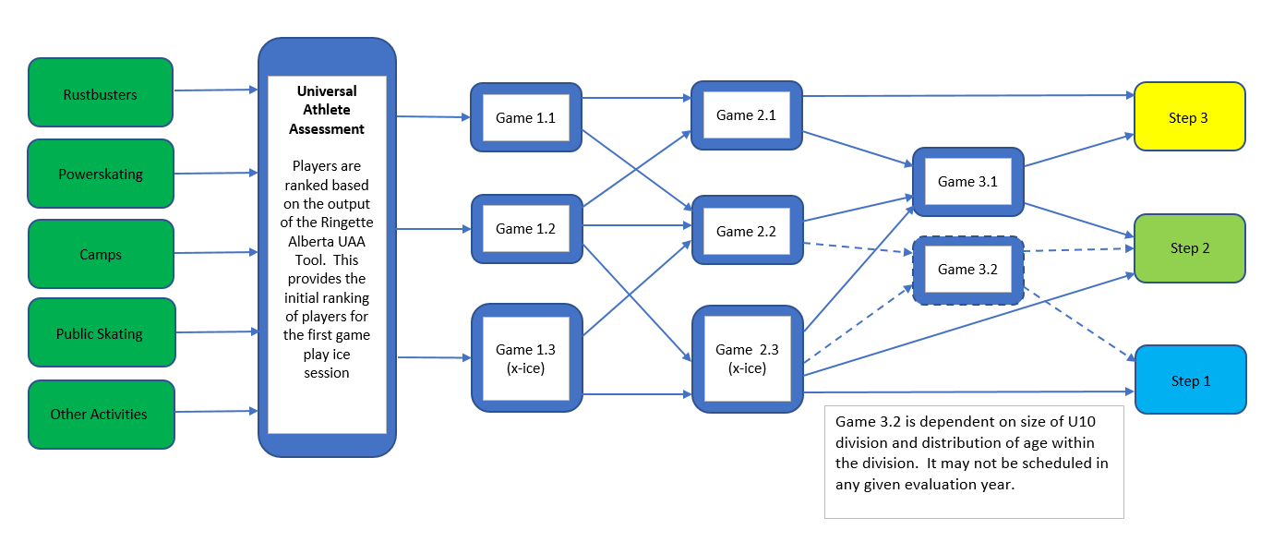

U12 EVALUATIONS FLOW CHART:
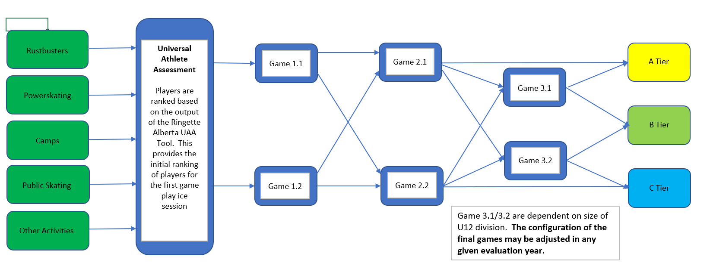

U14 EVALUATIONS FLOW CHART:
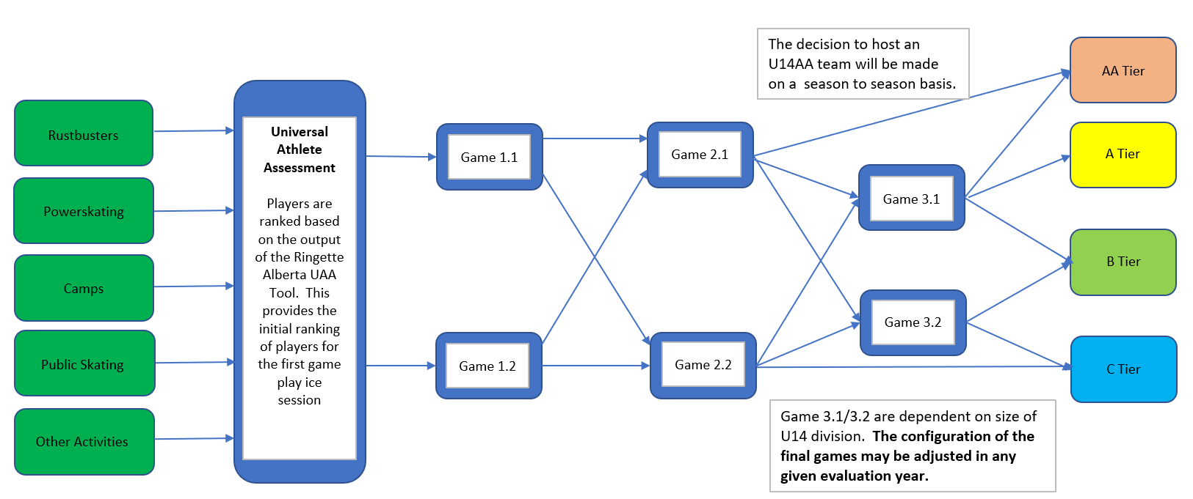

U16/19 EVALUATIONS FLOWCHART:
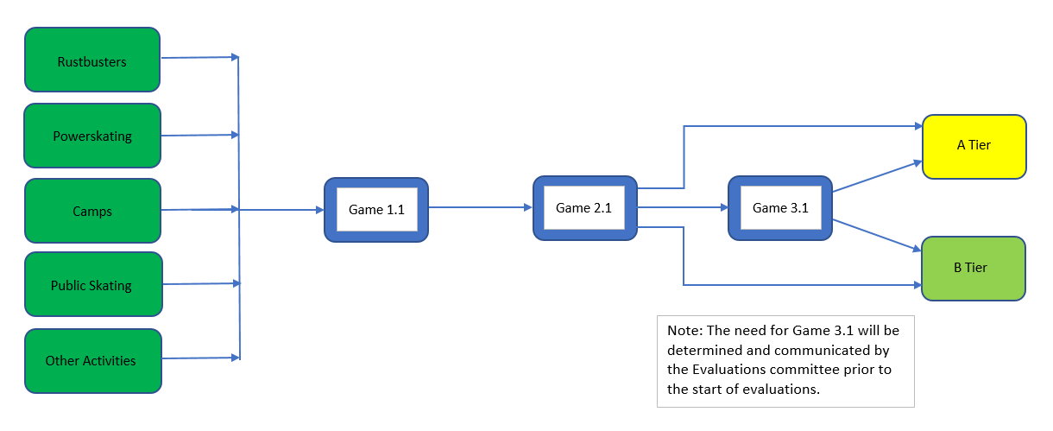

APPENDICES:
APPENDIX A: Weighting of Evaluation Scores by Division
 | U10 | U12 | U14 | U16 | U19
UAA SKILLS SESSION | 30% | 30% | 30% | N/A | N/A
GAME PLAY SESSIONS | 70% | 70% | 70% | 100% | 100%

APPENDIX B: 2 Team Snake DrawPool Build Methodology
- Players are ranked 1,2,3,4 …….24.
- Players are then pooled as:
  - (1&2), (3&4), (5&6), etc.
- Coaches would be selected.
- Coaches would draft teams by pool.
- Draft teams would be reviewed by coaches and Evaluations committee.
- Slight adjustments may be made.
- Teams are accepted by coaches and Evaluations committee.
- Team rosters released.

APPENDIX C: 3 Team Snake Draw Team Build Methodology
- Pool of players are ranked 1,2,3,4 ……. 36 (or more depending on player pool size).
- Players are then pooled as:
  - (1,2 & 3), (4,5 & 6), (7,8 & 9), etc.
- Coaches would be selected.
- Coaches would draft teams by pool, alternating first pick.
- Draft teams would be reviewed by coaches and Evaluations committee.
- Slight adjustments may be made.
- Teams are accepted by coaches and Evaluations committee.
- Team rosters released.

