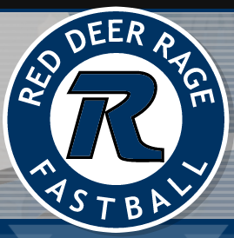

Coach: Stephen Pottage

- Tam

- Reynolds

M. Adams

N. Pugsley

O. Mack

P. Holowaychuk

R. Sampson

R. Bell

R. Bryar

S. Pottage

T. Sorenson

T. Carlyle

Congratulations on making the U10A roster!

