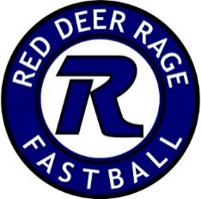

April 30, 2020

Hello Rage Families!
I hope that all of you are healthy and safe.
The past couple of months have turned our lives upside down, and we are all finding a new normal. It has been difficult to say the least, but it seems that the efforts put forward by everyone have worked, and that curve is flattening!
However, with the City of Red Deer facilities closed until June 30th, and the cancelling of Provincials by Softball Alberta, we are making the very difficult decision to cancel the season for the majority of our teams. At this time, we are postponing the seasons for the three A teams (U14, 16, 19) that were formed in the fall. We are waiting to see if anything can be salvaged for these teams as they do have some events outside of Alberta in late summer.
Should the Provincial/City situation improve, and we are able to play late summer/fall ball, we are definitely going to look at this an option. We want to see everyone out on the diamonds at some point this year! If we are able to create a modified season, you will be notified about a new registration link.
We are going to issue refunds at this time for all registrations affected. We recognize the importance of this at this time, and will get it done as soon as possible. It is a huge task, so please be patient.
Thank you for your patience and understanding throughout this process. Please reach out if you have any questions.

Christa Lawrence
President Red Deer Rage Fastball

