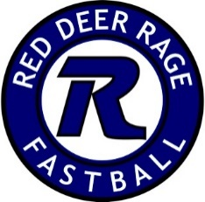

March 31, 2020

Dear Rage Families,
I hope that all of you are healthy, and finding some good in the current world situation.
Covid-19 has made all aspects of our lives very different, very suddenly. With all of the information provided to us, by local and Provincial governments, we are continuing to put the 2020 Season on hold, but are not cancelling it as of yet.
We will be taking direction from Softball Alberta and Softball Canada in regards to what this season could look like. We are expecting an update from these organizations on April 15th, and will pass along this information to you as we get it.
We appreciate your patience with this process. We are at the mercy of this pandemic and NEED to keep our ball families as safe as we can.
Please reach out to me if you have any further questions or concerns regarding this season.
Thank you!
Christa Lawrence
President- Red Deer Rage

