2023 RLSA FALL General Meeting
November 14, 2023 8:30 PM via Zoom
- Call to order – 8:38
Teams not in attendance: Dakota, Iskotew, TATC

- Adoption of agenda – Motion to adopt as presented: 1st: Jolene Sentes; 2nd: Leila Mohr, carried.

Poll Results:
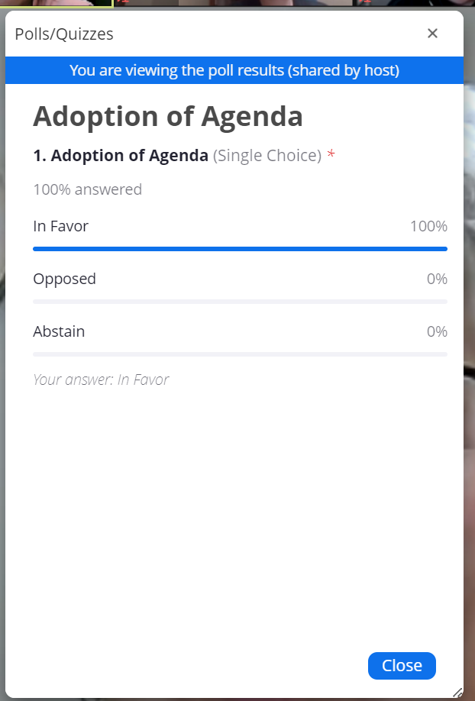

- Adoption of minutes from Spring 2023 Meeting (can be viewed on RLSA website under ‘About Us/Meeting Minutes’) – motion to accept as presented:1st: Karen Thull; 2nd: Georgina Carter; carried.

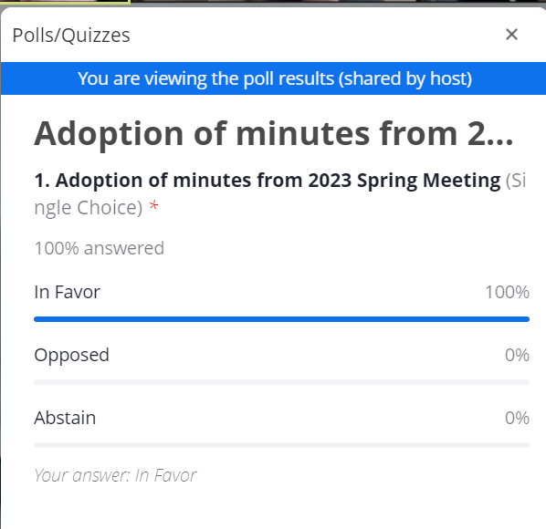

- Treasurer’s report – Sydney Ellis
Key Highlights:
- Revenue increased due to the increase in the number of bingos worked; expenses up as well to account for paying workers.
- No tournament held in 2023
- Small amount of expenses for general diamond upkeep

Sydney Ellis made a motion to accept the Treasurer’s Report as presented; 2nd: Sarah Stelmacovich; carried.

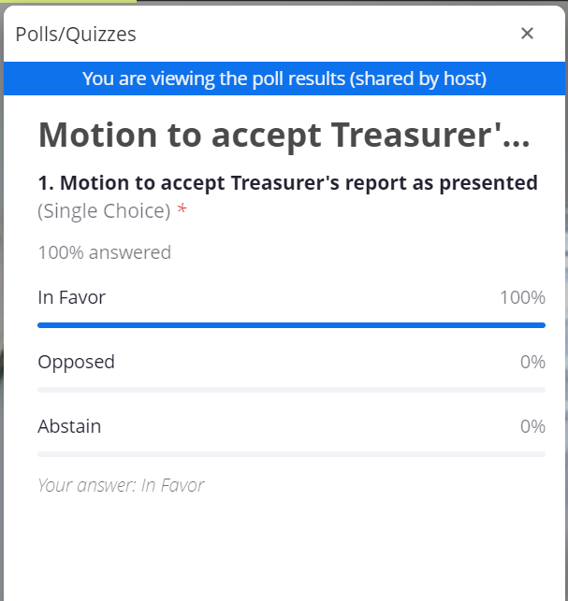

- Bingo report – Brenda Anderson

- We have received more bingos lately due to less charities wanting to work, however, one of the bingo halls in Regina is closing the end of this calendar year so unsure if this will impact the number we are allocated.
- If you are interested in working bingos, you can contact our Bingo Coordinator Maureen.

- Douglas Park report – Brenda Anderson
- Warning Tracks – Brenda Anderson has met with stakeholders at the City about the possibility of installing them. Would require a maintenance plan to ensure that they are getting the proper maintenance to support them.
- Diamond 2 – work to reduce the sun impact on the diamond. The City does have some ideas about how to shelter the sun. Brenda has a meeting coming up.
  - Will be difficult to do much with the diamond but potentially some sort of shade structure could be added.
- Pickle Ball courts are still planning to be built in two stages; some being built this fall and the rest next year. The only impact we foresee is just on the parking.
- Pitching bullpens – We will need to come up with a plan to maintain them going forward. This could include purchasing different equipment to enable PCC to better drag them.
- Fence toppers: looking to get ordered in early spring and have installed. Cost is estimated around $3500-$4000.
- Field maintenance:
  - Question from Brenda: for double headers, would teams like to have rakes left out to do some maintenance to the diamonds between games? Response from teams would be “yes”.
  - ACTION: Executive to determine where teams can go to get the equipment.
  - Question: Would there be any access to water for dry days to give the batter’s box/pitching mound some water between the games?
  - Action: Executive to look into what could be used

- 2023 Season review:
  - Regular season – May 15th to July 13th = 16 games

  - Division structures – 17 teams (Division I – 6 teams; Division II – 11 teams)

- Interlocking games – Top 5 teams in Division II played interlocking games with Kaos & Iskotew from Div I

- Rescheduling games –11 due to smoke/rain/unplayable diamond; 13 games rescheduled by teams.

- Default games = 2 regular season, which was significantly down from the prior season

- League tournament – Kim Picot

- Due to the low number of entries, the Executive decided to cancel the tournament.

- League playoffs – July 17th-Aug 1st; Division I – 5 teams; Division II – 8 teams; double knockout format.

- RAMP registration process – Sarah Stelmacovich

- This year went a little better than the first year
- Softball Saskatchewan has indicated that they plan to use RAMP going forward as their registration system.

- Umpires – Ian Bowers
- Generally, we had 8 umpires each night
- No umpires have indicated that they will not be back next year
- Would love to attract some younger/new umpires

- 2024 Season Preview
- Start date –Sunday, May 12th or Monday, May 13th
- RLSA tournament dates – Tentative dates May 31st-June 2nd
- There will need to be some discussion with the new Tournament Coordinator to determine if the RLSA teams would be interested in playing a tournament if the entries are mostly Regina teams?
  - Sleek, Titans both stated they would prefer not to play in the tournament unless there are out of town teams to play
  - Feedback from Elite about how early in the season the tournament is held
- Team indications – Brenda Anderson has not received any new teams that are looking to join RLSA or any current team’s intentions to withdraw or ask for a leave of absence.
- U19 players – In Softball Sask rules, any U19 player with a Regina address is required to register with their minor association, which would be RMSL. If they are wanting to play with a team other than an RMSL team, they would be required to request a release.

- Constitution & By-laws Amendments – see below for proposed changes.

- General Operating Rule Amendments – see below for proposed changes

- Executive position elections
- Vice-President –
- Kim Picot will retire from this position but has spent many years as a part of the league as a player, coach, and Executive Member. Thank you, Kim, for your contributions.

- No nominations put forward at the meeting.

Note: Deanna Gerrard contacted Brenda Anderson after the meeting on November 14th and agreed to take on the role of Vice President. Thank you Deanna.

- Treasurer – Sydney will let her name stand

- Thank you for letting your name stand Sydney.
- No other nominations put forward at the meeting.

- Statistician – Sue Getzlaf has put her name forward

- Was held by Matt Johner who has decided to retire after many decades dedicated to the League. Thank you Matt!
- No other nominations put forward at the meeting.

Question from Debbie Tanner – does the role require updating the information on the website? Answer was yes.

- Scheduler/Tournament Coordinator –
- Ian has decided to retire from the position but has spent many years with the League as a coach, umpire. Thank you Ian!
- We have received a nomination from Chelsea Jones to take over this position. Thank you Chelsea! Ian has offered to mentor Chelsea this season.
- No other nominations received at the meeting.

- Facilities Coordinator –
- No nominations received at the meeting.

- No votes required.

Brenda Anderson has confirmed that this will be her final season as the President.
- The hope is that we can find someone interested that can mentor with Brenda this season.
- Please talk to your team members about the importance of filling these roles to continue to have a league to play in

- Other Business
- 2024 Canadian Native Fastball Championships – August 2nd -4th

- First meeting will be held in a couple of weeks
- May be looking for someone to take on a paid Coordinator role if anyone is interested. Will know more after the meeting.

- RAMP team app
- Reminder to the teams that we can use the “Team App” functionality that is covered in your league fees
- Refer to Softball Saskatchewan website or contact office for information on coaching clinics, sport medicine & science workshops, athlete skills development clinics.
- Important dates
  - Mid-February - Email will be sent to teams to indicate their intentions for the 2024 season. Deadline will be end of February.
  - Mid May – league fees due 24 hours prior to start of season. Budget $2,000
  - Mid May – team affiliation due 24 hours prior to start of season.

- Acknowledgements & Adjournment

2023 Regular Season
Division I – Sleek
Division II - Pride

2023 Playoffs
Division I – Sleek
Division II - Diamondbacks

- Congratulation to Rampage who won the Women’s Open Provincial Championship.

Motion to adjourn: 1st: Debbie Tanner, 2nd: Jolene Sentes, carried.

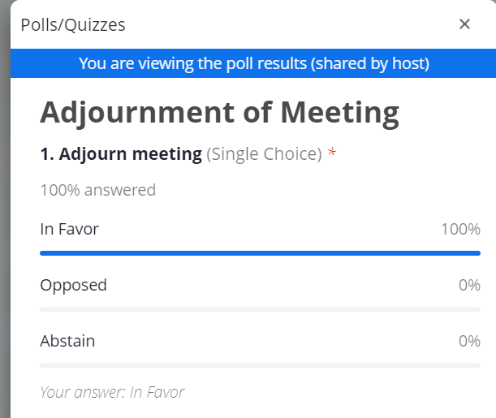

PROPOSED CONSTITUTION & BY-LAW CHANGES FALL 2023

Submitted by RLSA Executive

4. FEES – Performance Bond

The performance bond amount will be set at the fall annual general meeting.

PROPOSED bond amount – performance bond remain at $500.

Poll Results from meeting:

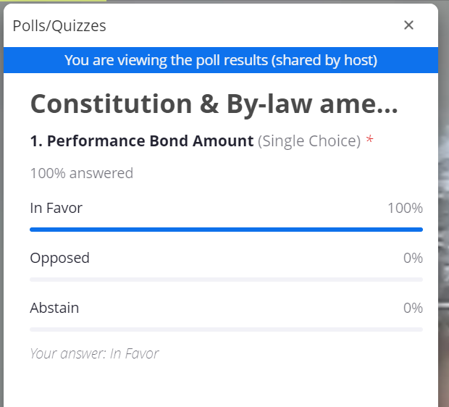

6. POWERS AND DUTIES OF THE EXECUTIVE
F) Statistician

EXISTING - shall notify the media of all Association events and game/league statistics.

PROPOSED - remove as now duty of Communications Manager to be contact with media.
Poll Results from Meeting:
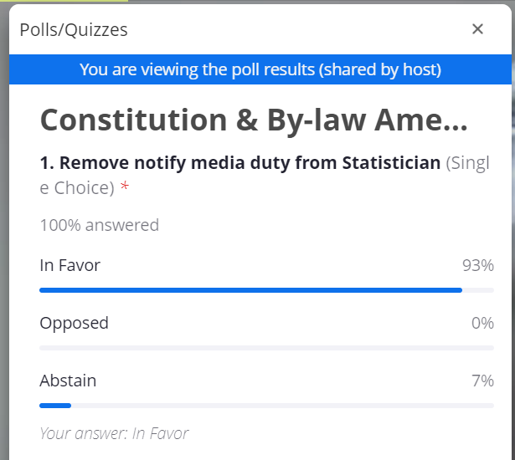

H) Scheduler/Tournament Coordinator – (to align with existing Operating Rule 1. Schedule)
EXISTING - create regular season schedule according to the format decided at the spring organizational meeting. The schedule is to be completed prior to May 1st of the current year.
PROPOSED - create regular season schedule according to the format decided at the spring organizational meeting. The schedule is to be completed and distributed to teams a minimum of 10 days prior to the start of the season.

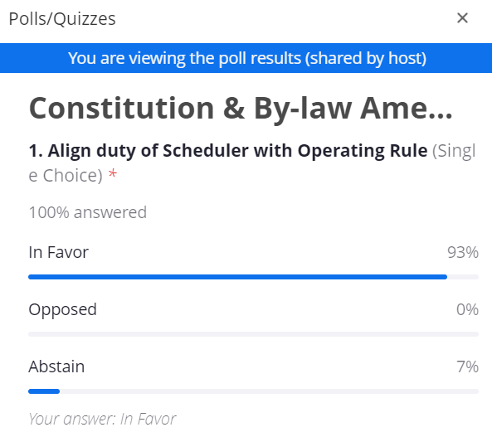

PROPOSED OPERATING RULE CHANGES FALL 2023

Submitted by RLSA Executive

3. Registration of Players – (to reflect change from paper based registration to online registration)

EXISTING – C. A player shall be considered to be registered with a team when her name has been forwarded to the Registrar.

PROPOSED - A player shall be considered registered with a team when the player has completed her online registration under the appropriate team.

Question from Georgina: how does this rule apply for RMSL teams as they register with a league and not a team?
Response: The U19 players would still be registered with a specific team under RMSL.

Question from Debbie Tanner: Once you register, you are considered “on a team”?
Response: The teams are set up in the registration system and it is the responsibility of the team contacts to forward the invites to their players to register/affiliate their players.

EXISTING – E. A completed team roster is to be provided to the Registrar 24 hours prior to the start date of the regular season. Failure to provide a team roster by the established registration date results in scheduled games being defaulted until the roster is provided to the Registrar. Players can be added to a team roster up until May 8th via notification to the Registrar.

PROPOSED - A completed team roster is to be entered into the online registration system 24 hours prior to the start date of the regular season. Failure to have a roster available to be viewed by the Registrar through the online registration system by the established registration date, will result in scheduled games being defaulted until the roster is completed. Players can be added to a team/registered online until the affiliation deadline set by Softball Sask. The Registrar must be notified of players added after the start of the regular season.

Poll Results from the meeting:
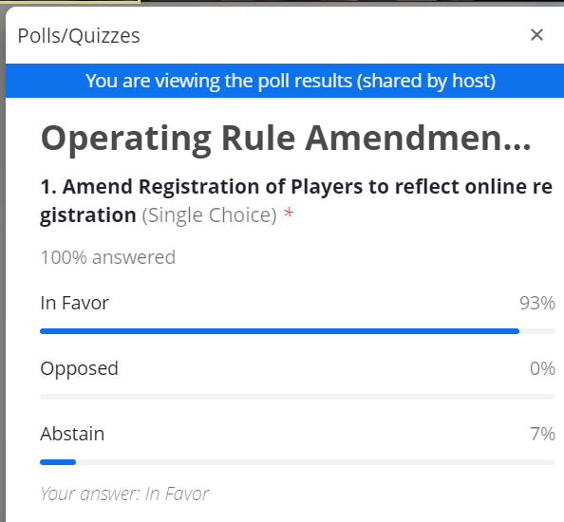

4. Playoffs

PROPOSED - add rule F. Home team for all playoff games will be the team with the highest standing after the regular season.

Poll Results from Meeting:
