2024 RLSA FALL General Meeting
Tuesday, December 3, 2024 7:30 PM via Zoom
- Call to order – 7:41 – delayed due to not having enough teams present for a quorum
Teams missing: Pride, Iskotew, Rage, Moose Jaw

- Adoption of agenda
Motion to accept as presented; 1st: Jolene Sentes; 2nd: Rod Hauk.
Motion accepted – 100%

- Adoption of minutes from Spring 2024 Meeting (can be viewed on RLSA website under ‘About Us/Meeting Minutes’)
Motion to accept as presented; Danielle Swartz, 2nd: Sue Getzlaf, Passed.
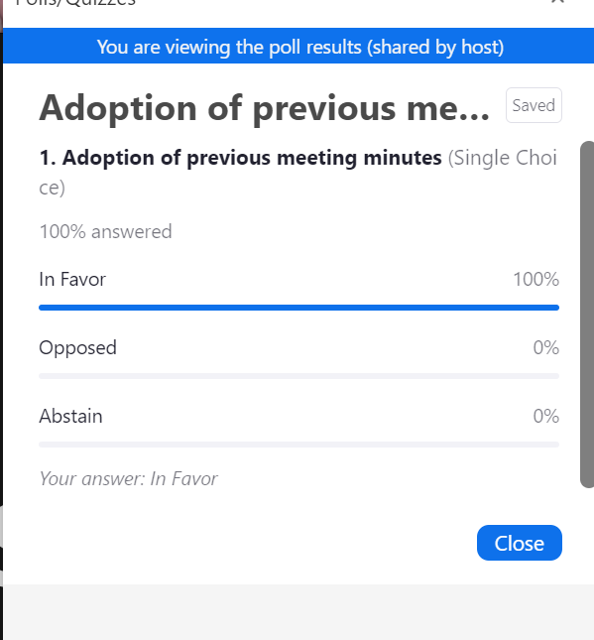

- Treasurer’s report – Sydney Ellis
- Increase in revenue due to grant money received
- Tournament resulted in additional income and expenses
- Excess in cash in the operating account – to be discussed under point 6. Douglas Report.
Motion made by Sydney Ellis to accept the report as presented; 2nd: Jolene Sentes; Passed.

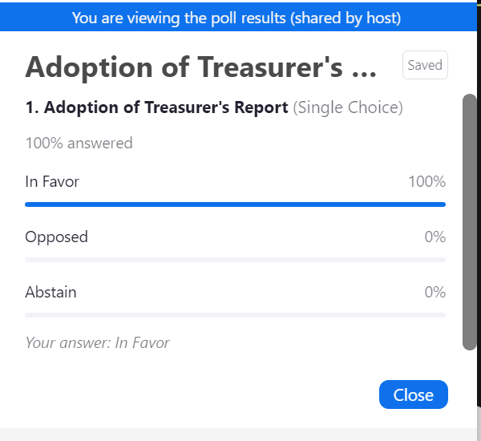

- Bingo report – Brenda Anderson
- Since the spring meeting, have had 31 bingos
- Have the schedule until the end of February; if any teams are interested in working one, they can find the contact’s email (Maureen) on the RLSA website.
- We are averaging over $8000 in bingo proceeds per month.

- Douglas Park report – Brenda Anderson
A few options for upgrades at the park:
- Option to add bleachers to the outfields for fans to watch the game.
- Bleachers: generally, the bleachers that you can purchase now are lower compared to our current ones. For that reason, the Executive would prefer that we instead fix our current ones rather than purchasing new.
- Water source – increase availability of water for diamond maintenance.
- Potential work to the batters’ boxes or pitching mounds; adjust or fix the bricks that are under the ground.

- Another option the Executive talked about was to use some of the funds to support our league teams to attend Westerns or Canadian Championships or to help support players via the establishment of a scholarship program. Jolene Sentes has offered to put together a proposal for this (criteria, application process, etc.). If anyone has any ideas, please share them with Jolene.

- 2024 Season review:
  - Regular season – start date May 13th = 15 games
  - Division structures – 17 teams (Div I – 9 teams; Div II – 8 teams)
- Rescheduling games – Regular season extended from July 4 – July 18 due to number of games rained out & reschedule requests
- Default games = 7 game nights (up from 2 games last year)
- League tournament – June 1-2; 4 teams in each division, Open A & Open B; 3 of 8 were non RLSA league teams
- League playoffs – July 18th-July 30th; Div I – 7 teams; Div II – 6 teams; two game guarantee format.
- RAMP registration process – Sarah Stelmacovich
  - Ensure that Respect in Sport is completed
- Umpires – Duane Bakken has retired. We thank Duane for all that he has done for the league for many years.
  - Some senior umps from RMSL will be doing more RLSA games in 2025
  - District 2 does have an umpire’s association, and they are putting together an umpire development initiative and RLSA donated to help fund this work.
  - Some feedback provided by the Umpire’s Association:
    - Incomplete lineup cards
    - Cases of verbal abuse of the umpires. This will not be tolerated by the RLSA. Comes back to respect for the game and is essential to keep umpires around to run an effective league.

- 2025 Season Preview
  - Start date –Monday, May 12th
  - RLSA tournament dates – Tentative dates May 30th-June 1st. Executive was curious whether teams are interested in participating in the tournament if there are mostly RLSA teams. Results: 45% - yes, 55% - no.
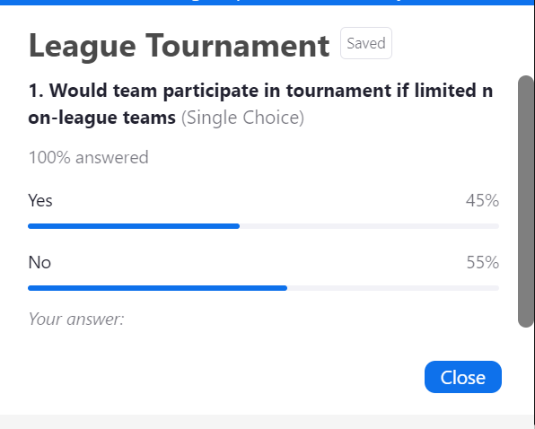

Some members of the Executive will look to increase awareness for the tournament by contacting teams, posting early online. A decision will be made at a later date.
If interested in helping with the tournament, reach out to Deanna Gerrard.

  - Team indications – interest from 4 new teams
- Pilot Butte – U19 team
- Graduating players from RMSL are considering entering a team
- Lumsden looking enter a team
- Potential interest from one of the reserves to come back into the league
Questions:
Will the divisions stay the same?
- At this point, no decisions made but RLSA has not received any specific requests from teams.
If more teams do come in, any chance of moving back to 3 divisions?
- Will depend on the number of teams registered.
- Not ideal if one division is very small
- This will be looked at prior to the Spring meeting

Comment: if there is another team being made up of Regina players, there can be impact to the existing teams who are not notified and then are stuck to find players.

  - U19 players – Softball Sask. rules regarding release of players
- Underage players require a release from their designated minor league. Contact Softball Saskatchewan if any questions.

- Constitution & By-laws Amendments – see below for proposed changes.

- General Operating Rule Amendments – see below for proposed changes

- Executive position elections
  - President – Deanna Gerrard will let her name stand. If elected, will need to elect Vice-President
- No other nominations received at the meeting
- As Deanna will take the role of VP, the position of VP will be open for nomination.

  - Secretary – Natasha Zeiler will let her name stand.
  - No other nominations received at the meeting

  - Registrar – Sarah Stelmacovich will let her name stand for another term
  - No other nominations received at the meeting

  - Communications Manager – Jolene Sentes will let her name stand for another term
  - No other nominations received at the meeting

  - Facilities Coordinator – position currently vacant. Brenda will let her name stand (will be one year term).
  - No other nominations received at the meeting

Other Business
- 2024 Canadian Native Fastball Championships – August 2nd -4^{th;} 19 Sr. Ladies teams + 5 Masters teams
- RAMP team app
Question: Does your team use the RAMP team app??
In favour = yes
Opposed = no

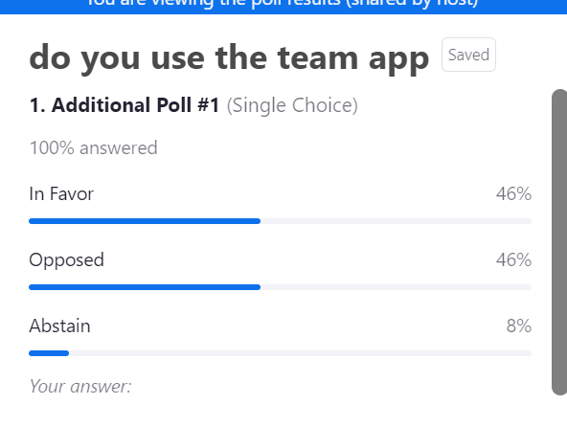

Known issue: when changes are made to an event, the prior availability entered carries forward rather than requiring the player to update.

- Refer to Softball Saskatchewan website or contact office for information on coaching clinics, sport medicine & science workshops, athlete skills development clinics.
- Important dates
  - Mid-February - Email will be sent to teams to indicate their intentions for the 2025 season. Deadline will be end of February.
  - Mid-March – spring meeting to allow for time to build the schedule and get out earlier to teams to make arrangements.
  - Mid-May – league fees due 24 hours prior to start of season. Budget $2,000
  - Mid-May – team affiliation due 24 hours prior to start of season.

- Acknowledgements & Adjournment
- League – Kaos & Vipers for 1st place in regular season & Sleek & Vipers for winning division playoffs
- Earl Grey – Gold- Women’s Open provincials
- Revenge – Gold - U20 provincials
- Moose Jaw Ice – Silver – U19A provinicals
- Carnduff Steelers –2nd at Women’s A provincials & Gold at Canadians

Motion to adjourn the meeting, Tyler Gerrard; 2nd: Natasha Zeiler, passed.
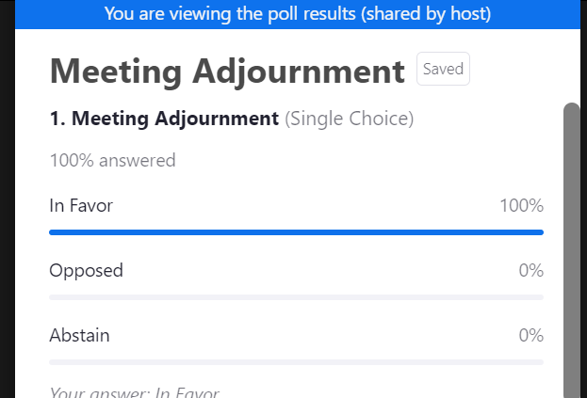

PROPOSED CONSTITUTION & BY-LAW CHANGES FALL 2024

Submitted by RLSA Executive

4. FEES – Performance Bond – set bond amount

The performance bond amount will be set at the fall annual general meeting.

PROPOSED bond amount – performance bond remain at $500.

Motion to keep bond at $500; passed.
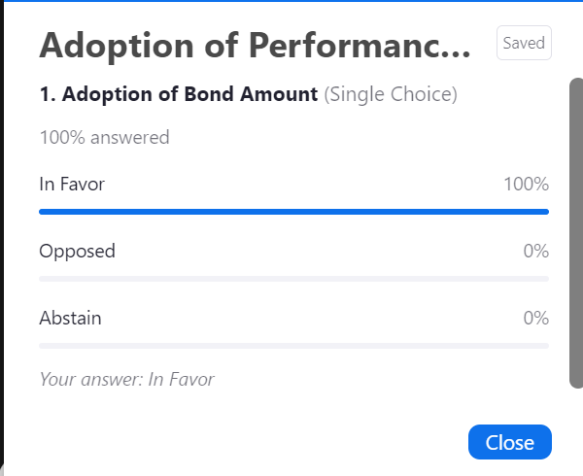

4. FEES – Performance Bond – propose a tiered system of penalties for default games

EXISTING - For each game night a team defaults, fifty percent of the performance bond will be deducted from their performance bond. A team that defaults two game nights will be suspended from the Association until reinstated by the Executive.
PROPOSED - For each game night a team defaults due to not enough players being available at the diamond, one hundred percent of the performance bond will be deducted from their performance bond.

For each game night a team defaults due to less than 12 hours- notice of not being able to play, fifty percent of the performance bond will be deducted from their performance bond.

A team that is penalized the entire amount of their performance bond will be suspended from the Association until reinstated by the Executive.

Motion to approve a tiered performance bond penalty. RLSA constitution notes that 75% must be in favour to make a change. As 75% was not obtained, the motion is considered defeated, and no change will be made.

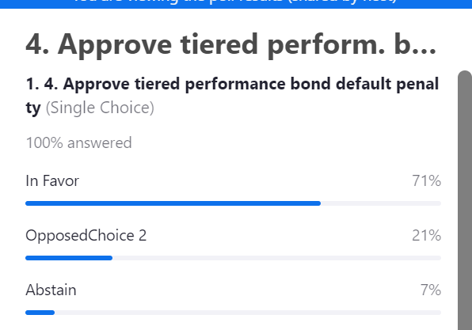

6. POWERS AND DUTIES OF THE EXECUTIVE
PROPOSED – move duty for rescheduling games from Vice-President to Communications Manager
• contact for arranging diamonds, umpires, and groundskeeper for rescheduled games.

Motion to move rescheduling duty from VP; passed.
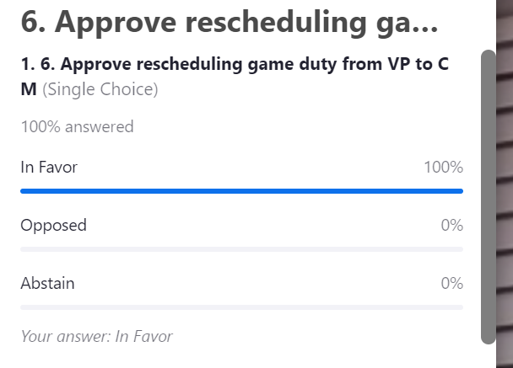

PROPOSED OPERATING RULE CHANGES FALL 2024

Submitted by RLSA Executive

5. Ground Rules – (update timeframe for end of second game of double header)
EXISTING – C) For games starting at 6:45 P.M., no new inning shall start after 8:30 PM. For the second game of a double header being played under the lights, no new inning shall start after 10:45 P.M.
PROPOSED - C) For games starting at 6:45 P.M., no new inning shall start after 8:30 PM. For the second game of a double header, no new inning shall start 1 hour 45 minutes after the start time declared by the umpires.
Motion made to change the end time for the second game of a double-header; passed at 100%.

5. Ground Rules – (combine rules D & J & delete requirement to put names of winning and losing pitchers on score sheet)

EXISTING – D) It is the responsibility of the home team to supply the official scorekeeper who must ensure the player first name, last name and number and the names of the winning and losing pitchers are clearly printed on the official score sheet.
EXISTING –J) At the completion of every game, a complete and accurate score sheet must be handed in to the Association umpires by the Home Team. Score sheets are to include: team name, first and last name of every player (including substitute players listed at the bottom), player numbers, player position numbers, as well as reflect anytime a substitution player is entered into the game. Teams handing in an incomplete or inaccurate score sheet will be given one warning from the Association Executive. Any subsequent incomplete or inaccurate score sheets will result in a $25 fine per score sheet.
PROPOSED - D) It is the responsibility of the home team to supply the official scorekeeper. At the completion of every game, a complete and accurate score sheet must be handed in to the Association umpires by the Home Team. Score sheets are to include: team name, first and last name of every player (including substitute players listed at the bottom), player uniform numbers, player position numbers, as well as reflect anytime a substitute player is entered into the game. Teams handing in an incomplete or inaccurate score sheet will be given one warning from the Association Executive. Any subsequent incomplete or inaccurate score sheets will result in a $25 fine per score sheet.

Motion to make changes to scorekeeper/scoresheet requirements; passed.
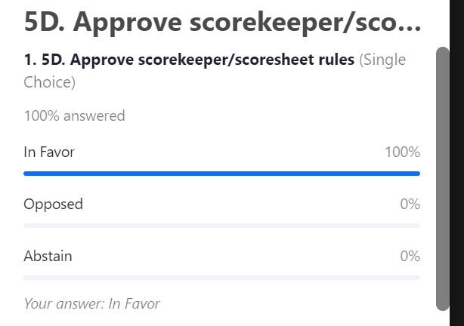

5. Ground Rules – (change timeframe to provide score of game as double header second game not complete yet)

EXISTING - F) After the game, it is the responsibility of the winning team to contact the publicity director/statistician by 9:30 PM with the game statistics.

PROPOSED - F) After the game, it is the responsibility of the winning team to contact the publicity director/statistician by noon the following day with the game score.

Motion to change the timeframe for providing game scores to the statistician; passed.
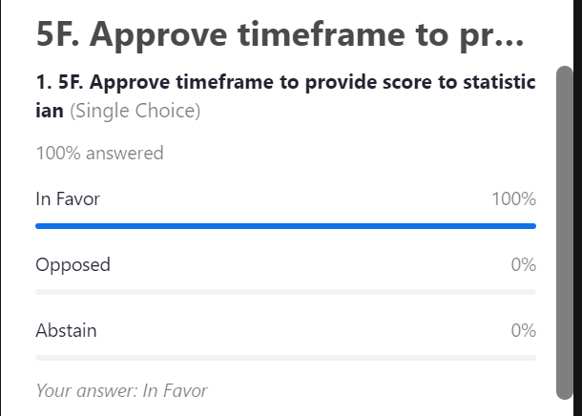

5. Ground Rules – NEW – penalty for incomplete lineup card
PROPOSED – It is the responsibility of each team to present a completed lineup card to the umpire prior to the start of the game. The lineup card must include the first and last name and uniform number of every player at the diamond. The player position must be included for the starting lineup. A team representative must sign the lineup card. Teams handing in an incomplete lineup card will be given one warning from the Association Executive. Any subsequent incomplete lineup card will result in a $25 fine per lineup card.

Motion to implement a $25 penalty for incomplete lineup cards; passed.
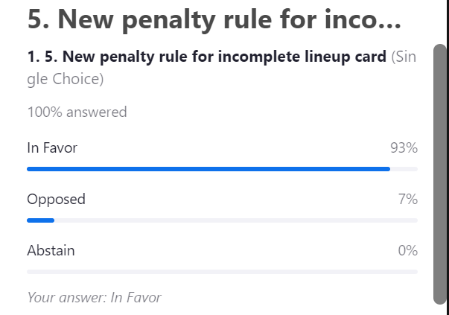
7. GENERAL – (lower advance notice from 24 hours to 12 hours)
EXISTING - B) If a team does not have enough players for a game, they must notify the Communications Manager, opposing team, and Statistician 24 hours in advance of game time. The Communications Manager will notify the umpire-in-chief, groundskeeper, and Vice-President.

PROPOSED – B) If a team does not have enough players for a game, they must notify the Communications Manager, opposing team, and Statistician 12 hours in advance of game time. The Communications Manager will notify the umpire-in-chief, and groundskeeper.

Motion to change the notice required to notify RLSA of not enough players to 12-hours; passed.

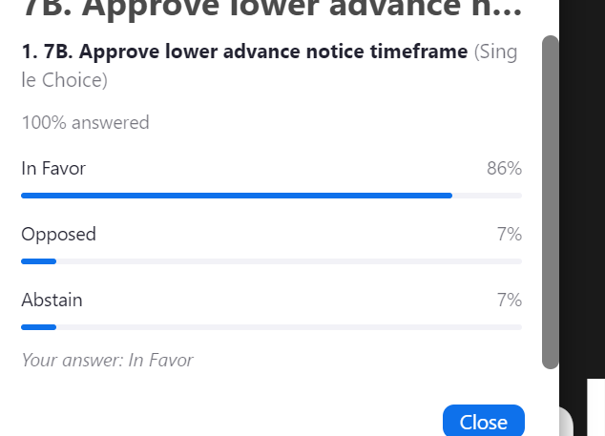
7. GENERAL – (expand definition of default if tiered penalty system approved)
EXISTING - C) Each team is allowed to cancel two game nights which are to be rescheduled as soon as practical. A third cancelled game night will be treated as a default. This means a double header is considered one game night.

PROPOSED - C) Each team is allowed to cancel two game nights which are to be rescheduled as soon as practical. A third cancelled game night will be treated as a default and fifty percent of the performance bond will be deducted from their performance bond. This means a double header is considered one game night.

**This proposal is no longer required due to the proposed Constitution change related to FEES – Performance Bond – propose a tiered system of penalties for default games – not being accepted.

7. GENERAL – (change Executive member responsible for rescheduling games)
EXISTING -D) All cancelled or rain out games are the responsibility of the Vice-President to reschedule.

PROPOSED -D) All cancelled or rain out games are the responsibility of the Communications Manager to reschedule.

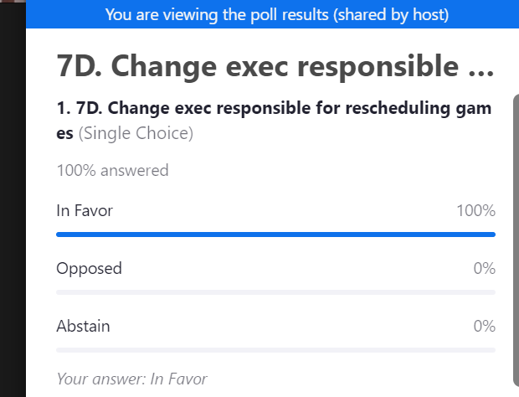
4. PLAYOFFS (change penalty description if tiered default penalty system approved)
EXISTING - B) The Scheduler/Tournament Coordinator shall set the playoff schedule and give notice to the teams concerned at least three days prior to the first game. A team that indicates they will participate in playoffs and subsequently withdraws after the playoff schedule has been created, will be accessed a penalty equal to the default fee of two games.
PROPOSED - B) The Scheduler/Tournament Coordinator shall set the playoff schedule and give notice to the teams concerned at least three days prior to the first game. A team that indicates they will participate in playoffs and subsequently withdraws after the playoff schedule has been created, will be accessed a penalty equal to fifty percent of the performance bond amount.
**This proposal is no longer required due to the proposed Constitution change related to FEES – Performance Bond – propose a tiered system of penalties for default games – not being accepted.

