2025 RLSA FALL General Meeting
Tuesday, November 18, 2025 7:00 PM via Zoom
- Call to order
Meeting called to order at 7:15pm (waited for enough teams to arrive to have quorum).

- Adoption of agenda
Karen Thull motioned, Tyler Gerrard seconded. Approved.
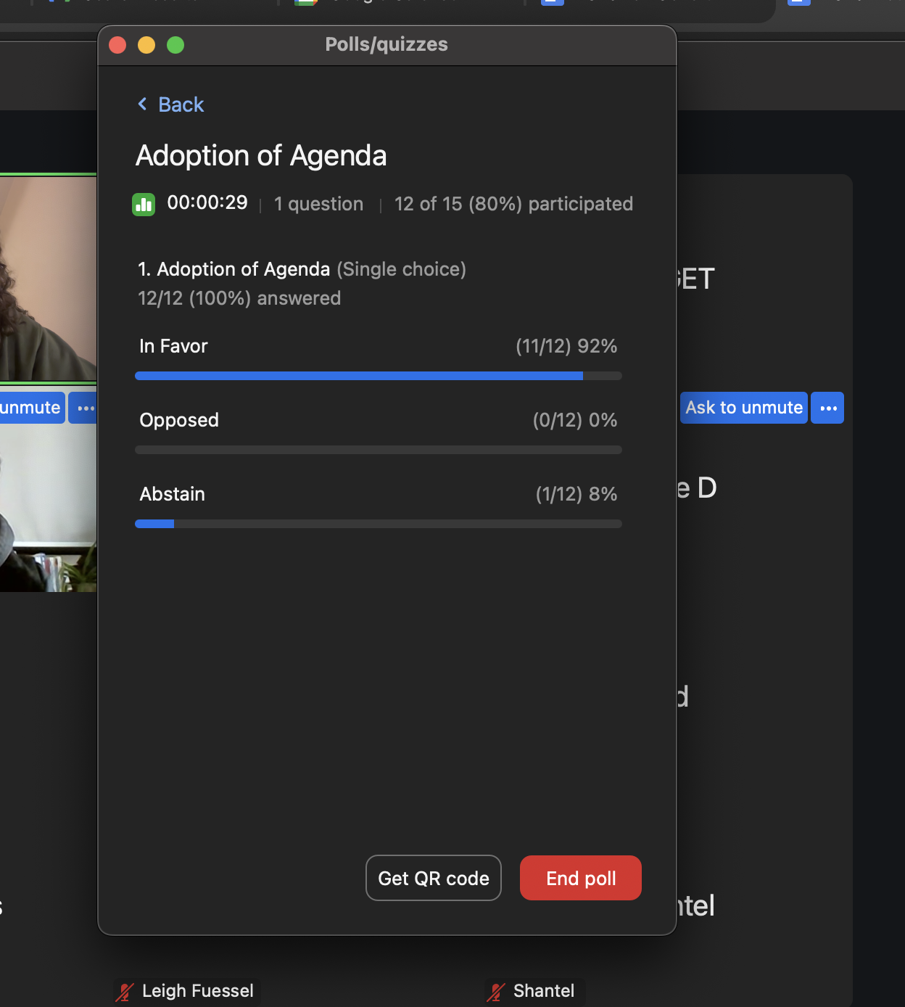

- Adoption of minutes from Spring 2025 Meeting (can be viewed on RLSA website under ‘About Us/Meeting Minutes)
Natasha Zeiler motioned, Danielle Swartz seconded. Approved.
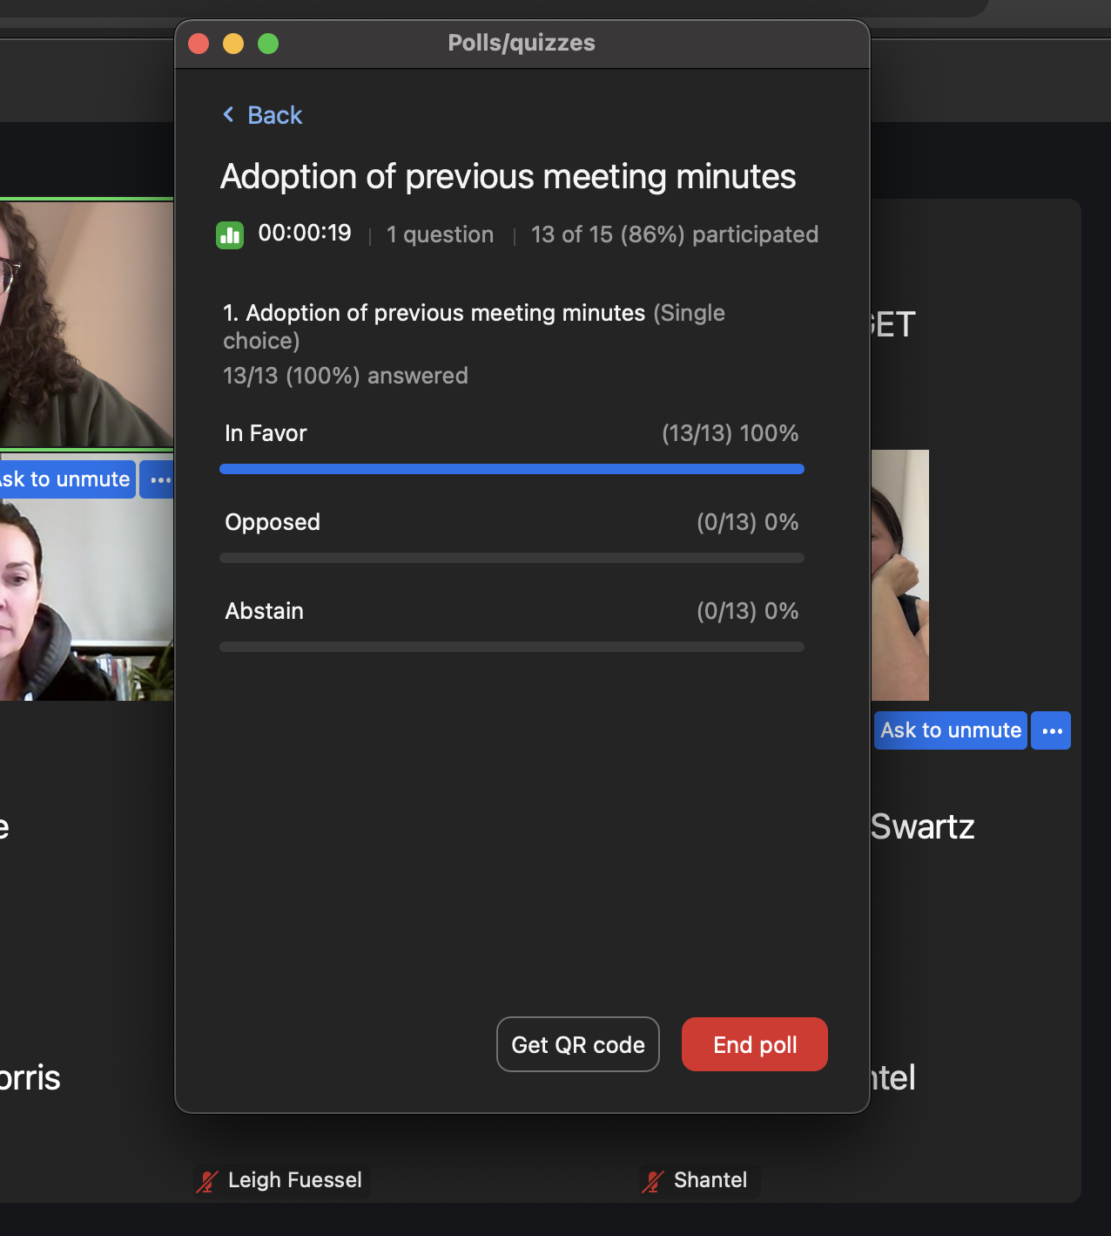

- Treasurer’s report – Sydney Ellis
- No questions on the report overall. Discussion on suggestions for what to do with our funds.
- Over 100k to add warning tracks to outfields
- Question about what would be done on diamond 2? Potential shade screens/etc to correct the sun affecting players.
- Suggestion for more lights on other diamonds so we can do more double headers in a week. The issue is that we don’t have enough umps for more late games. Costs for lights on diamonds were quoted as 150K just to get the lights delivered plus power to the diamond, stands, etc.
- Debbie Tanner motions, Rod Hauk second. Accepted treasurers report.
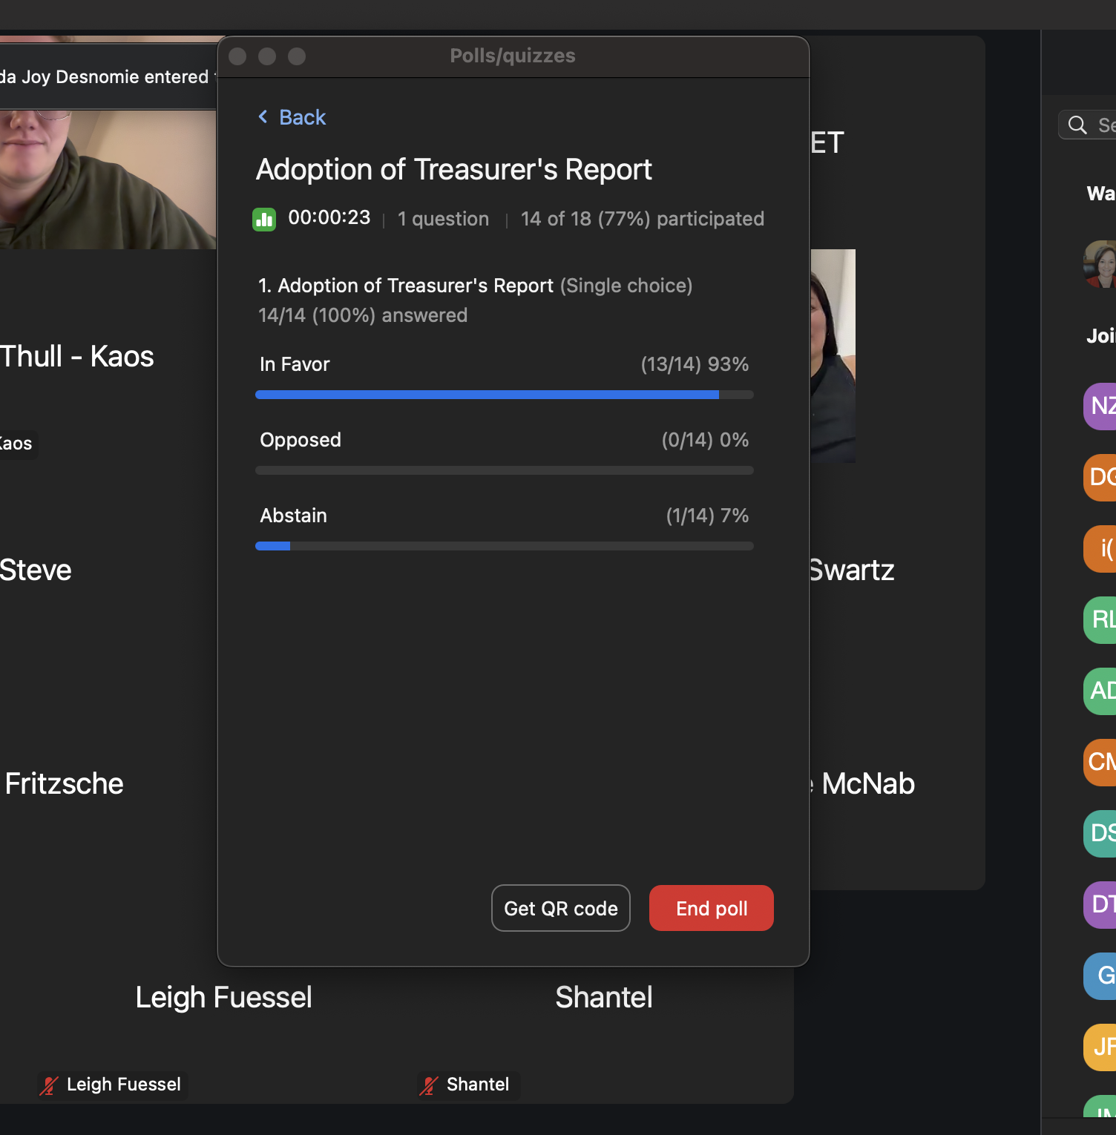

5. Bingo report
  - 44 bingos Dec 1/24- Oct/25; 11 bingos scheduled Nov-Feb/26
    - Reminder you are able to work these bingos to have the bingo fund returned
    - Bingo schedule is posted on the website

6. Douglas Park report – Brenda Anderson
  - Water is plumbed to the building
Got some painting and cleaning done inside the building as we had a tour come through because the city applied to host the 2030 Canadian Special Olympics. Some things to be completed for 2026 are fixing up the base holes, work around the building for landscaping for grading and the cement pad, bleacher fixes, the bases shed needs fixing (or replacement).

Question Des Desnomie: Bases shed, are we building a new one or what's happening?
- Replace it. Will have a new lock on it (city does this we technically don’t have say in this)

7. 2025 Season review:
  - Regular season – start date May 13th = 15 games
  - Division structures – 20 teams (Div I – 8 teams; Div II – 12 teams)
- Rescheduling games – Regular season extended from July 4 – July 18 due to the number of games rained out & reschedule requests. There will be reimbursements for teams that were unable to play due to rain.
- Default games - 5 game nights
- Line up cards- 8 incorrect all year (7 before the warning in June). There will only be one warning at the spring meeting and that is it. Fines will be handed out.
    - Names of positions do not count for being filled in correctly. I let it fly this year but not next year. If you have questions please contact me and I can show you examples. (28 with names only)
- League tournament – May 30th-June 1
    - 4 teams in Open A (2/4 non-league teams), 6 teams in Open B (3/6 non-league teams)
- League playoffs – July 18th-July 30th; Div I – 6 teams; Div II – 9 team two game guarantee format.
- RAMP registration process – Sarah Stelmacovich .

- 2026 Season Preview
  - Start date –Monday, May 11th-July 3rd, rain outs week of July 6th, playoffs July 13-31st
  - RLSA tournament dates – Tentative dates May 29th-31^{stt}.
  - Umpires- anyone interested in becoming an umpire can contact Regina District Umpire in Chief Andrew Walker, 306-536-9456 or RLSA umpire Ian Bowers, 306-530-5977.
  - Team indications – interest from Lumsden 1 team in each division (confirmation that only one team joining Div1)
  - Discussion about Division structures
    - Half scheduled teams in separate divisions- removing Div 2 teams and make a 3rd division to even out
    - Number of teams in each division (7-8)- only play everyone 2 times (12-14 games)
    - Lowering the amount of games will allow more time for playoffs to ensure we can do a 2 game knock out rather than 2 game guarantee.
    - U19 players – Softball Sask rules regarding release of players
- Question about the three divisions and potentially having Div1 half schedule teams with the lower Div 2 teams, does this fit the usual ‘strong level, medium, weak’ structure or does this impact competitiveness? It might affect this but we are trying to do our best to schedule everyone with requests that were brought forward.
- After discussion regarding half schedule teams and their scheduling difficulties, Deanna notes they will not be allowed next year.
- Concerns about scheduling: starting a week earlier (rainouts and umping a potential issue here), concerns about tournaments if we do weekend games, concerns about playing sundays or fridays and availability of players.
- Discussion about start of season vs end of season timing, rainout week, playoff timing. All to be considered when making the 2026 schedule.

- Constitution & By-laws Amendments- no proposed changes

- General Operating Rule Amendments – see below for proposed changes ( more to come at spring meeting)

  - Existing REGISTRATION OF PLAYERS 3.A)
    - A player must be 18 years of age as of December 31st of the current playing year except for affiliated substitute players called to play in Regina Ladies Softball Association games. These AP must be at least 16 years of age as of December 31st of the current playing year.
      - Proposed - A player must be 17 years of age as of December 31st of the current playing year except for affiliated substitute players called to play in Regina Ladies Softball Association games. These AP must be at least 16 years of age as of December 31st of the current playing year.
- Tyler Gerrard motioned, Rod Hauk second. Approved
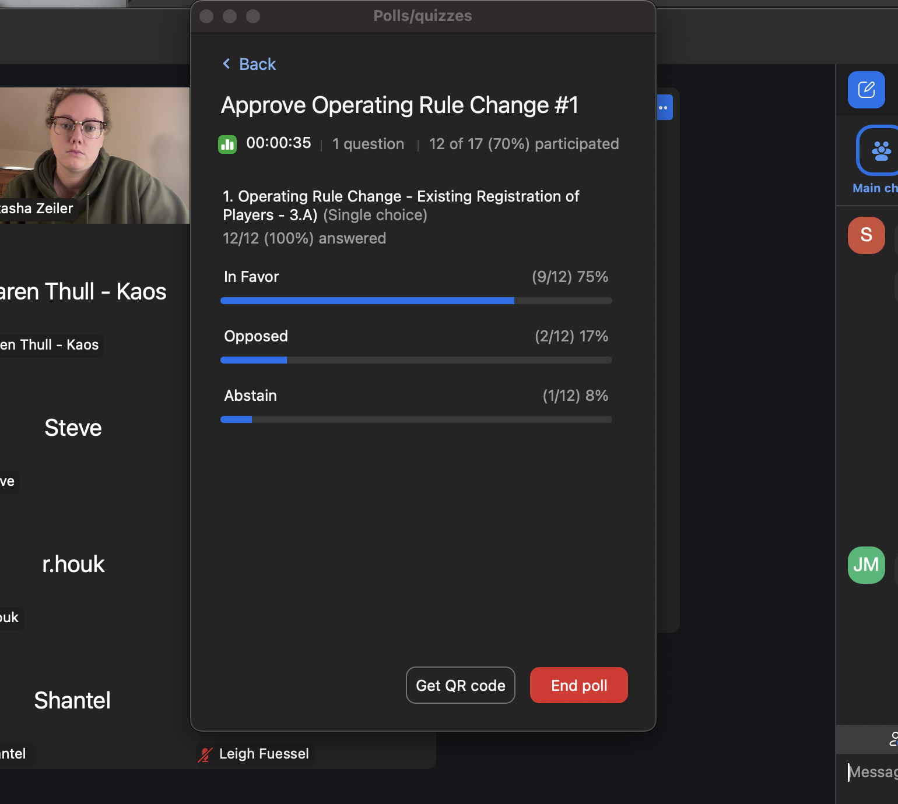

  - Existing- GROUND RULE 5G)
    - The home team will occupy the dugout on the 1st base side of the diamond; the visitor team will occupy the dugout on the 3rd base side of the diamond.

      - Proposed- The home team will occupy the dugout on the 3rd base side of the diamond; the visitor team will occupy the dugout on the 1st base side of the diamond.
Steve Lang motioned, Des Desnomie seconded. Approved.

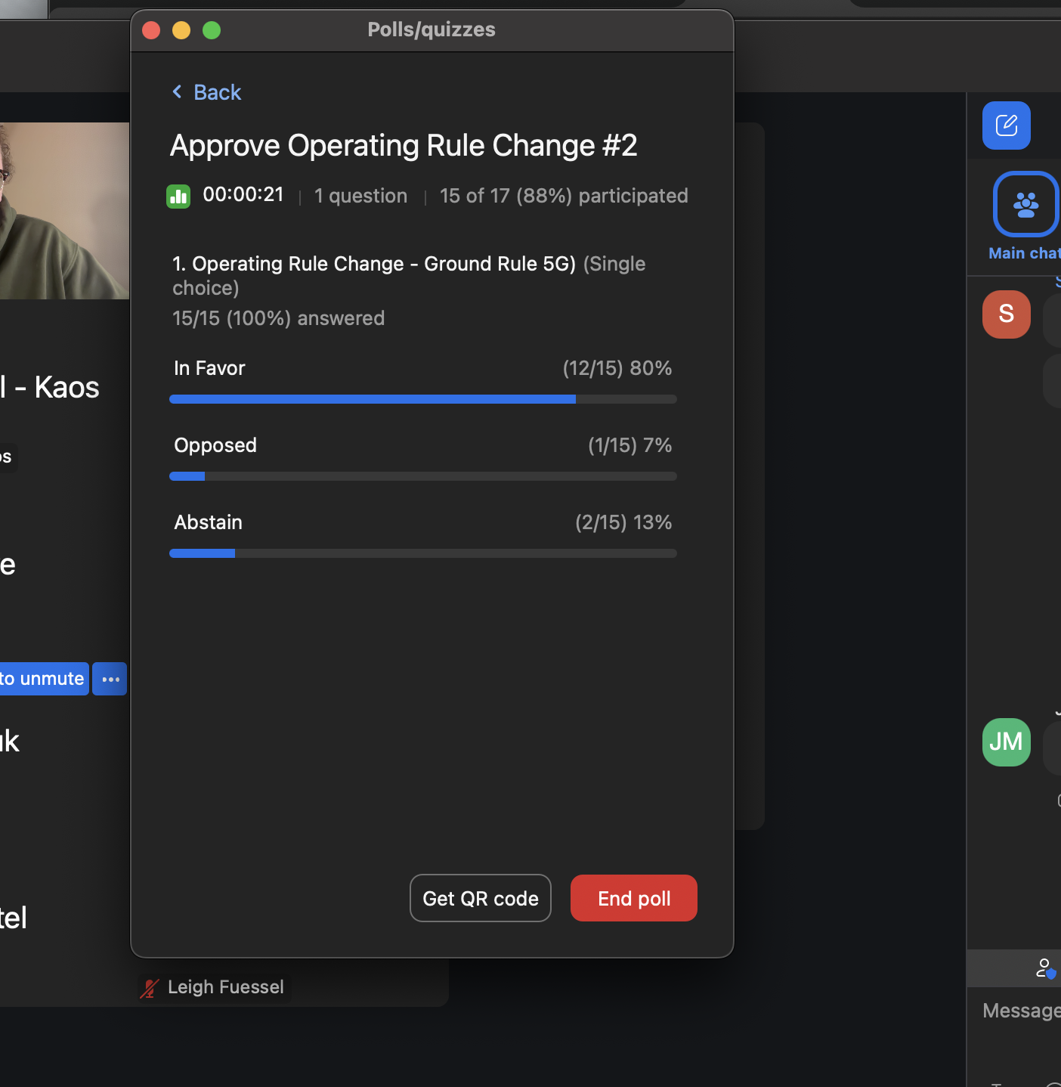

  - REGISTRATION OF PLAYERS
    - Existing- The team representative must obtain permission from the coach of the AP before contacting the AP to play in an upcoming game. Just prior to the game the AP(s) must be identified on the lineup card and the opposing coach advised. The AP players(s) cannot be in the starting lineup if there are a minimum of nine regular team players available to start the game.
      - Proposed- The team representative must obtain permission from the coach of the AP before contacting the AP to play in an upcoming game. Just prior to the game the AP(s) must be identified on the lineup card and the opposing coach advised. The AP players(s) cannot be in the starting lineup if there are enough regular team players (9 or 10) available to start the game. If the starting lineup is going to be 10 players and there are only 9 regular team players, then the AP can be in the starting lineup.
Brenda Anderson motioned, Tyler Gerrard seconded. Approved.
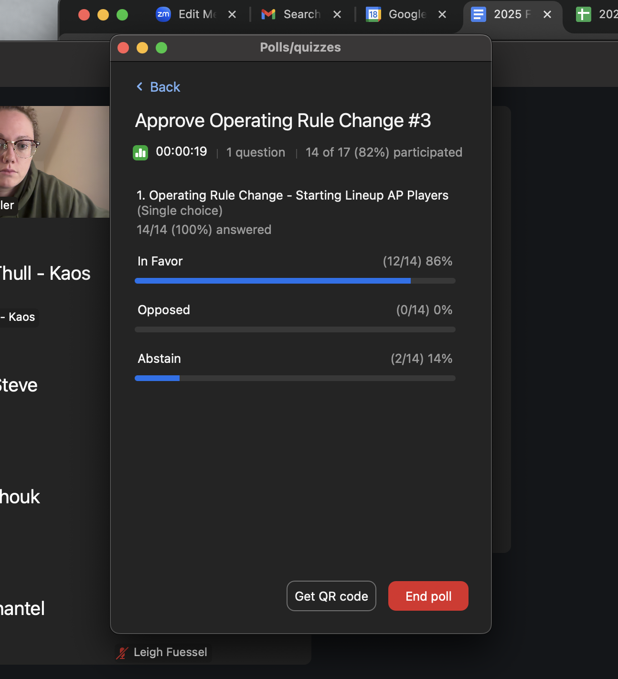

- Executive Position Elections:
    - Vice President-
    - Treasurer-
    - Scheduler-
    - Statistican- Sue has offered to let her name stand
    - Facilities Coordinator- Brenda has offered to let her name stand
    - Communications Manager (1 year term)
- Email was sent to teams players and coaches advising them of the open positions. No one responded, no volunteers came forward during meeting.

- Other Business
- Dave & Karen Heward- did good job of diamonds this year
- RAMP team app- any teams that don’t use it? Any questions or changed to app.
- Refer to Softball Saskatchewan website or contact the office at 306-780-9235 for information on coaching clinics, sport medicine & science workshops, & athlete skills development clinics.
- Refer to battingzone.ca for information on Regina’s first 24/7 indoor batting facility
- Important dates
  - Mid February - Email will be sent to teams to indicate their intentions for the 2026 season. Deadline will be end of February.
  - Mid March – spring meeting
  - Mid May – league fees due 24 hours prior to start of season. Budget $2,000
  - Mid May – team affiliation due 24 hours prior to start of season.

13. Acknowledgements League
    - League – White Butte Storm & Regina Wild for 1st place in regular season & Sleek & Regina Wild for winning division playoffs
    - Regina Revenge U19C – 3rd place provincials
    - Regina Riot U19B- 1st place provincials
    - Regina Kaos U19A- 3rd place provincials
    - White Butte Storm U19A- 2nd place provincials
    - Earl Grey – 1st - Womens Open provincials for the 2nd year in a row
    - Carnduff Steelers –1st at Womens A provincials & Gold at Canadians for the 3rd year in a row
    - Weyburn Youngfellows – Softball Saskatchewan Hall of Fame Inductee
    - Duane Bakken & Brenda Anderson – Softball Saskatchewan Outstanding Service Awards

14. Adjournment
Debbie Tanner motioned, Des Desnomie second. The meeting adjourned 8:45pm.

