2026 RLSA Spring General Meeting
Monday, April 13th 7:00 PM via Zoom

- Call to order
Chelsea Jones motions, Tyler Gerrard seconds

- Review of voting process
  - teams applying for membership cannot vote until their application is approved

- Adoption of agenda

- Adoption of minutes from Fall 2025 Meeting (can be viewed on RLSA website under ‘About Us/Meeting Minutes)
- No questions on the fall minutes.

- Team Applications
- Lumsden A - Div 1
- Wolfpack - Div 1
- Lumsden B - Div 3

VOTE to accept the new membership applications - Approved

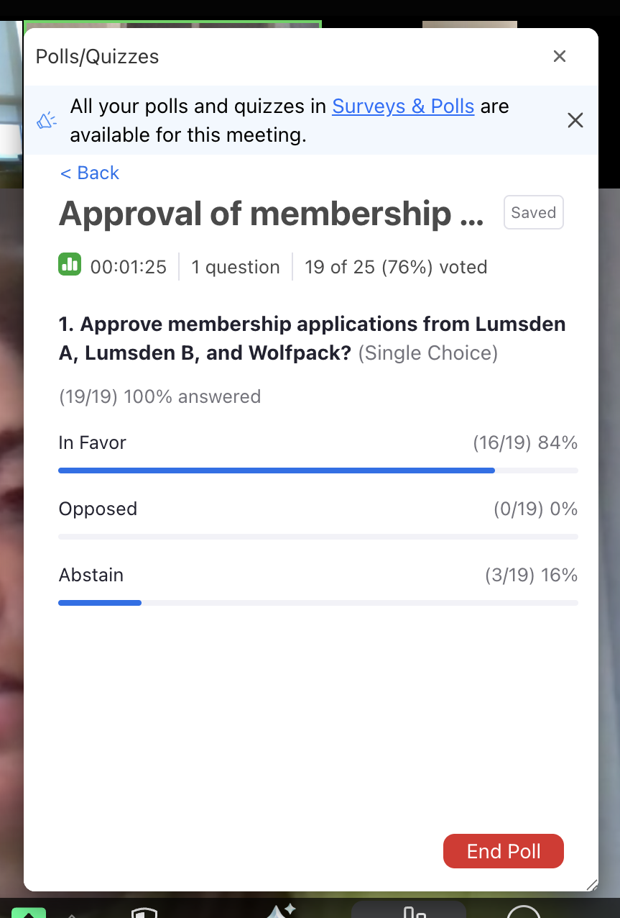

- Treasurer’s report- Brenda
  - Bingo account- $250,749.38 as of April 5th
  - General account- $68,909.92 + $59,078.10 term deposit = $127,988.02 as of April 5th
Chelsea Jones motions to accept Treasurer’s report, Sue Getzlaf seconds.

- 2026 Season Preview
  - Start date –Monday, May 11th - July 3rd, rain outs week of July 6th, playoffs July 13-31st
  - League structure
    - No half schedule teams this year
    - Leave of absence- Earl Grey Heat, TATC Queens, Edge and GWA
    - Every team playing each other 2 times in Div 1 and 2 for a total of 12 games
    - Div 3 will play each other 3 times for a total of 12 games
Div 1 | Div 2 | Div 3
1. Sleek | 1. Vipers | 1. Revenge
2. Iskotew | 2. Thunder | 2. Storm
3. Rampage | 3. Elite | 3. Cote Blue Jays
4. Kaos | 4. Riot | 4. Anonymous
5. Pride | 5. Diamondbacks | 5
6. | 6. Wild
7. | 7. Lady Rebels
Lumsden A |  | Lumsden B
Wolfpack

    - Playoffs will double knock out if time allows and depending on how many teams are interested. Tentative dates July 13th – 31st. Teams interested in committing to playoffs will be required to do so by mid-June (date to be provided in future).

    - Scorebook and lineup book will be delivered to the diamond at the first game. Contact Deanna Gerrard 306-718-7133 if you are wanting to pick up prior to that date and hopefully something can be arranged.

- Umpires-
  - Proposed increase from $50- $65/game and $75-$80/game solo
  - $500 donation to Umpire Mentorship Program
  - Anyone interested becoming an umpire can contact Andrew Walker, 306-536-9456 or alwalker@sasktel.net
Tyler motions to accept increase in umpire fees, Rod Hauk seconds.

Vote for increasing umpire fees - approved
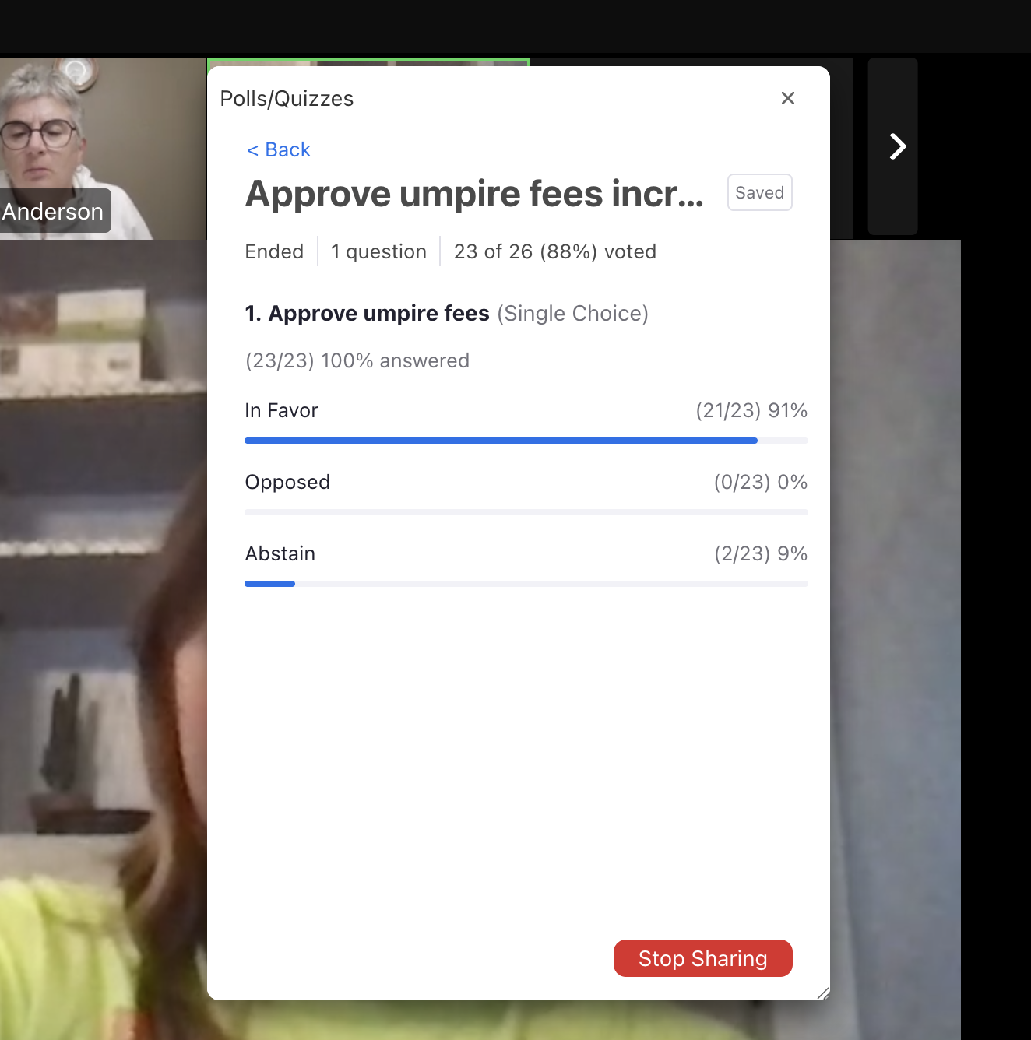

- League Fees
  - $2000 ($1,225 league, $275 affiliation, $500 bingo) due by Sunday, May 10th.
  - E-transfers can be sent to reginaladiessoftball@gmail.com
  - Each team will be sent an email and or text with the total of fees due as some teams have credits and some have fines.

Brenda Anderson motions to accept team fees set to $2000. Steve Lang seconds.
Vote to accept team fees at $2000 - Approved

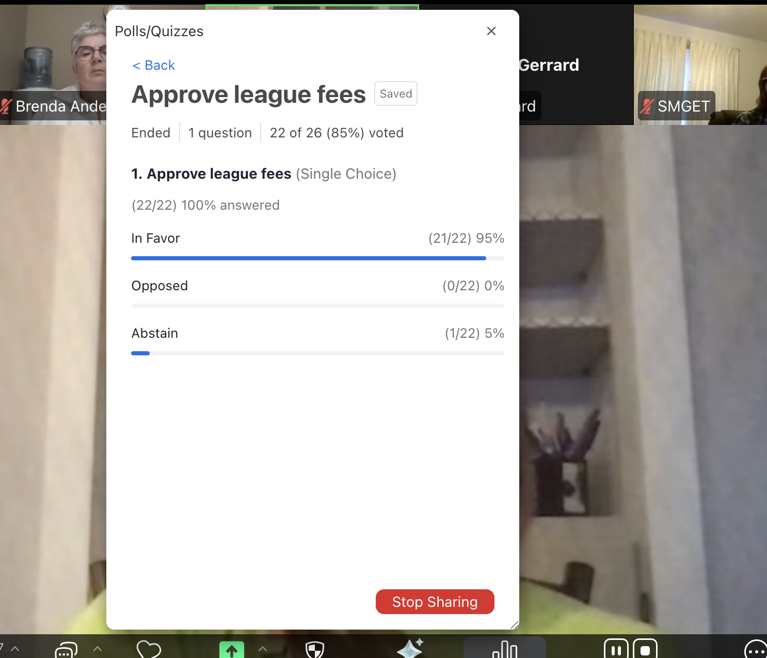

- RLSA Registration System
  - RAMP registration system will be used again this year. To be eligible to play in RLSA, must be 17 years of age by December 31, 2026. Coaches must have completed the Respect in Sport for Activity Leader program.
  - Players in the U19 category (born 2007 or 2008) must get a release from the closest minor softball association from their address.
  - AP players have to be 16 years of age
  - For Coaches/Managers, a Criminal Record Check is required when your team has any players under the age of 18.
  - RLSA deadline for players to be registered is Sunday, May 10th. Changes can be made until Softball Saskatchewan affiliation deadline of June 1st.
  - Ramp Team App will be purchased for teams to use.

Steve Lang - For the release of players for u19 girls, they got the release from Estevan but do we need a letter/etc or is it just an agreement with the minor league closest to them? Sarah - most organizations have a release of player form that you can send to us. If they don’t have anything there’s a link on Softball Sask for release forms. Verbal agreement is not acceptable.

Glen - The PB Storm team is affiliated through PB Minor ball and the whole team is under 18, do they need the check submitted to RLSA? Sarah - no the PB minor league will take care of their registration and anything they require, doesn’t have to go to RLSA.

- League Tournament – May 29th-31st. Open A & Open B divisions. To enter, complete the application form found on the league website. Entry fee $550. Entry deadline May 15th.

The website has been updated with a new form and Sue will be emailing out the new form, as the new email has been added. Teams are encouraged to register and invite other teams as we are currently low on numbers.

- General Operating Rule Amendments – see below for proposed changes

  - Going to change the first Operating rule and will see how things go this season and can re-evaluate in the fall.

  - Existing Registration of players k)
    - A team will be allowed to use a maximum of two substitute Affiliated Players in regular season league games. A team will be allowed to use a maximum of two substitute Affiliated Players in playoff games in order to fulfill a nine person roster.
      - Proposed: A team will be allowed to use a maximum of three substitute Affiliated Players in regular season league games. A team will be allowed to use a maximum of two substitute Affiliated Players in playoff games in order to fulfill a nine person roster.
Rod Hauk: for pickups, they can only be your division and also the division below? Yes both are acceptable. Confirming that if a pickup is from the same division they cannot pitch or catch, if they’re from the division below they can pitch or catch. Deanna confirms Yes this is correct.

Karen Thull motions to accept the operating rule change. Brad Sigmeth seconded.

Vote to update Operating Rule - Existing Players (K) - approved

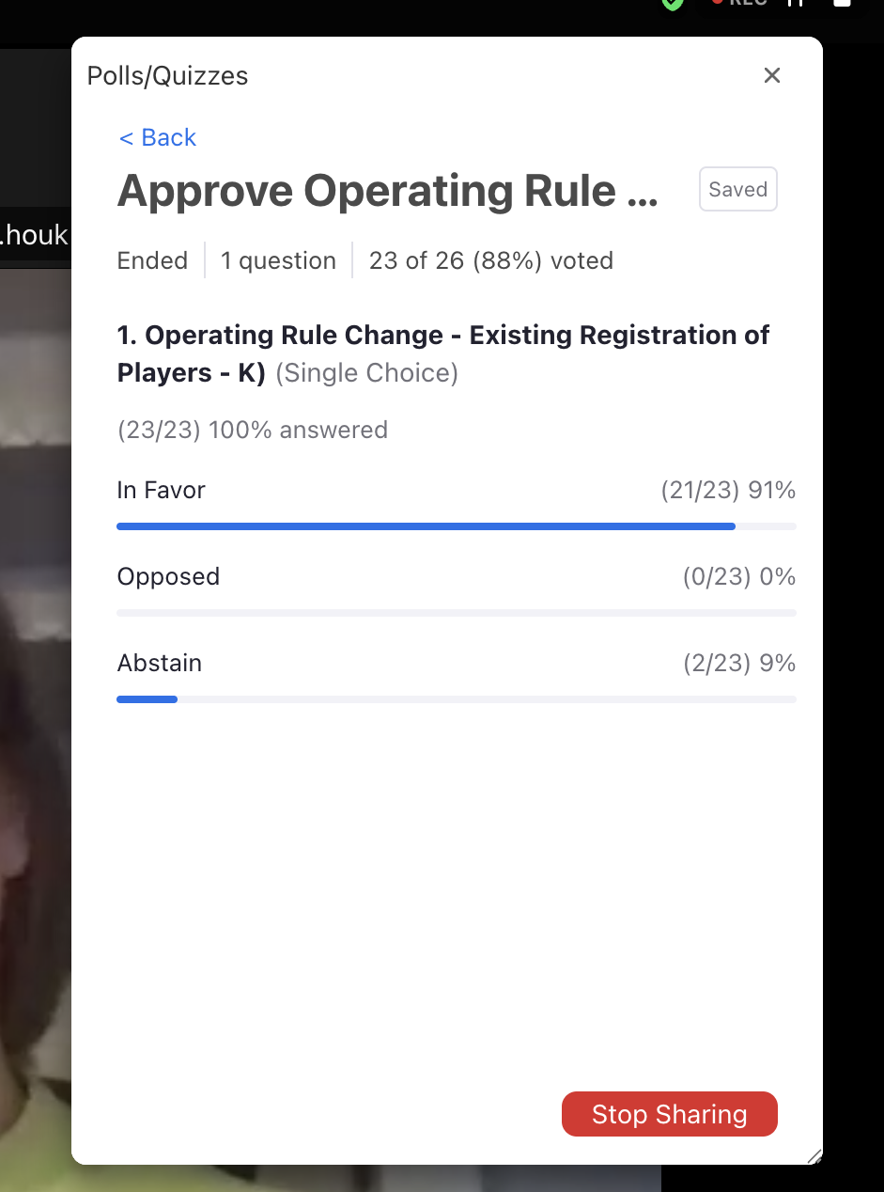

- Douglas Park report
  - Looking into getting another set of lights on a diamond 4 - this year we are getting quotes, will know more at the fall meeting
  - Redoing base markers
  - New bleachers at all diamonds

No comments on anything additional that might be needed. Deanna states to contact her if teams think of anything during the season.

- Executive Position Elections:
    - Vice President -
    - Treasurer -
    - Scheduler- Karen Thull
    - Communications Manager (1 year term)

No one comes forward for these positions during the meeting.

- Other Business
  - Changed our email address to gmail account- reginaladiessoftball@gmail.com
  - There is a Facebook page Regina Ladies Softball - DO NOT RELY on this for updates. I will do my best to keep this updated but rescheduling and cancelling of games will happen through Karen Thull 306-757-4302.
- Dave & Karen Heward - they are doing diamonds again this year
- Important dates
  - May 10th – league fees due and team registration complete
- Review of Team Responsibilities. Review on league website reginaladiessoftball.ca under ‘Team Info/Team Responsibilities’.
- Scheduling practice diamonds. Contact Karen Thull 306-757-4302. Check availability on the website calendar. Two hour timeframe on weekends.
- Go to the Softball Saskatchewan website for information on coaching clinics.
- City of Regina Smoking Bylaw - The bylaw prohibits smoking and vaping on all City-owned or controlled land. This includes our diamonds at Douglas Park.

Addition:
Sue notes that we don’t have a ton of teams registered in the tournament so if more teams could be encouraged to join that would be great. Deanna can send out some emails

Des - Would love to have most games for Anonymous as double headers as they have to travel so far for games. Deanna has noted that we have it on their registration form that they want that so Karen will do her best to make that happen.
Debbie - there’s a facebook page? Deanna - Regina Ladies Softball Association but please do not rely on this page for updates on game cancellations/etc. Mostly to find additional people for the executive positions.

- Adjournment
Motion to end the meeting by Debbie Tanner, Sarah Stelmacovich seconded. Meeting adjourned.

