REGINA LADIES PLAYER & COACH REGISTRATION PROCEDURES 2024
- You will receive an email from Regina Ladies Softball Association with the subject Regina Ladies Softball Association : “Your Team Name” - Team Registration Invite. Check your Junk folder if the email is not in your Inbox.
It will include a link to the registration website as well as the Team Invite Code.
- Click on the link in the email. The Regina Ladies Softball Association registration website will appear.
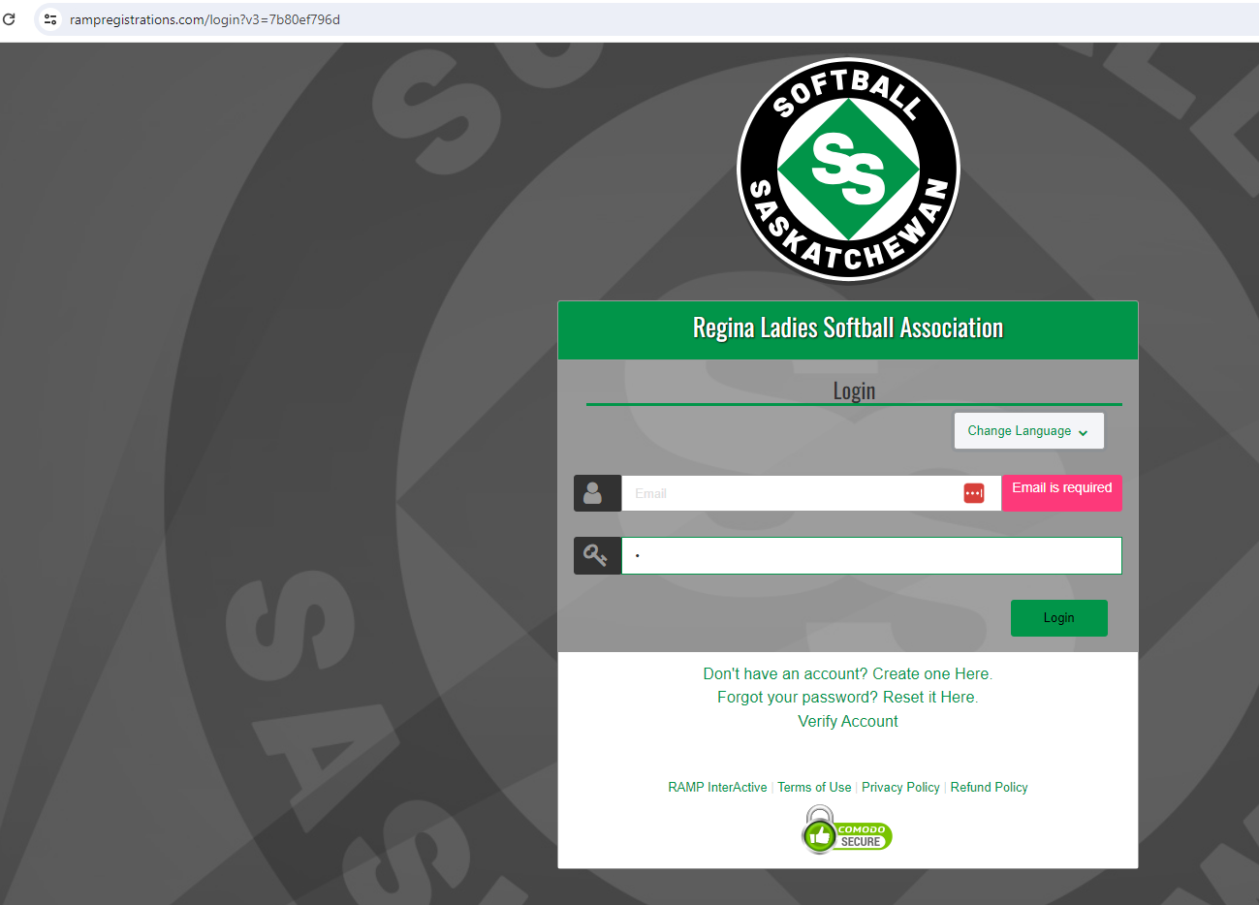

- If you have an existing RAMP account (even for another sport), login using that email & password.

If you do not have a RAMP account, click on ‘Create one Here’. The Regina Ladies Softball Association Create an Account screen will appear where you can create your own account and then Log in to complete player registration.
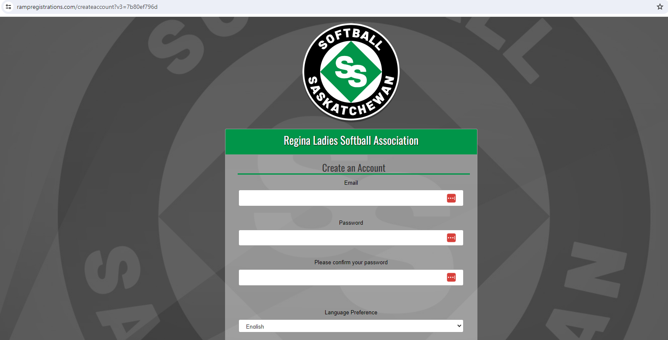
- The Regina Ladies Softball Association screen will appear, choose Register to a Team
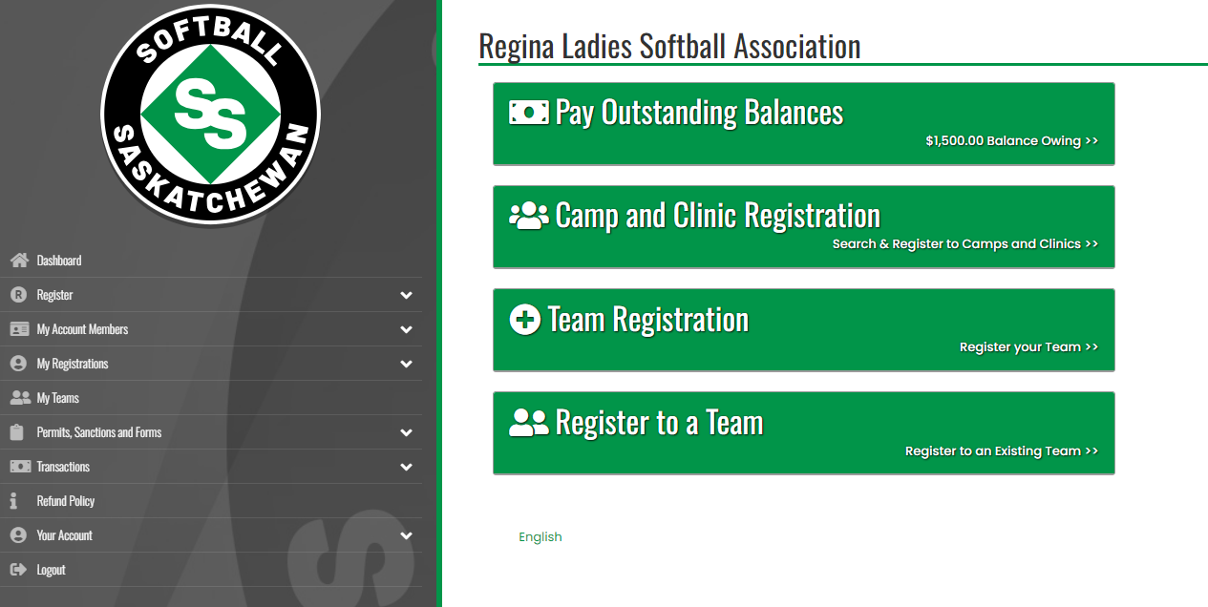

- The Regina Ladies Softball Association Register to a Team screen will appear, use team invite code sent from your team contact.

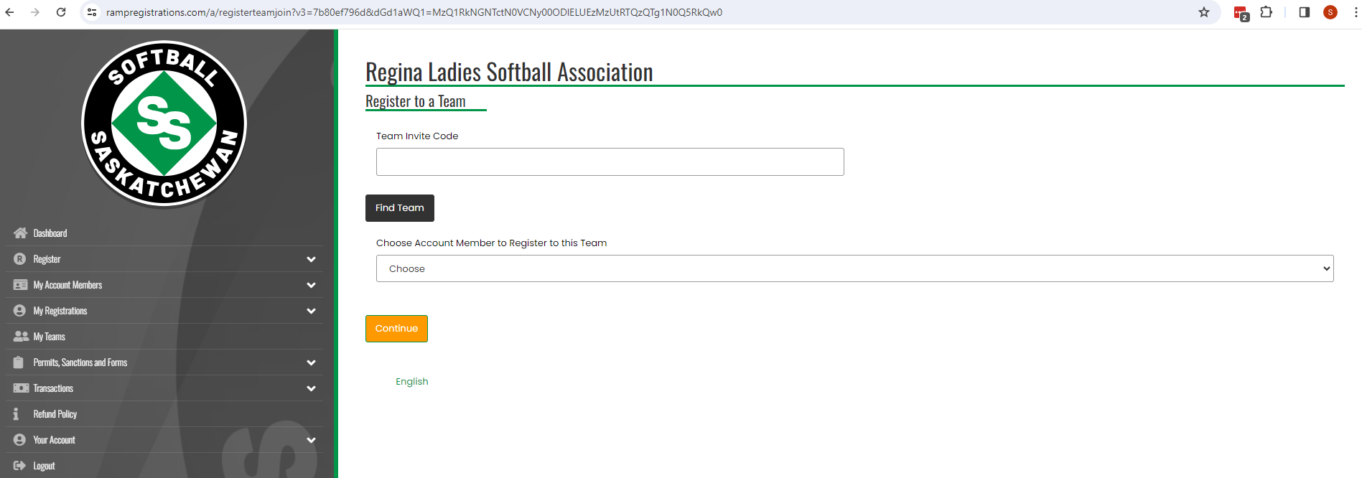

- The 2024 Season-Adult- YOUR TEAM screen should appear.

- Click on the down arrow to select the Family Member. If the correct family member is not displayed, click on Add a Family Member.

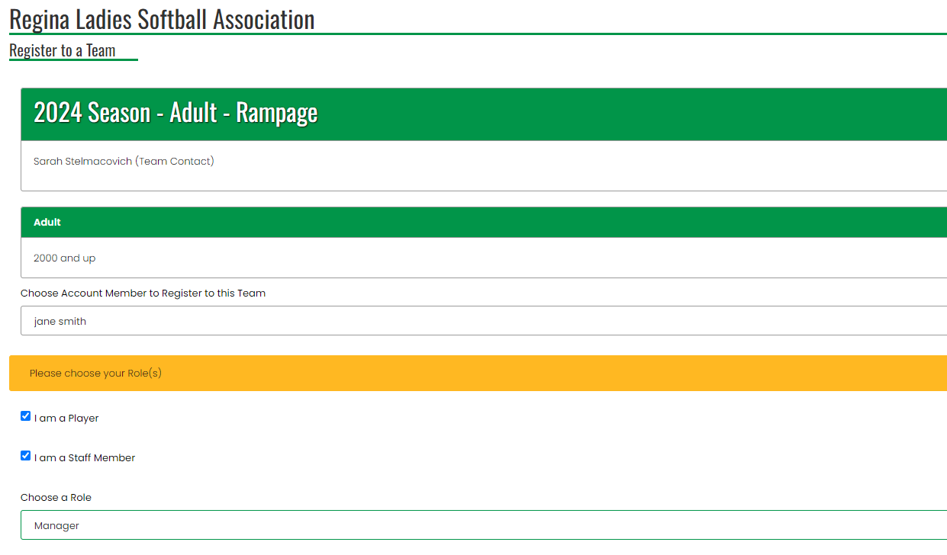

  - For coaches, assistant coaches, and managers, unclick ‘I am a Player’ and click on ‘I am a Staff Member’. Select the appropriate Role. Be sure to input your Respect in Sport ID as it is a required field. NOTE* SOFTBALL SASK DOES NOT ACCEPT RESPECT IN SPORTS FROM HOCKEY TAKEN BEFORE 2014.

For players that act as coaches, you will have to have one of each account: player and coach.
- You should be able to click on both at once, you may be prompted to answer questions twice.

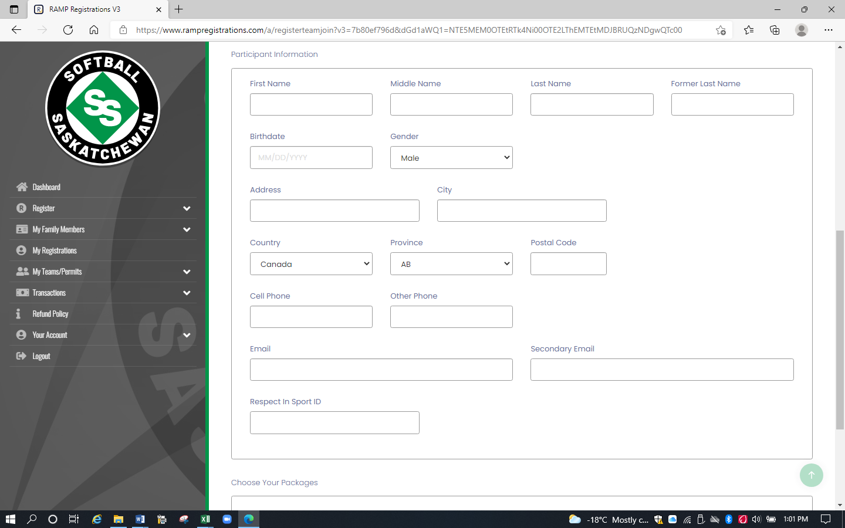

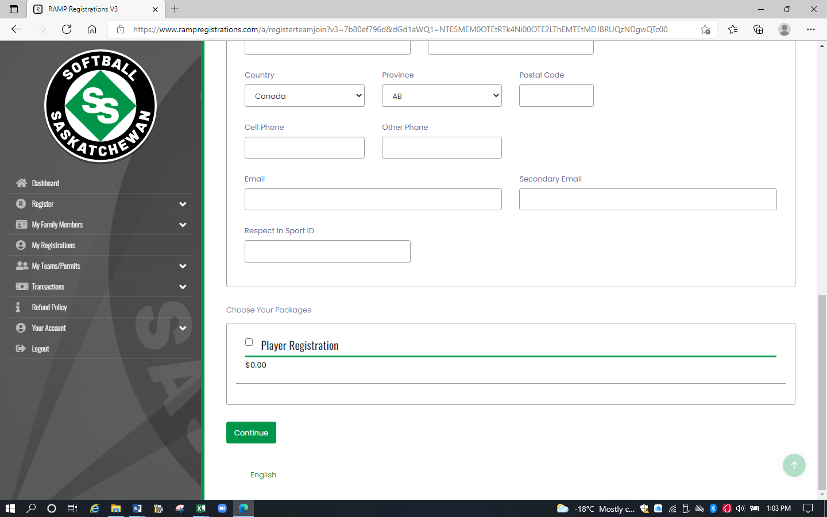

- Complete player info. Click Player or Staff Registration in the Choose Your Packages box at bottom of screen (both packages must be checked if a player is also staff)

- Click Continue. The Questions screen will appear.

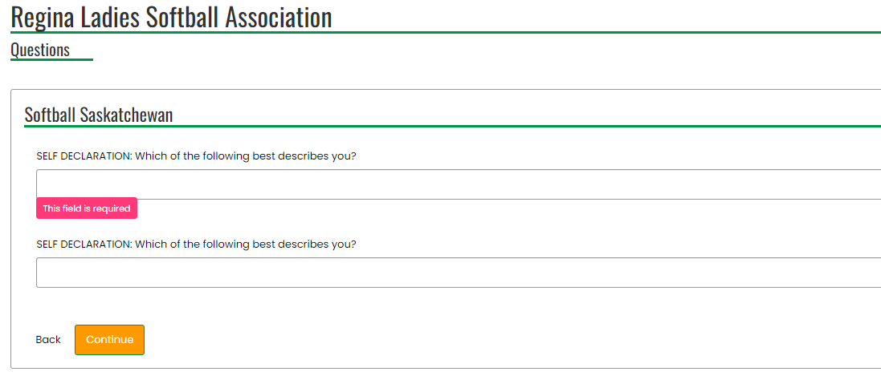

- Answer questions:
  - There is no district question this year on the form.
  - There will be no waivers to be signed for this year from Softball Sask.

- Click Continue. The Confirm Details and Submit Registration screen will appear.

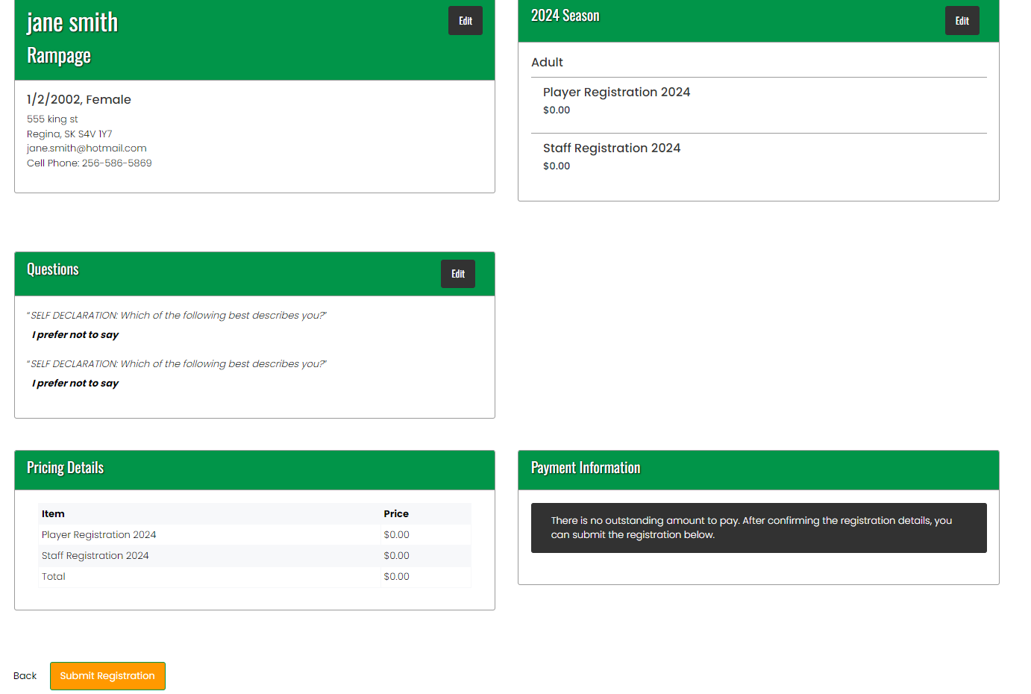

- Click on Submit Registration. The Registration Complete screen will appear.

- You will receive a confirmation email from Regina Ladies Softball Association with the subject ‘Regina Ladies Softball Association Registration Confirmation’. Check your Junk folder if the email is not in your Inbox.

