REGINA LADIES PLAYER & COACH REGISTRATION PROCEDURES 2026
- You will receive an email from Regina Ladies Softball Association with the subject Regina Ladies Softball Association : “Your Team Name” - Team Registration Invite. Check your Junk folder if the email is not in your Inbox.
It will include a link to the registration website, as well as the Team Invite Code.
Online registration must be completed for a player or coach to be eligible for games.
- Click on the link in the email. The Regina Ladies Softball Association registration website will appear.
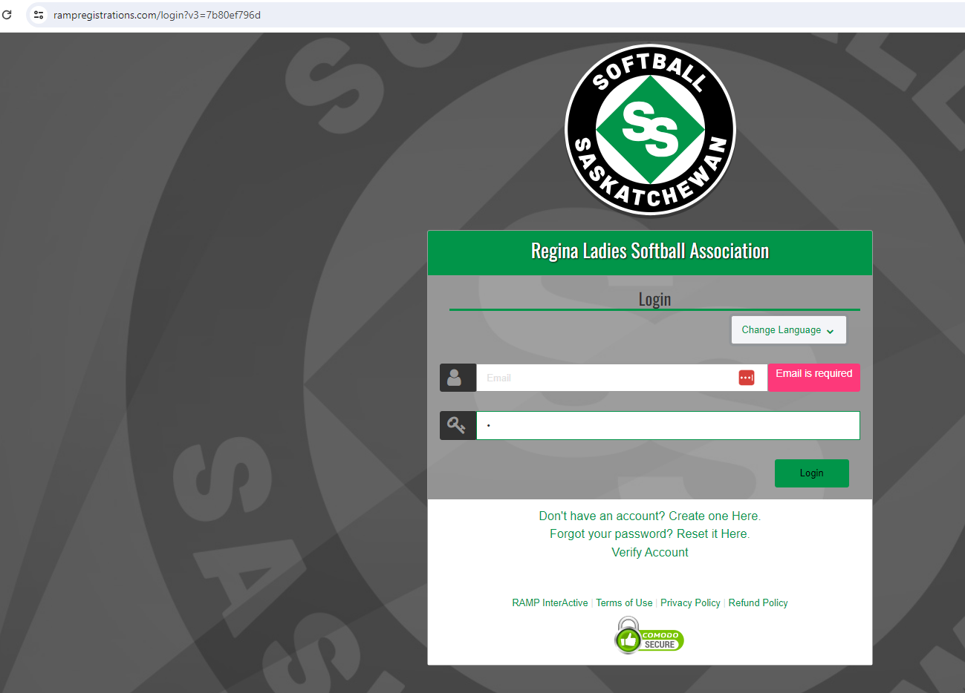

- If you have an existing RAMP account (even for another sport), login using that email & password.

If you do not have a RAMP account, click on ‘Create one Here’. The Regina Ladies Softball Association Create an Account screen will appear where you can create your own account and then Log in to complete player registration.
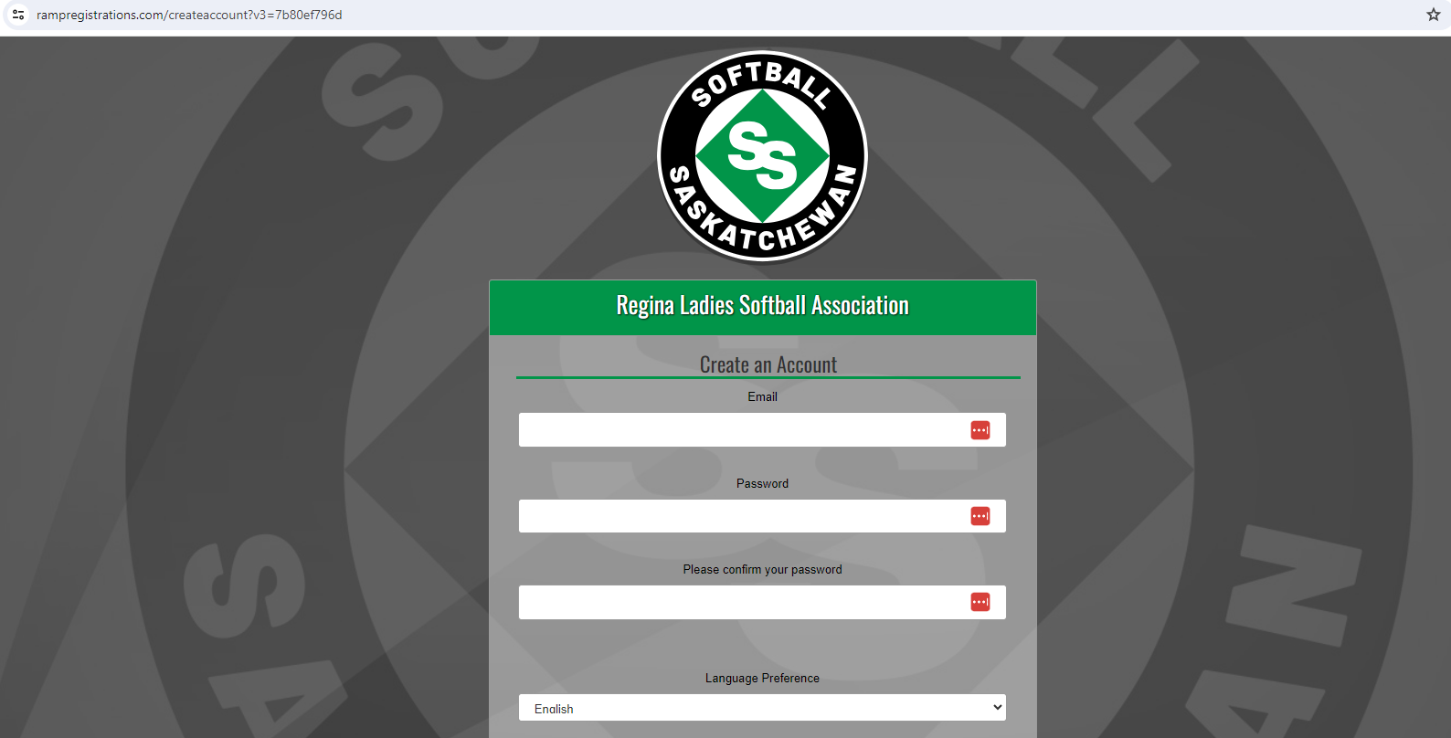

- The Regina Ladies Softball Association screen will appear, choose Register to a Team
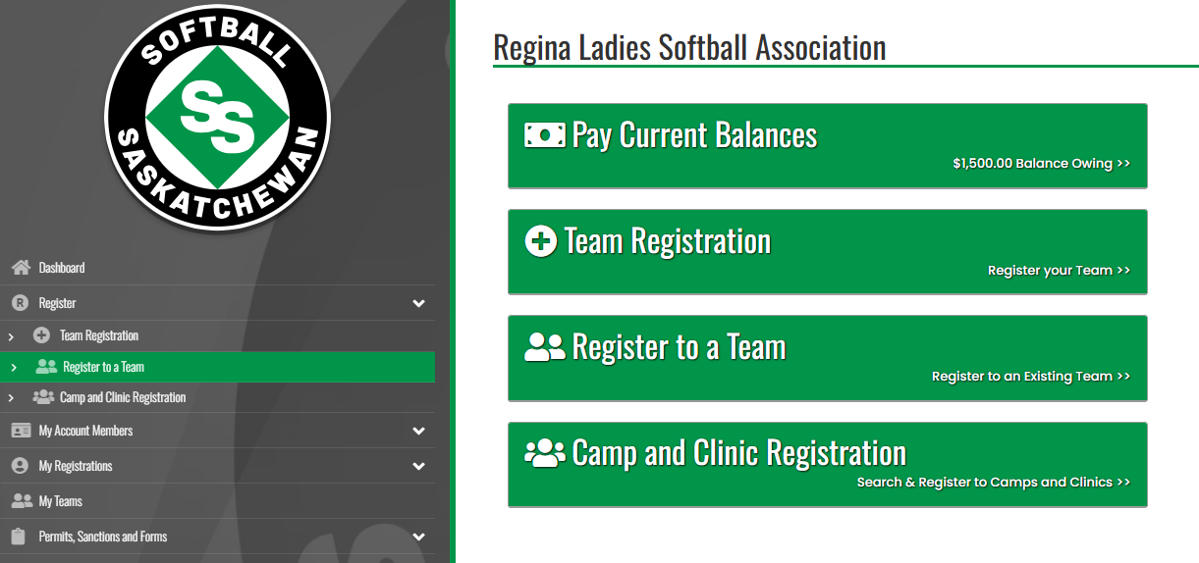
- The Regina Ladies Softball Association Register to a Team screen will appear, use team invite code sent from your team contact, Find team

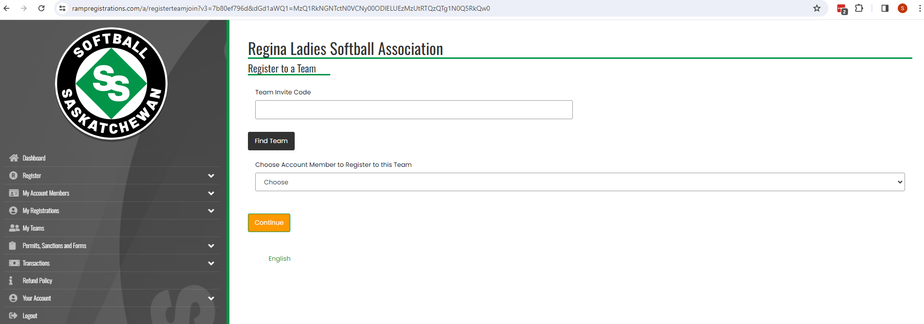

- The 2026 Season-Adult- “YOUR TEAM” screen should appear.

- Click on the down arrow to select the Account Member. If the correct member is not displayed, click on Add an Account Member.

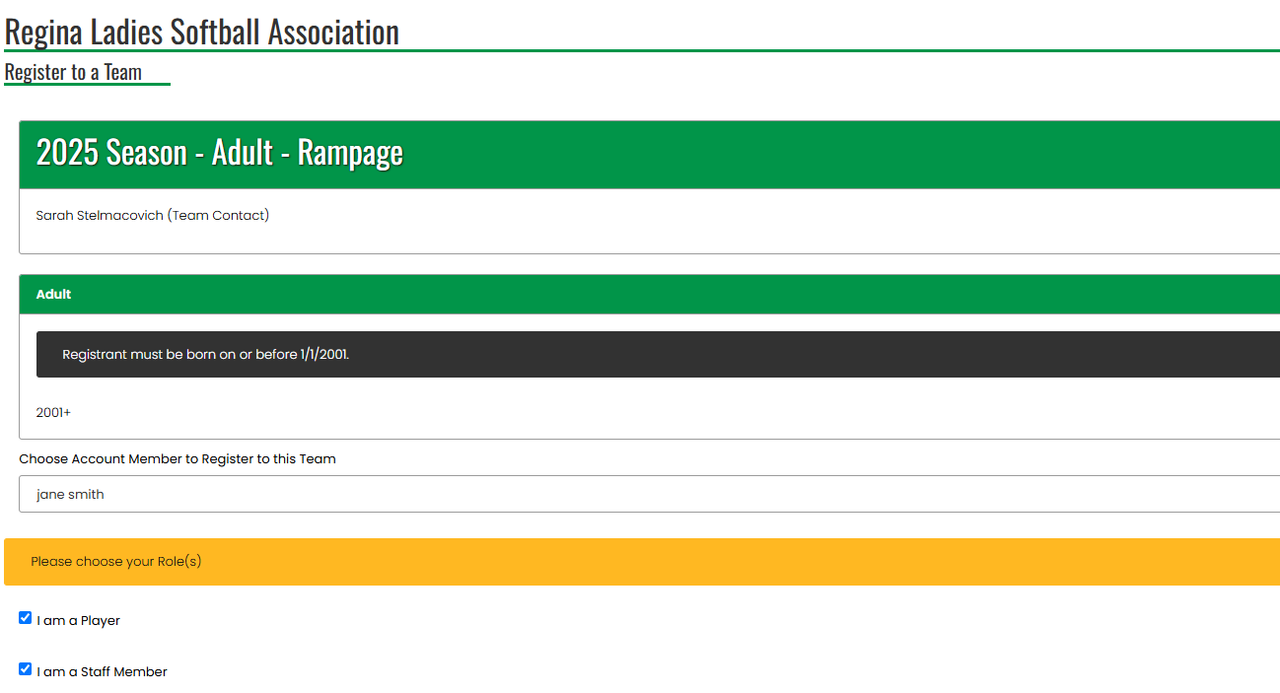

  - For coaches, assistant coaches, and managers, unclick ‘I am a Player’ and click on ‘I am a Staff Member’. Select the appropriate Role.
  - Disregard age restriction when registering to an adult team as a player. If problems arise with this, please contact the registrar (Sarah 306-540-2009).
  - Be sure to input your Respect in Sport ID as it is a required field – Enter RiS number under secondary email if no data box available for RiS.
  - Returning staff may see RiS verified under secondary email, in this case you do not have to re-enter your RiS number
  - NOTE* SOFTBALL SASK DOES NOT ACCEPT RESPECT IN SPORTS FROM HOCKEY TAKEN BEFORE 2014.

For players that act as coaches, you will have to have one of each account: player and coach.
- You should be able to click on both at once, you may be prompted to answer questions twice.

- Complete player info. Click Player or Staff Registration in the Choose Your Packages box at bottom of screen (both packages must be checked if a player is also staff)
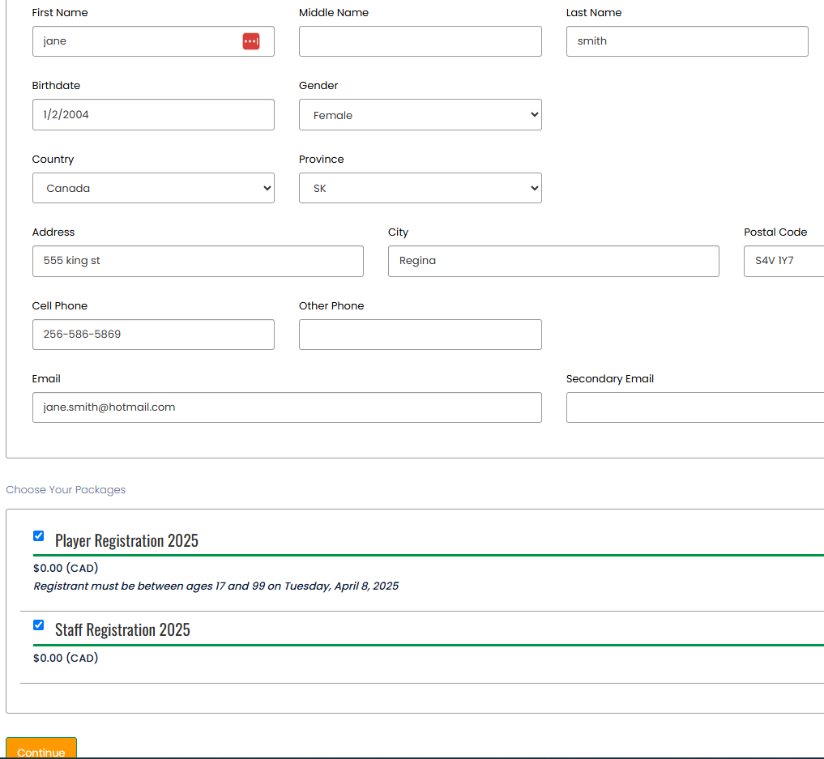

- Next page is where you can upload copies of your criminal record check and vulnerable sector checks. You can complete your registration before having these checks completed. However, to be affiliated with softball sask as a staff member, these checks will need to be completed at the affiliation deadline June 1, 2026.

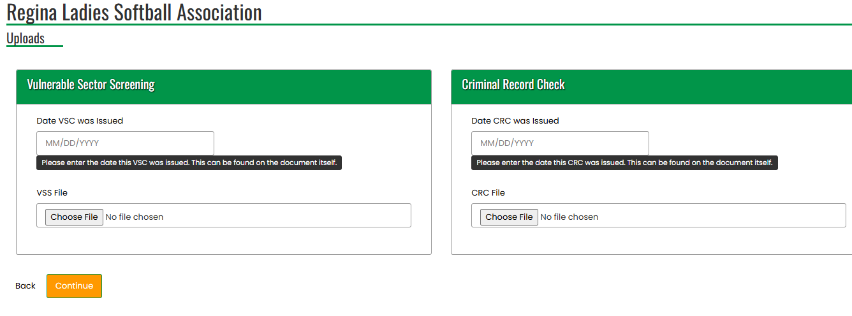

- The Questions page will appear next.
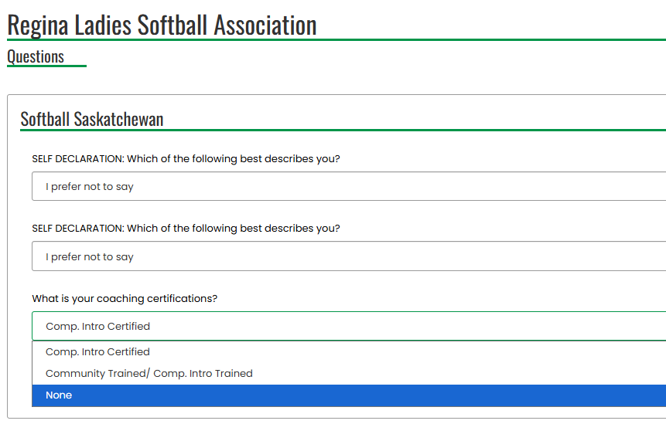
- Answer questions:
  - No coaching certifications (other that RiS) are needed for Regina Ladies Softball Association, however if a team is entering provincials, certain levels of coaching may be required. Please contact softball sask for those requirements.
  - There will be no waivers to be signed for this year from Softball Sask.

- Click Continue. The Confirm Details and Submit Registration screen will appear. Remember to click submit registration.

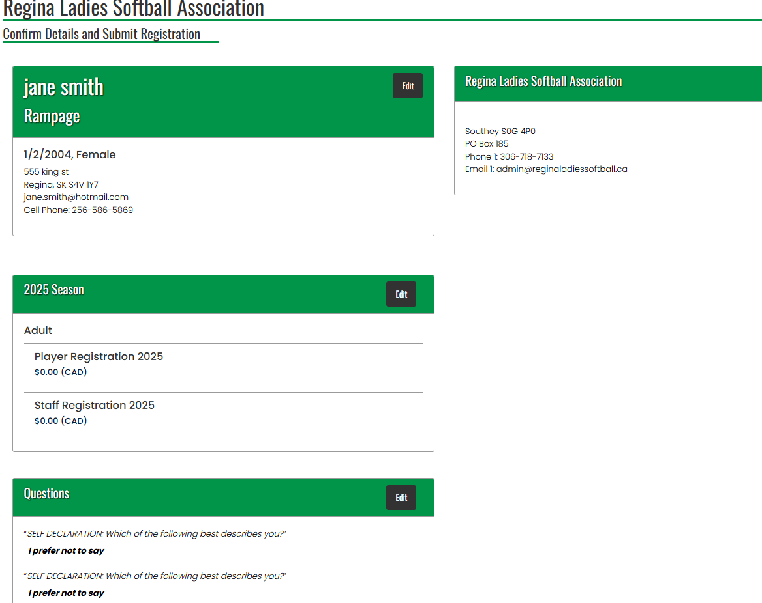

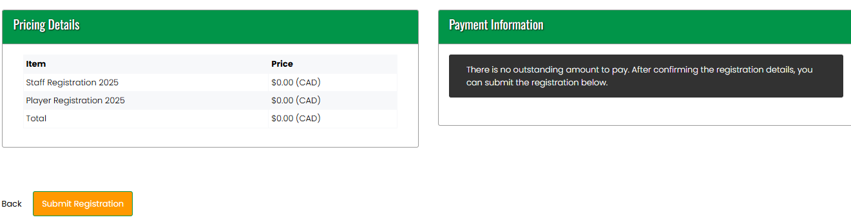

- You should see the “Registration Complete” page. You will receive a confirmation email from Regina Ladies Softball Association with the subject ‘Regina Ladies Softball Association Registration Confirmation’. Check your Junk folder if the email is not in your Inbox.

