REGINA LADIES PLAYER REGISTRATION PROCEDURES
- You will receive an email from Regina Ladies League with the subject Regina Ladies League : <insert team name> - Team Registration Invite. Check your Junk folder if the email is not in your Inbox.
The body of the email will advise that <insert team name> has invited you to join <insert team name>. It will include a link to the registration website as well as the Team Invite Code.
Prior to starting the registration process, you need to know what softball district you live in, ex. Regina is district 2. For other locations, go the the Softball Sask website, Memberhip & Affiliation, Handbook. District locations start on page 100. 2022 Handbook UPDATEDFINALFINAL.pdf (rampinteractive.com)
- Click on the link in the email. The Regina Ladies League registration website will appear.
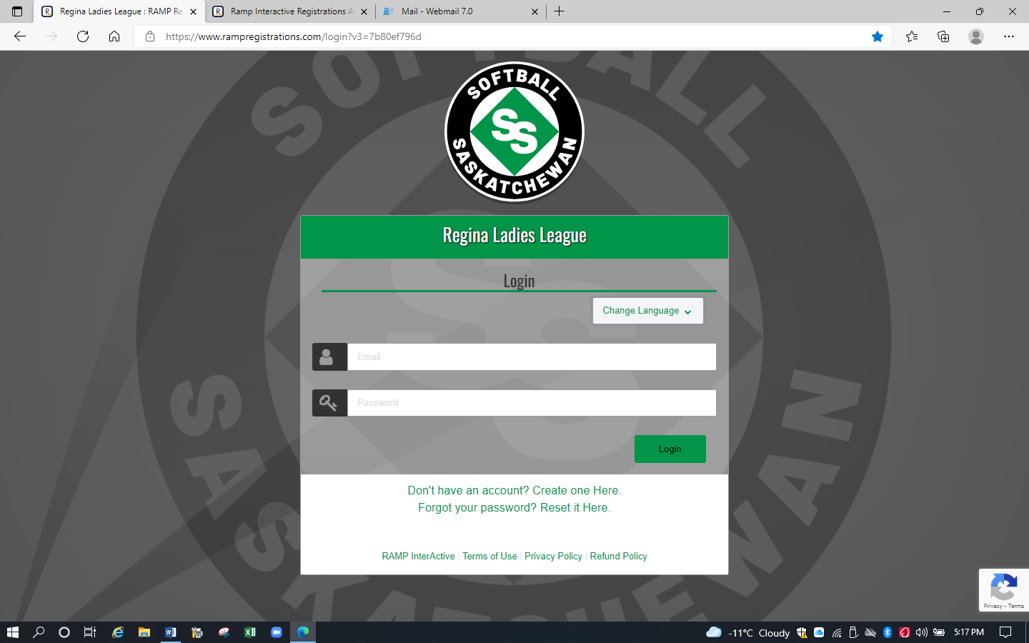

- If you have an existing RAMP account (ex. for another sport), login using that email & password. Go to step 6.

If you do not have a RAMP account, click on ‘Create one Here’. The ‘Regina Ladies League Create an Account’ screen will appear.
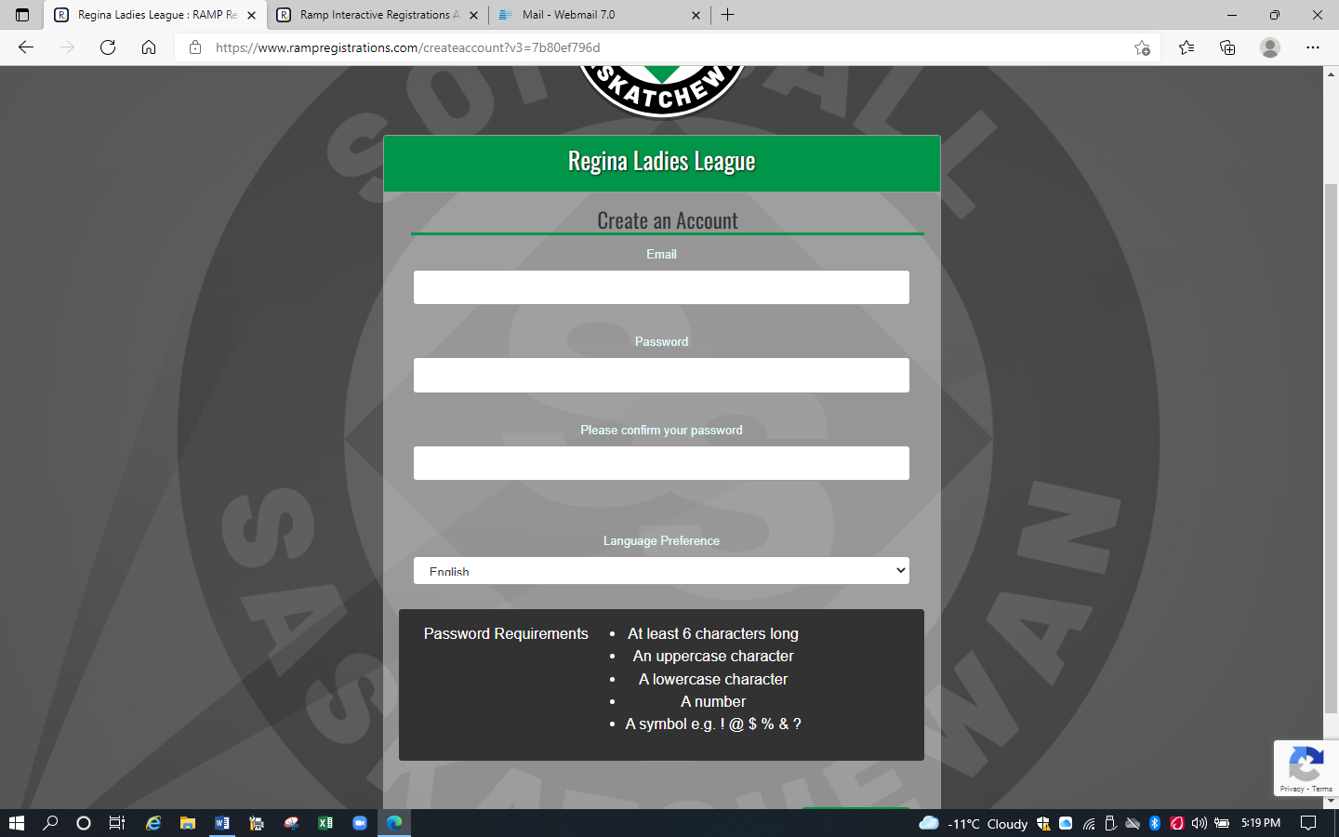

- Create Account.

- The Regina Ladies League Registration screen will appear. Login.

- The ‘Regina Ladies League’ screen will appear.
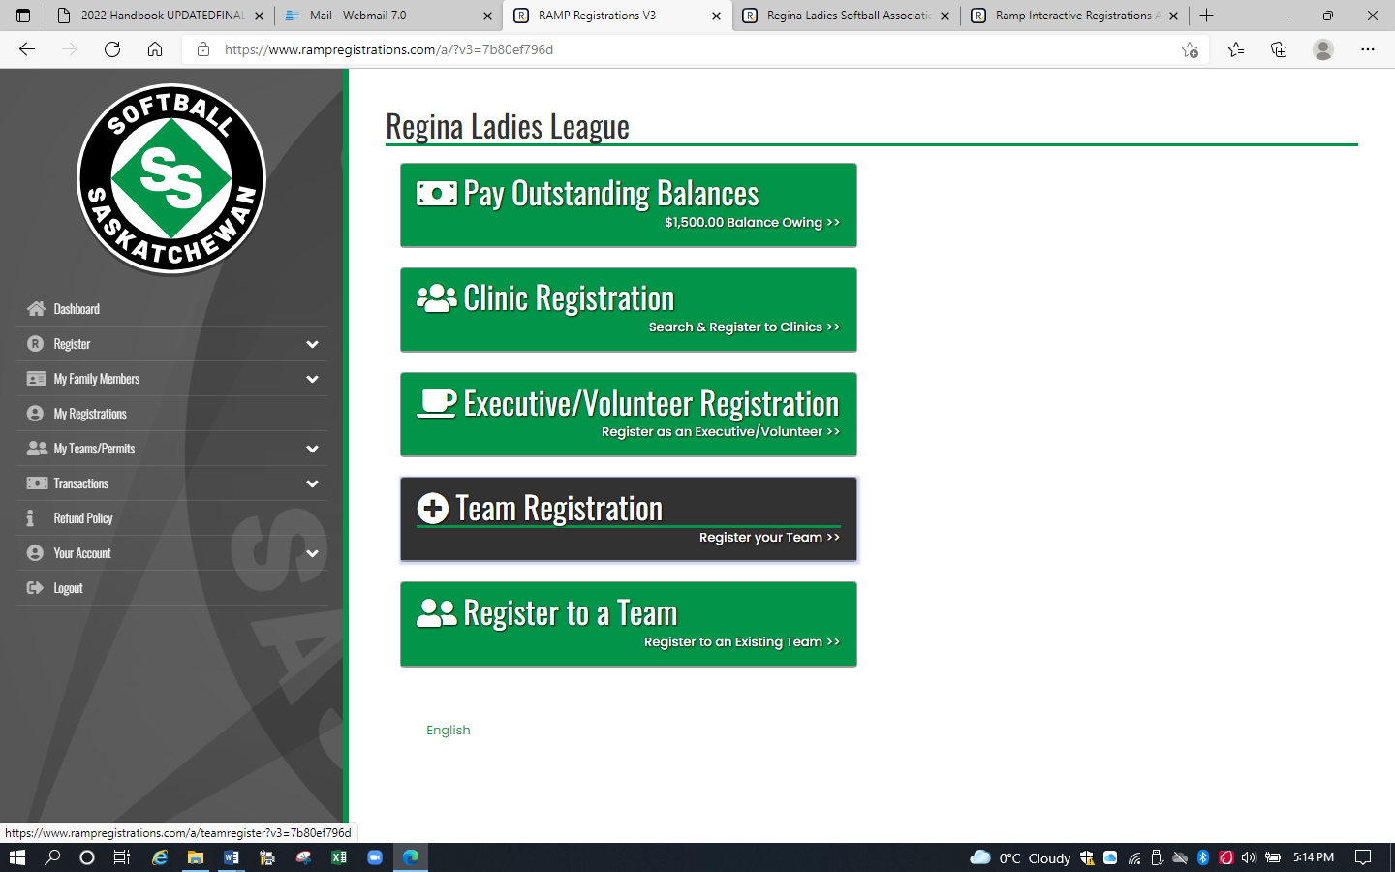
- Click on ‘Register to a Team’. The ‘Regina Ladies League Register to a Team’ screen will appear.
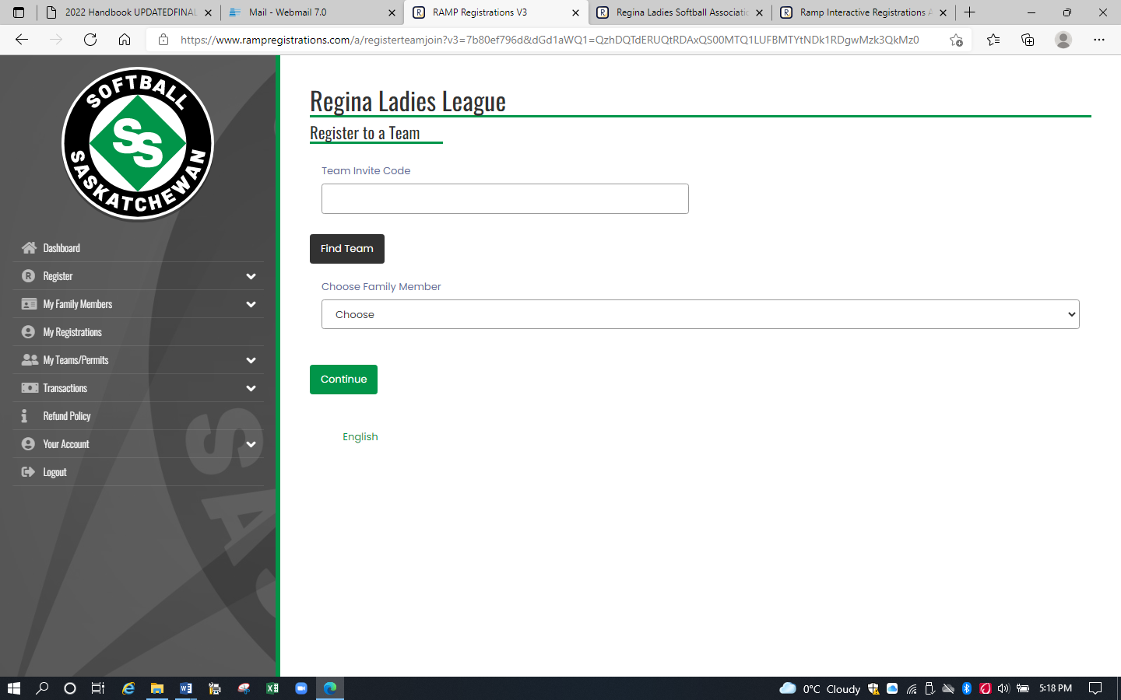

- Input the Team Invite Code received in the invite email & click on ‘Find Team’. The 2022 Season-<insert team name> screen will appear.

- Click on the down arrow to select the Family Member. If the correct family member is not displayed, click on ‘Add a Family Member’.

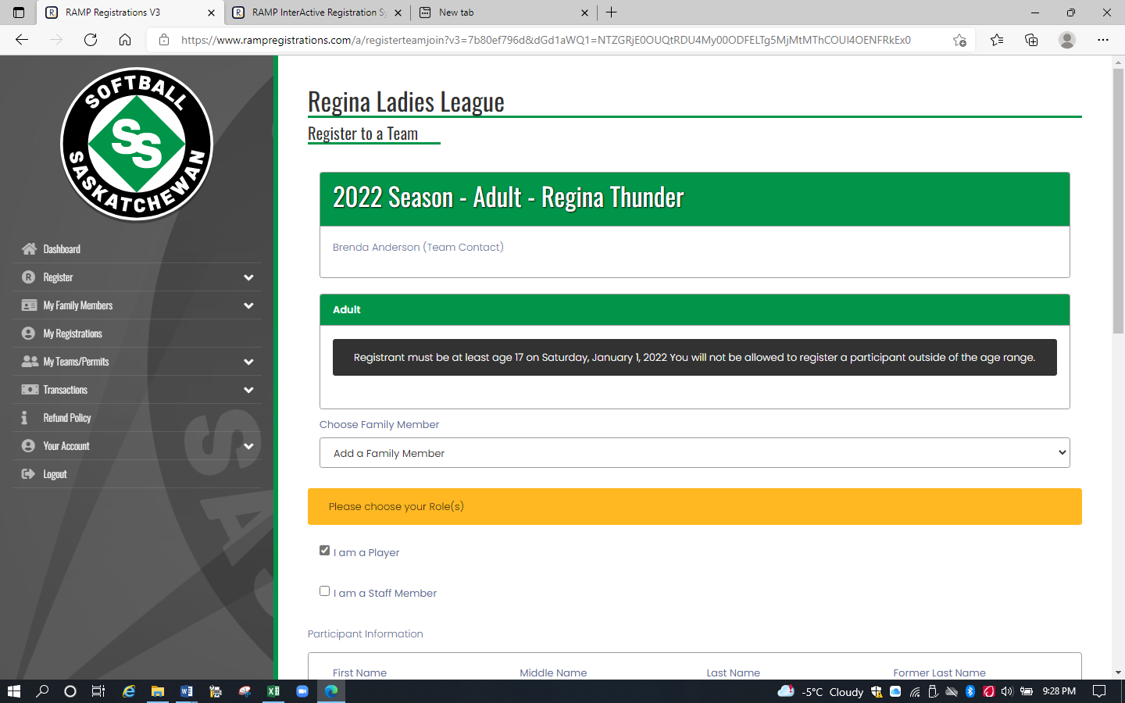

For people who are a player/coach, click both the ‘I am a Player’ box and the ‘I am a Staff Member’ box.
For coaches, assistant coaches, and managers, who are not players, unclick ‘I am a Player’ and click on ‘I am a Staff Member’. Select the appropriate Role. Be sure to input your Respect in Sport ID as it is a required field.

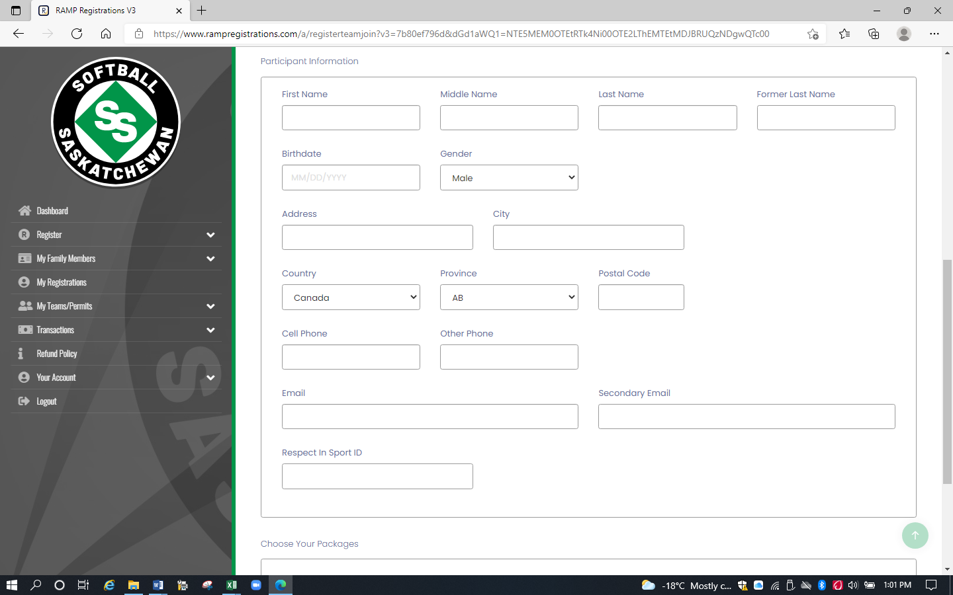

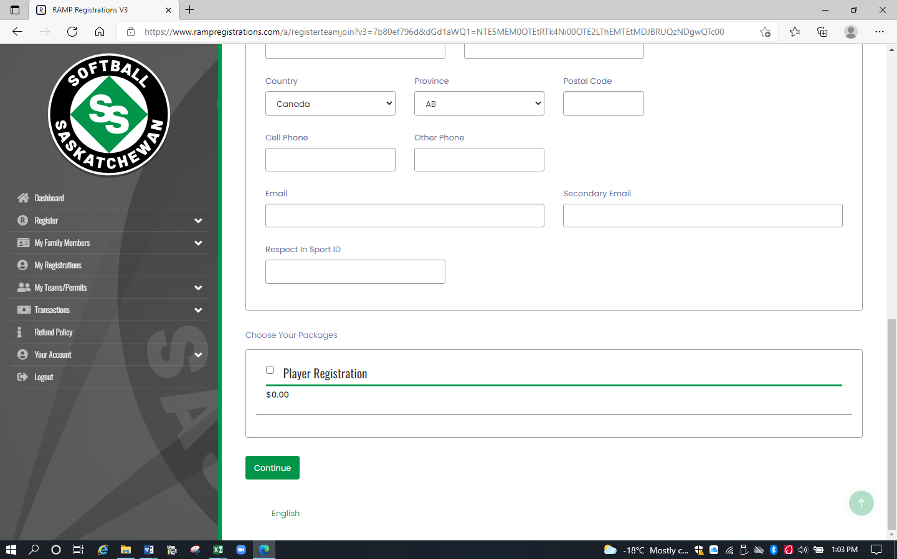

- Complete info. For players, click the Player Registration box in the ‘Choose Your Packages’ field at the bottom of the screen.

- Click Continue. The waiver screen will appear.

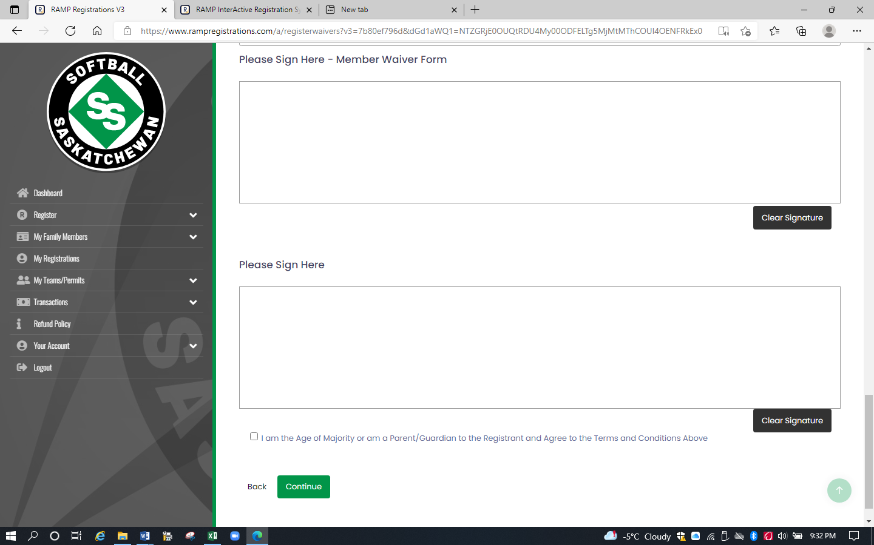

- Player/coaches will have two waivers to sign. Sign in all signature boxes.

- Click the box on the Age of Majority statement.

- Click Continue. The ‘Regina Ladies League Questions’ screen will appear.

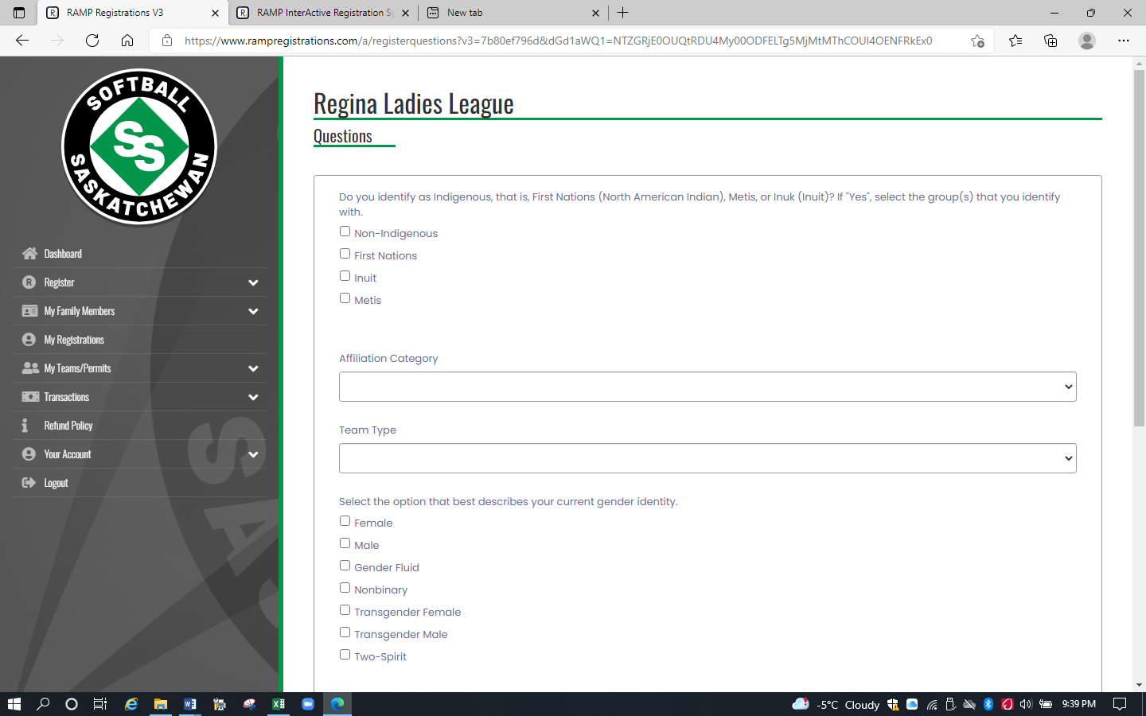

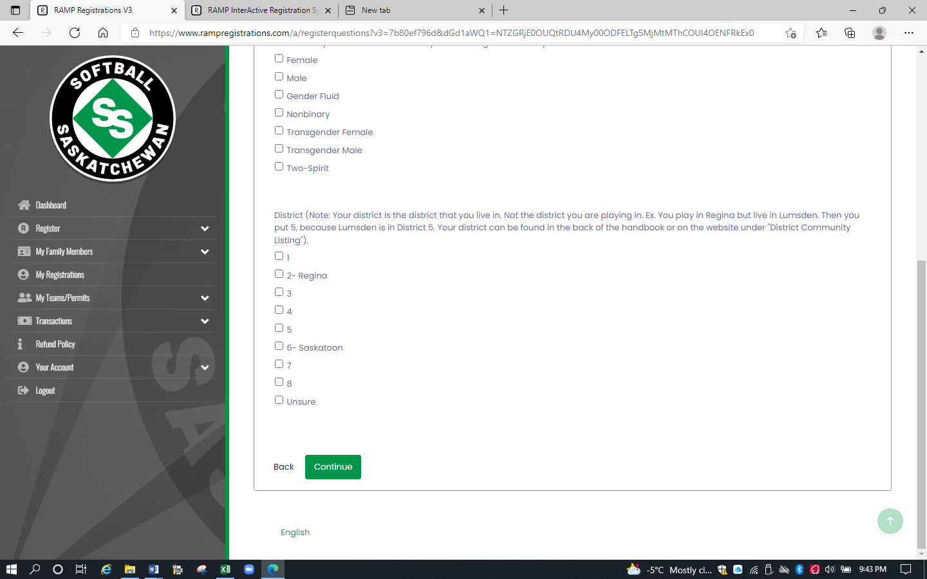

- Answer questions. Note that a player/coach will have to answer these questions twice.
  - Affiliation Category – select category based on your age, U19 (born 2003, 2004), U23 (born 1999, 2000, 2001, 2002), Adult (born 1998 & earlier)
  - Team Type – select Softball/Fastpitch
  - District - select the district in which you live. Ex. Regina is District 2.
For other locations, go the the Softball Sask website, Memberhip & Affiliation, Handbook. District locations start on page 100.

- Click Continue. The ‘Confirm Details and Submit Registration’ screen will appear.

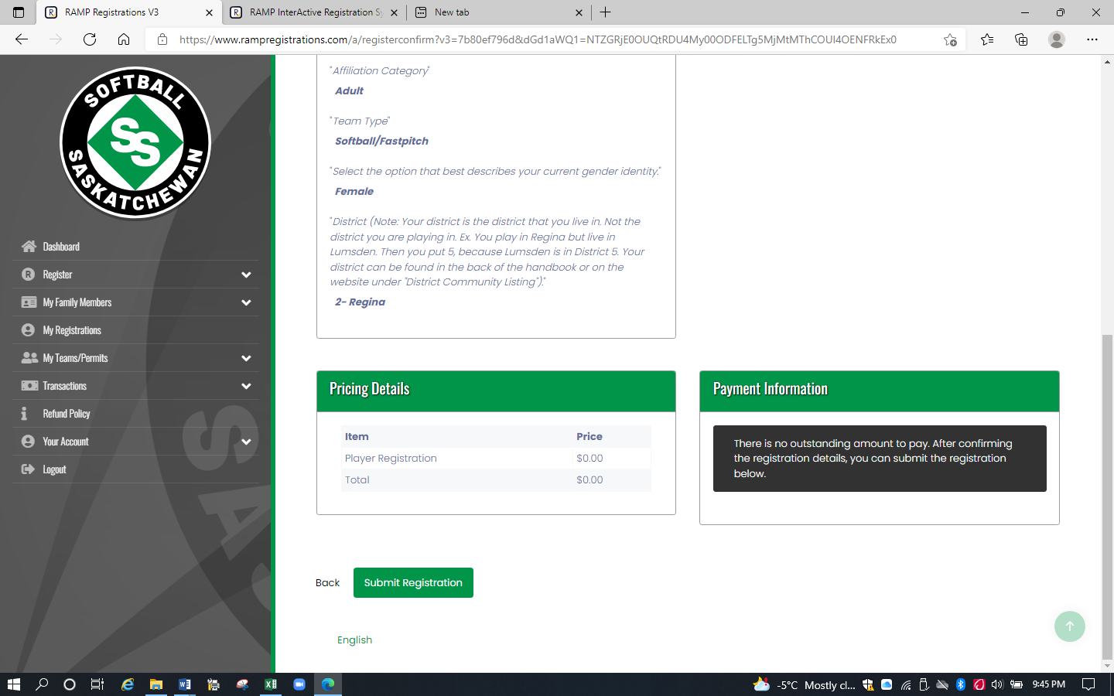

- Click on Submit Registration. The ‘Registration Complete’ screen will appear.

- You will receive a confirmation email from Regina Ladies League with the subject ‘Regina Ladies League Registration Confirmation’. Check your Junk folder if the email is not in your Inbox.

