**2025 RLSA SPRING GENERAL MEETING AGENDA – March 31, 2025 at 7:00 PM via Zoom**

1. Call to order

***Meeting called to order at 7:07 pm***

1. Review of voting process

***Deanna reviewed voting process; she mentioned that new teams are not eligible to vote until after their acceptance.***

1. Adoption of agenda

***Danielle Swartz motioned agenda be adopted as presented. Jolene Sentes seconder. Carried.***

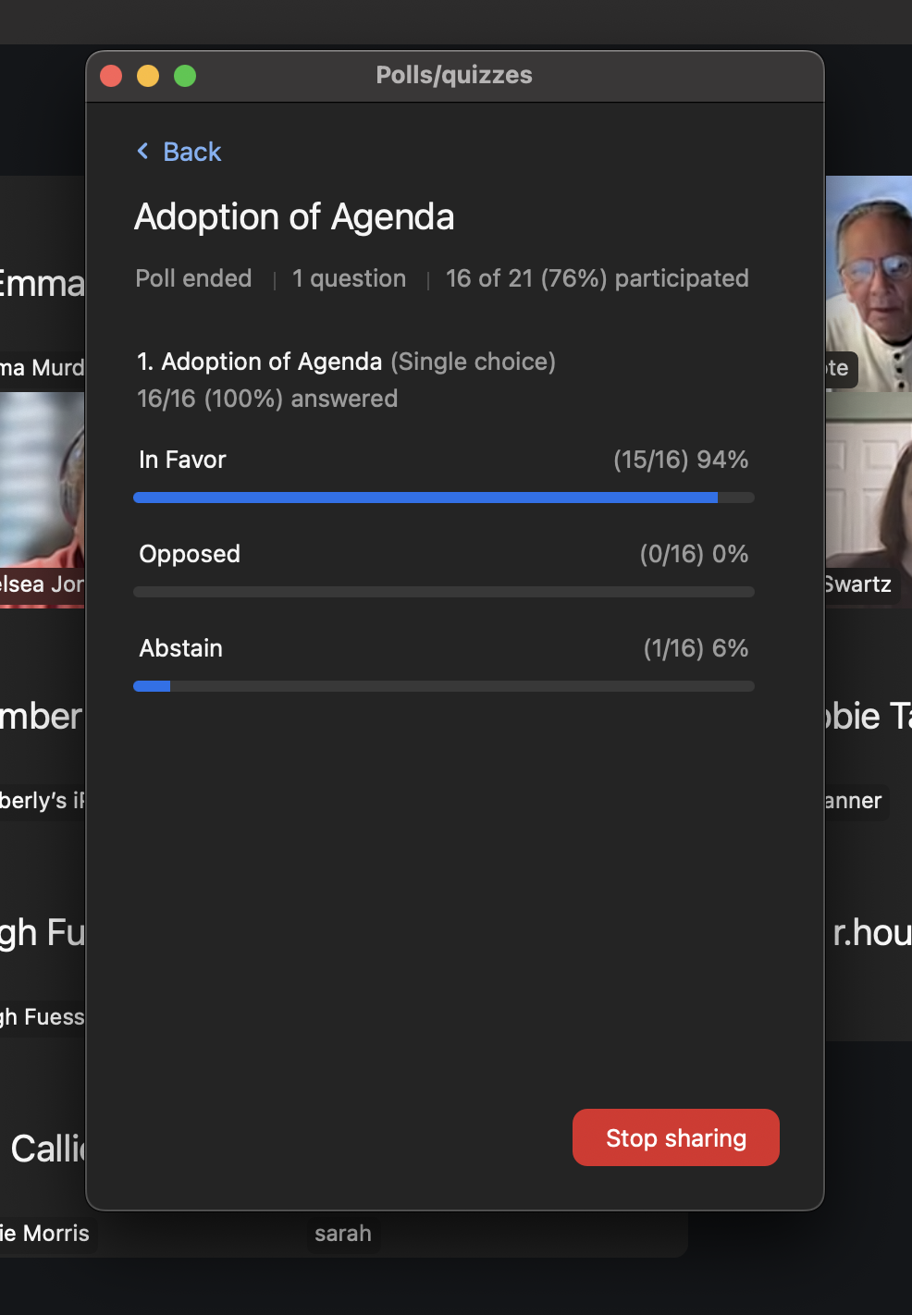

1. Adoption of minutes from 2024 Fall League meeting. Review on league website reginaladiessoftball.ca under ‘About Us/Meeting Minutes’.

***Brenda Anderson motioned minutes be adopted as presented. Tyler Gerrard seconder. Carried***

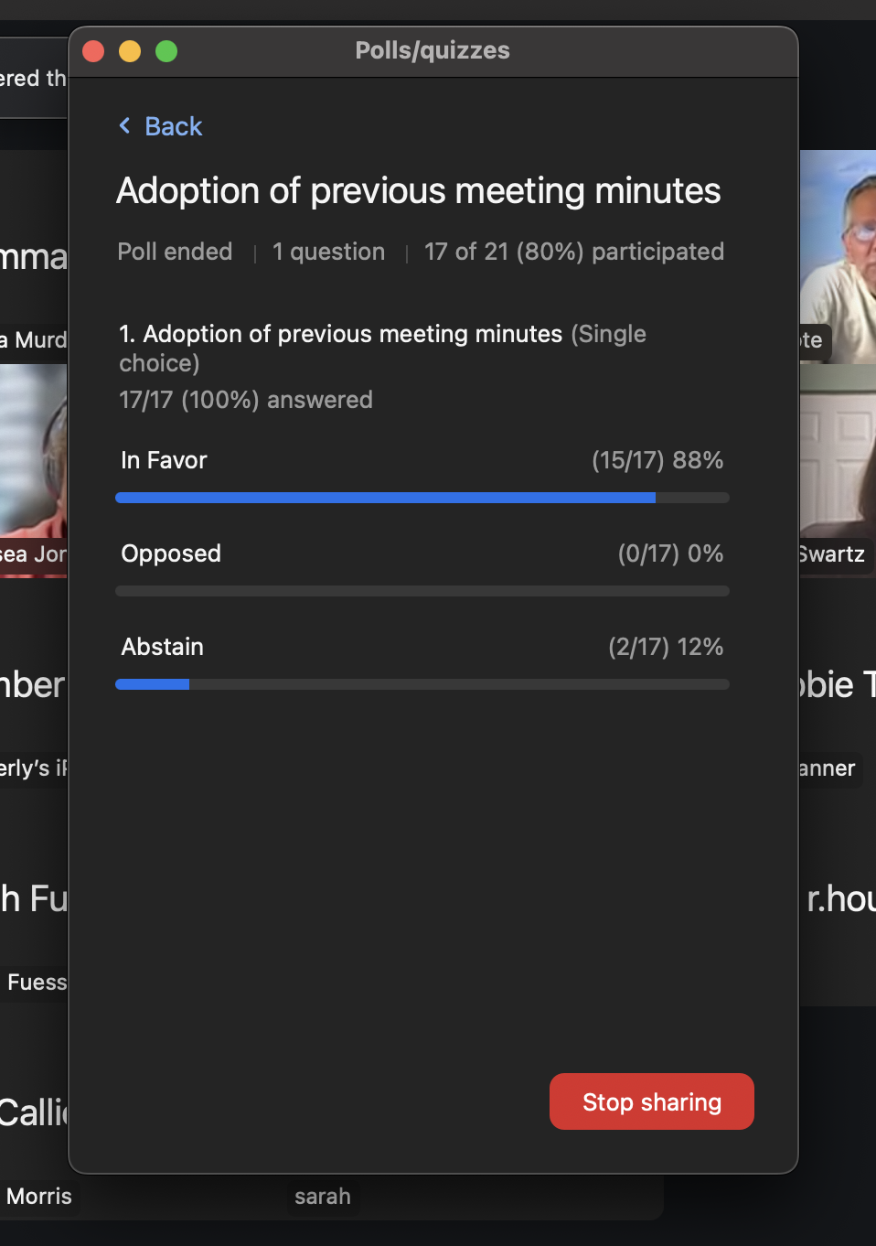

1. League Structure

* Applications for membership – Cote Blue Jays, GWA, White Butte Storm U19A
* Leave of Absence – Rage, Moose Jaw. **AMENDMENT as of April 5 - Dakota also taking leave of absence. Decided after the meeting.**
* Move request – Anonymous from Div I to Div II
* Return from leave of absence – TATC (half schedule), Lady Rebels (formerly Bomb Squad)
* Other request – Iskotew, Pride move from Full schedule to Half Schedule. **AMENDMENT as of April 5**
* RMSL will have 4 teams

***Leila Mohr motioned to accept all three applications for memberships. Sydney Ellis seconder. Carried.***

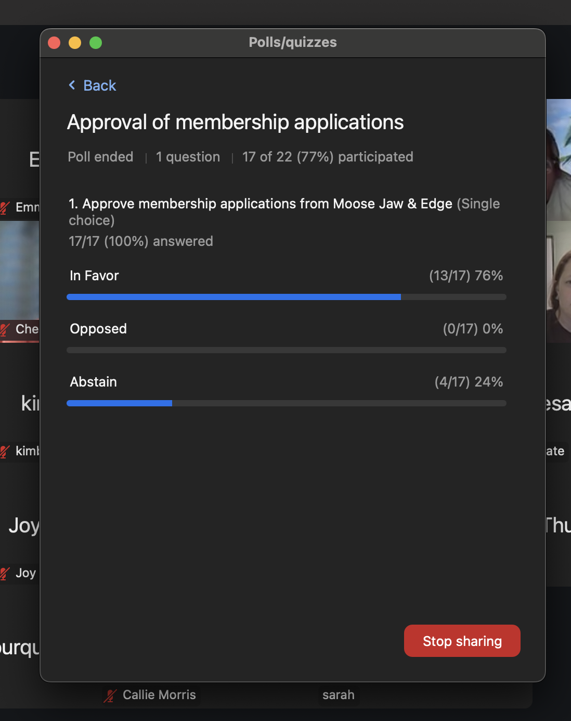

***\*\*NOTE** the poll formatting shows moose jaw and edge, but the new teams voted on were Cote, GWA, and Storm.***

* 1. Divisional structure – 21 teams (**AMENDMENT as of April 5 – 20 teams)**

Div I – 6 full schedule + 2 half schedule

Div II – 10 full schedule + 3 half schedule (**AMENDMENT as of April 5 – 2 half schedule)**

***Question asked by Rod Houk regarding how many full and half teams in Div 1; Deanna clarified that Anonymous is no longer in Div 1, and Iskotew and Pride want half schedule***

* 1. Regular season format and start date

- regular season of 15 games from May 12th - July 4th , rainouts week of July 7th, playoffs July 14th - 31st.

- schedule requests to Chelsea Jones, [c_jones18@outlook.com](mailto:c_jones18@outlook.com).

- scorebook, lineup book will be delivered to diamond at first game. Contact Brenda Anderson at 306-539-4943 if you want to pickup prior to that date.

* 1. Playoff format – to be determined depending on number of teams. Options are two game guarantee or double knockout. Tentative dates July 14th – 31st. Playoff commitment date mid June.

1. Umpire Fees

* Recommend fees stay same - $50/umpire/game for a two person system & $75 per game for a one person system
* Anyone interested becoming an umpire can contact Andrew Walker, 306-536-9456 or [alwalker@sasktel.net](mailto:alwalker@sasktel.net)
* Umpire clinic in Regina on Sunday, April 13th at Martin Collegiate. Online registration on Softball Saskatchewan website under Umpires.

***Natasha Zeiler motioned umpire fees stay the same as 2024. Tyler Gerrard seconder. Carried.***

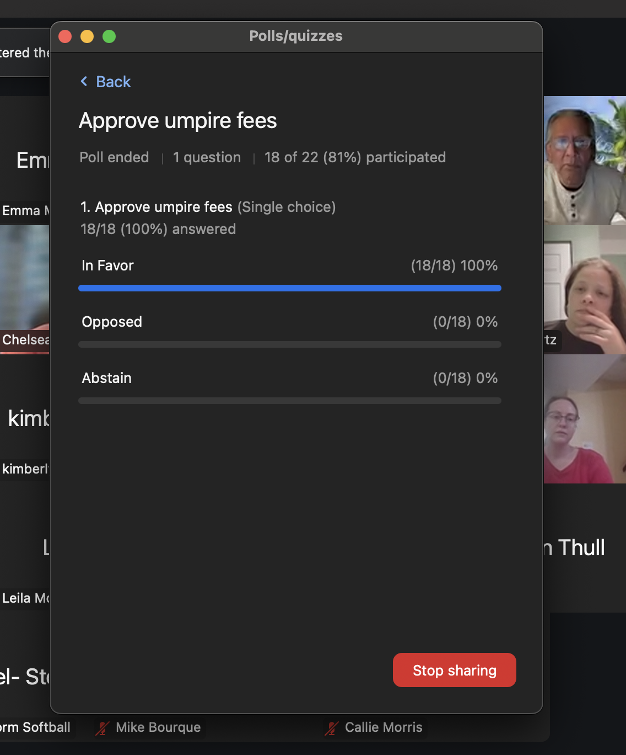

1. League Fees

* Propose same fee as 2024 of $2,000 ($1,225 league, $275 affiliation, $500 bingo) due by Sunday, May 11th. Can etransfer to [admin@reginaladiessoftball.ca](mailto:admin@reginaladiessoftball.ca)
* Each team will be sent an email with the total of fees due as some teams have credits and some have fines.

***Karen Thull motioned league fees stay the same as 2024. Jolene Sentes seconder. Carried.***

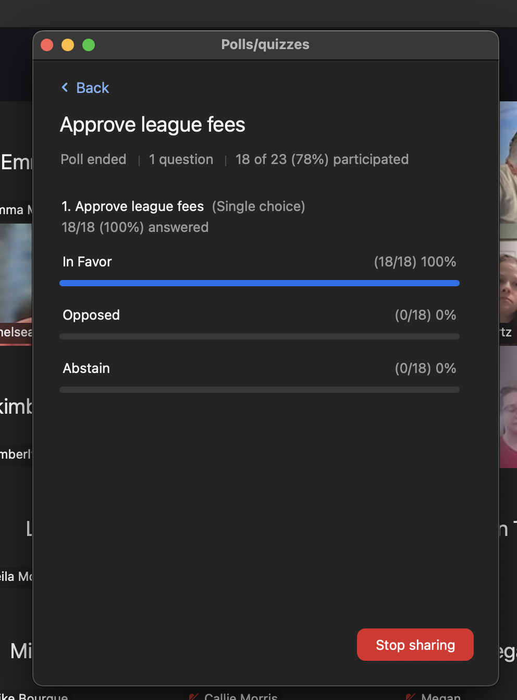

1. RLSA Registration System

* RAMP registration system will be used again this year. To be eligible to play in RLSA, must be 18 years of age by December 31, 2025. Coaches must have completed Respect in Sport for Activity Leader program.
* Players in the U19 category (born 2006 or 2007) **must get a release from the closest minor softball association from their address.**
* RLSA deadline for players to be registered is Sunday, May 11th. Changes can be made until Softball Saskatchewan affiliation deadline of June 1st.
* Ramp Team App will be purchased for teams to use.

***Sarah presented the Ramp information and gave information on Respect in Sport. information on the training can be found here:*** [***https://www.sasksport.ca/programs-education/respect-in-sport/***](https://www.sasksport.ca/programs-education/respect-in-sport/)

1. General Operating Rules update & review. Rules can be reviewed on league website reginaladiessoftball.ca under ‘About Us’.

***No General Operating Rules updates were proposed.***

Operating Rule Review

* 3H – Registration of Players – players must play in at least one regular season game to be eligible for playoffs.
* 3K – AP (Affiliated Player)
  + A team will be allowed to use a maximum of two substitute Affiliated Players in regular season league games. A team will be allowed to use a maximum of two substitute Affiliated Players in playoff games in order to fulfill a nine person roster.
  + To be eligible as an AP, the player must be affiliated with Softball Sask. These Affiliated Players must be at least 16 years of age as of Dec 31 of the current playing year.
  + League teams can use players from a lower Division as AP players. The AP players can play any position.
  + League teams can use players from the same Division as AP players. The AP players cannot play in the pitching or catching position.
  + The team representative must obtain permission from the coach of the AP before contacting the AP to play in an upcoming game. Just prior to the game the AP(s) must be identified on the lineup card and the opposing coach advised. The AP players(s) cannot be in the starting lineup if there are a minimum of nine regular team players available to start the game.
* 5C - GROUND RULES

For games starting at 6:45 P.M., no new inning shall start after 8:30 PM. For the second game of a double header, no new inning shall start 1 hour 45 minutes after the start time declared by the umpires.

* 5J – GROUND RULES (new for 2025)

It is the responsibility of each team to present a completed lineup card to the umpire prior to the start of the game. The lineup card must include the first and last name and uniform number of every player at the diamond. The player position must be included for the starting lineup. A team representative must sign the lineup card. Teams handing in an incomplete lineup card will be given one warning from the Association Executive. Any subsequent incomplete lineup card will result in a $25 fine per lineup card.

* 7B - GENERAL

B) If a team does not have enough players for a game, they must notify the Communications Manager, opposing team, and Statistician 12 hours in advance of game time. The Communications Manager will notify the umpire-in-chief, and groundskeeper.

*Communications Manager is Jolene Sentes, 306-551-0429*.

***Jolene requests texts preferred but will obviously be checking emails during the day to note if anyone cancels games.***

***No questions on the rule overview.***

* 7C - GENERAL

Each team is allowed to cancel two game nights which are to be rescheduled as soon as practical. A third cancelled game night will be treated as a default. This means a double header is considered one game night.

1. Election of Vice President

N***o new vice president brought forward.***

1. League Tournament – May 30th to June 1st. To enter, complete the application form found on the league website

* Entry fee – $550

1. Douglas Park and Bingo updates

* Held meeting with PCC to discuss project ideas regarding bleachers, building garage door, water tap in building storage area, storage shed for bases.
* City of Regina working on getting equipment to do shadow measurements on DP2.
* Equipment (rake & tamper & water spray tank) will be in umpire room for teams that want to do maintenance on diamonds between double header games
* Construction of pickleball courts north of DP1 building is complete
* 16 bingos since fall meeting, 7 scheduled April-May. Dates are on league website. Revenue of $44,328 October-January.

1. Review of Team Responsibilities. Review on league website reginaladiessoftball.ca under ‘Team Info/Team Responsibilities’.
2. Other Business

* AE (Athlete Era) Softball app provides all coaches easy access to practice plans and drills. Qualify for premier access as member of Softball Saskatchewan. Contact Jacqueline Eiwanger at Softball Saskatchewan, 306-780-9235 for more info.
* Scheduling practice diamonds. Contact Brenda Anderson at 306-539-4943. Check availability on website calendar. Two hour timeframe on weekends.
* Go to the Softball Saskatchewan website for information on coaching clinics.
* City of Regina Smoking Bylaw - The bylaw prohibits smoking and vaping on all City-owned or controlled land. This includes our diamonds at Douglas Park.
* Available players:
  + Letitia McKay – 306-551-9313, [letitia.mckay@gmail.com](mailto:letitia.mckay@gmail.com) – play in Div II, plays 1st & 3rd
* ***Addition after discussion during meeting: Sue noted that winning teams are to text her the score of their game by 12pm noon the next day after a game. Brenda noted that this is listed in the Team Responsibilities as well and this should be reviewed by all teams prior to the beginning of the season as mentioned in agenda point 13.***

***Jolene will add any contact information to the website. Debbie Tanner requested to be included in the ‘looking for players’ posting on the website and was instructed to contact Jolene to have that completed.***

1. Adjournment

***Meeting Adjourned at 7:47***