REGINA LADIES PLAYER & COACH REGISTRATION PROCEDURES
- You will receive an email from Regina Ladies League with the subject Regina Ladies League : “Your Team Name” - Team Registration Invite. Check your Junk folder if the email is not in your Inbox.
It will include a link to the registration website as well as the Team Invite Code.

- Click on the link in the email. The Regina Ladies League registration website will appear.
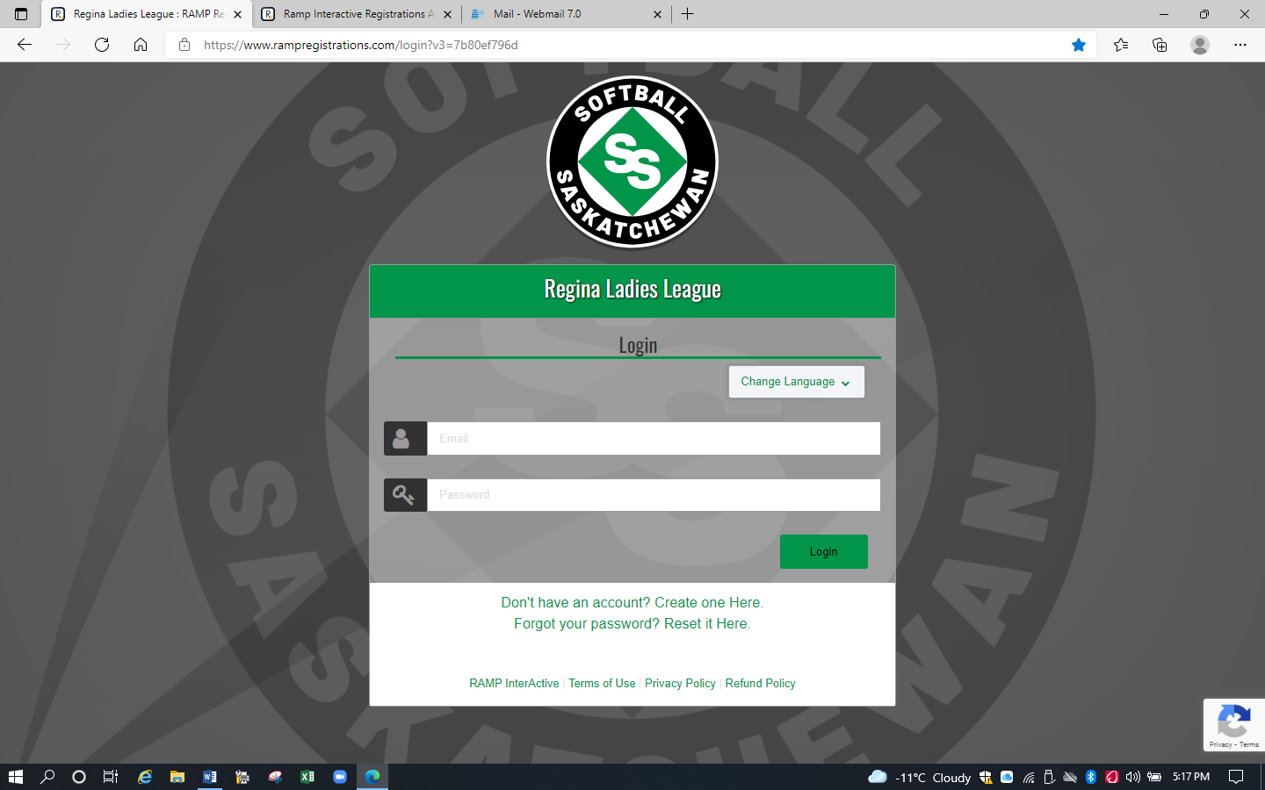

- If you have an existing RAMP account (even for another sport), login using that email & password.

If you do not have a RAMP account, click on ‘Create one Here’. The Regina Ladies League Create an Account screen will appear where you can create your own account and then Log in to complete player registration.
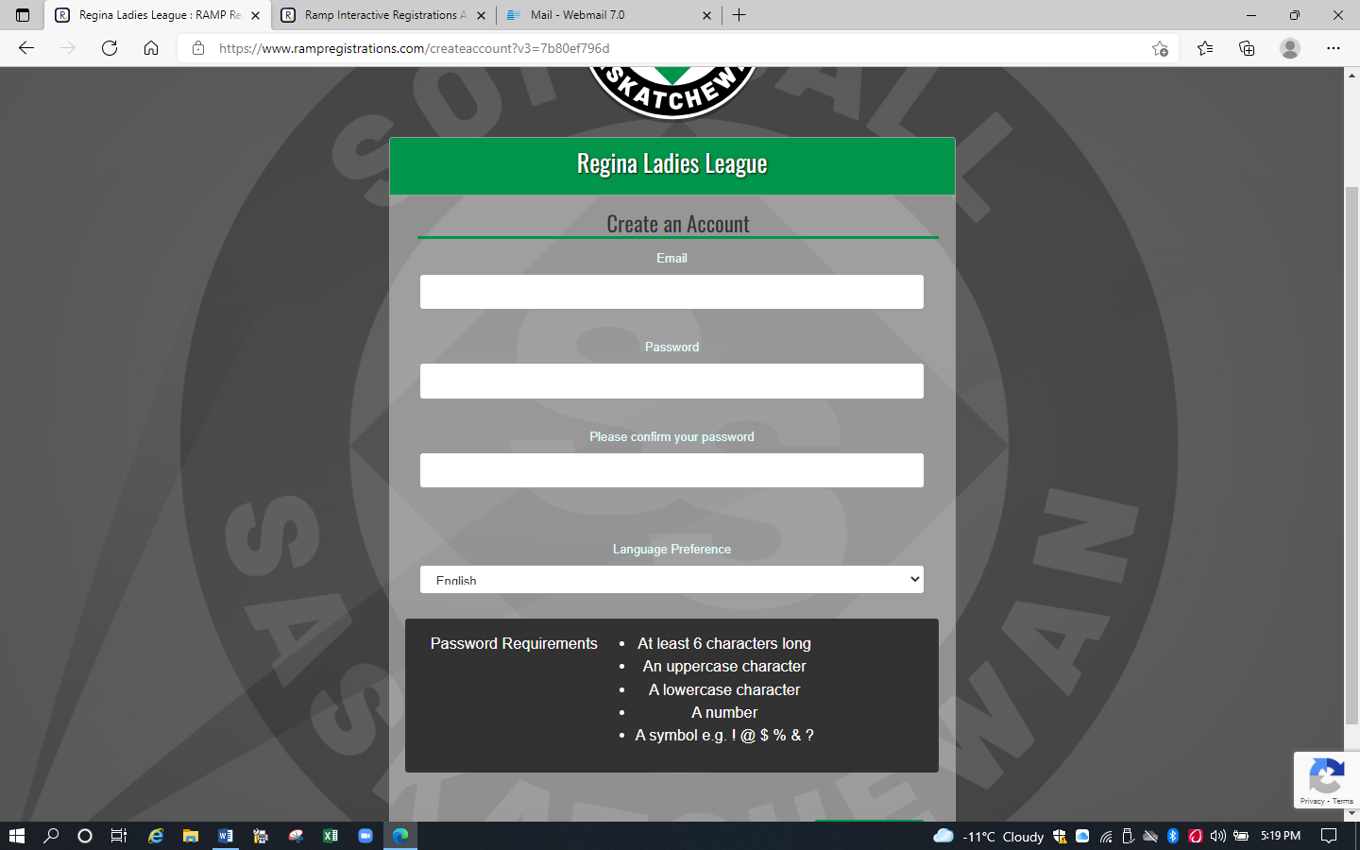
- The Regina Ladies League screen will appear, choose Register to a Team
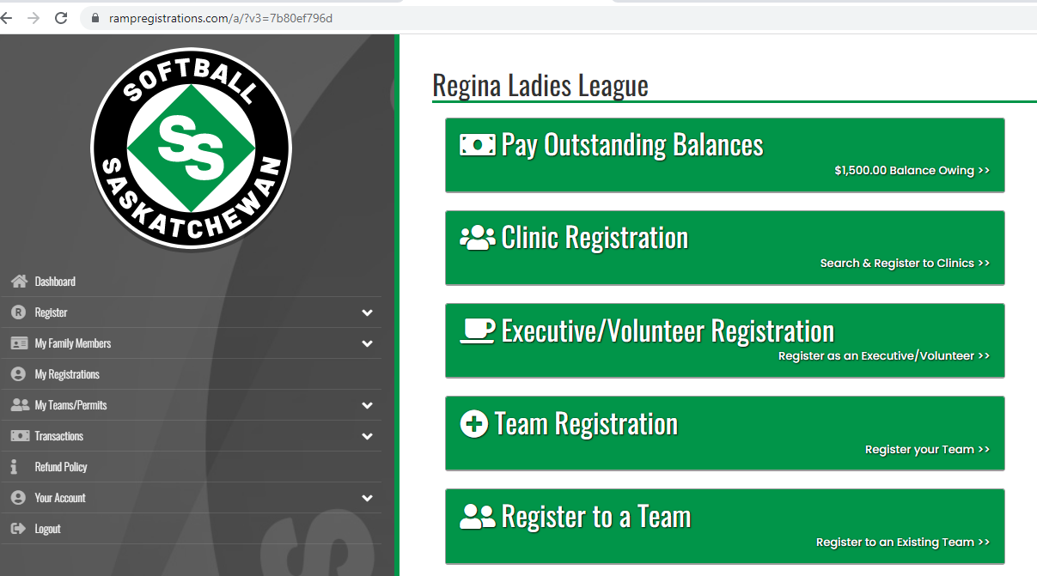

- The Regina Ladies League Register to a Team screen will appear, use team invite code sent from your team contact.
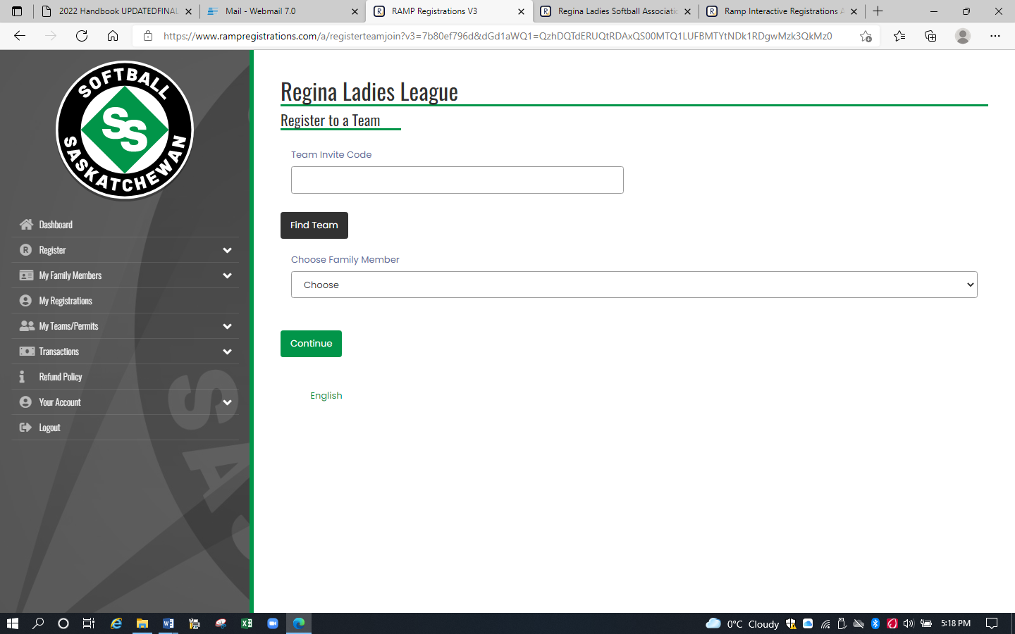

- The 2023 Season-Adult- YOUR TEAM screen should appear.

- Click on the down arrow to select the Family Member. If the correct family member is not displayed, click on Add a Family Member.

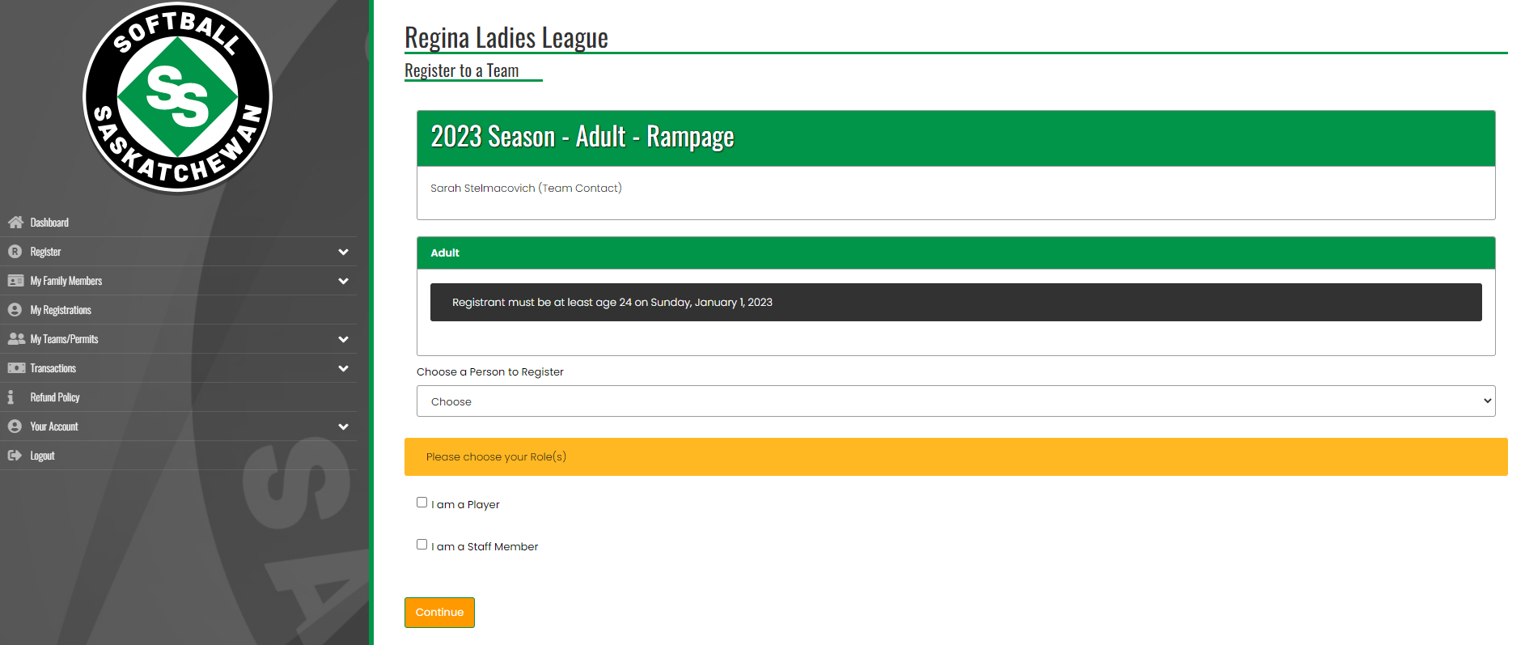

For coaches, assistant coaches, and managers, unclick ‘I am a Player’ and click on ‘I am a Staff Member’. Select the appropriate Role. Be sure to input your Respect in Sport ID as it is a required field.
For players that act as coaches, you will have to have one of each account: player and coach.
- This year, you should be able to click on both at once, you may be prompted to answer questions twice.

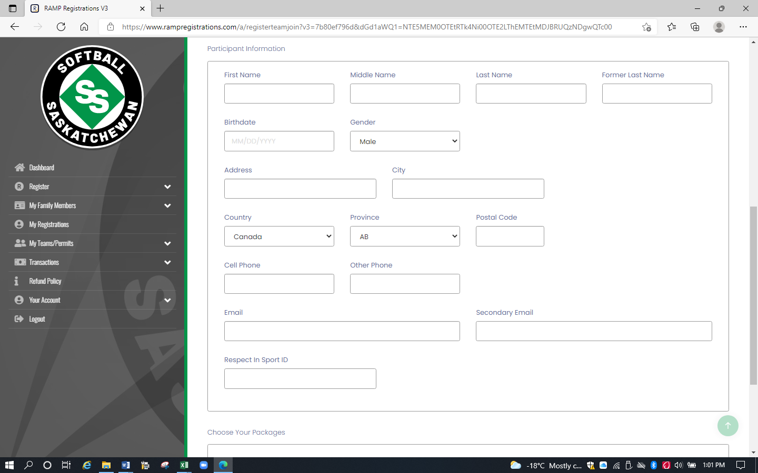

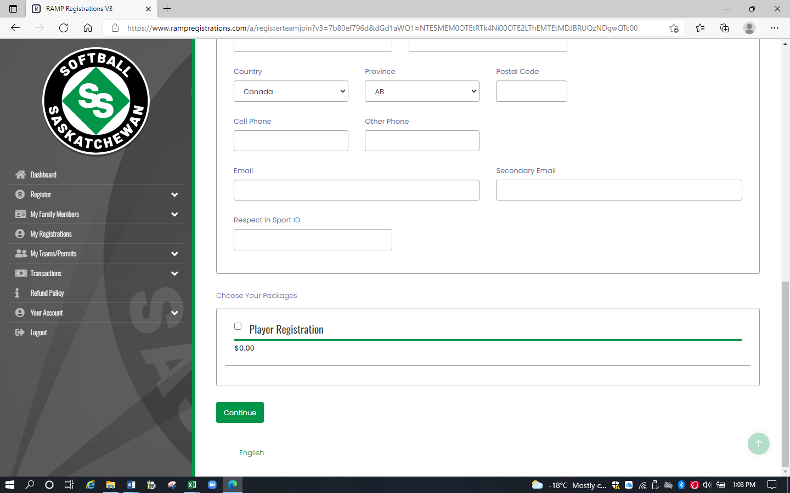

- Complete player info. Click Player Registration in the Choose Your Packages box at bottom of screen.

- Click Continue. The Questions screen will appear.

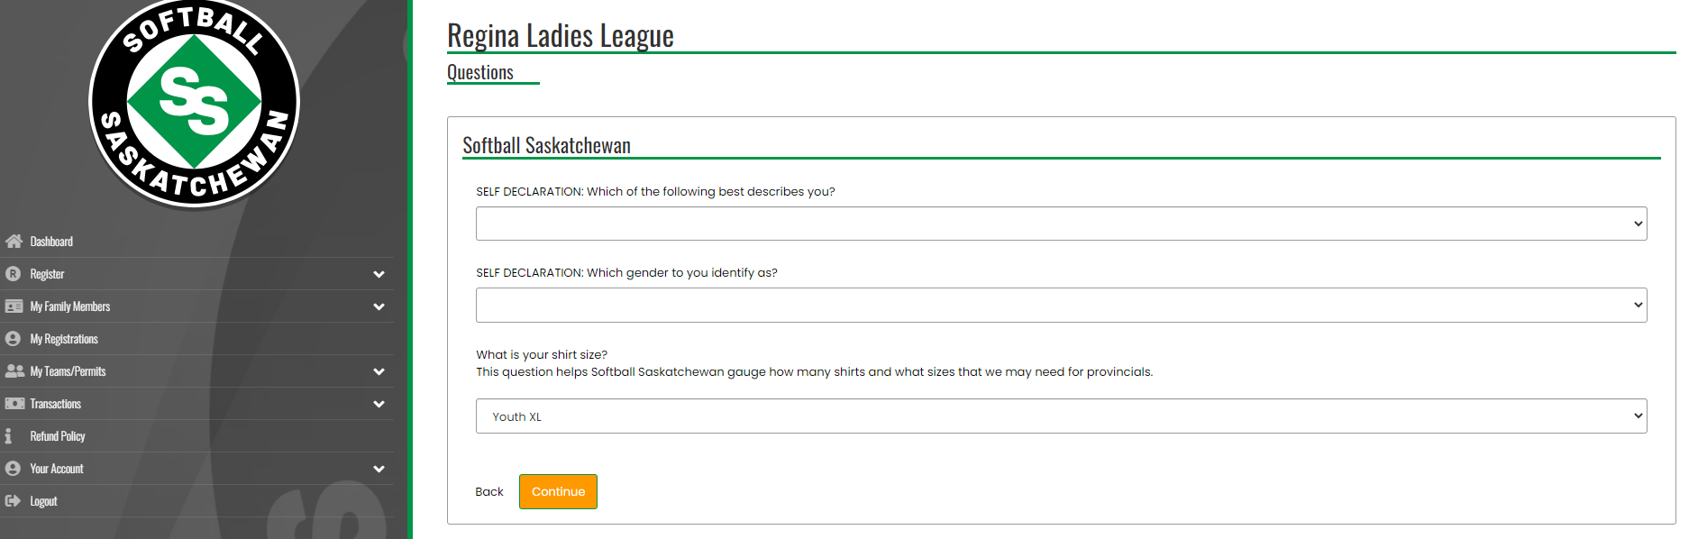

- Answer questions:
  - There is no district question this year on the form.
  - Softball Sask is collecting shirt info to help them with needs for provincials. You have to pick a size for registration purposes, you won’t be given or billed for a shirt from Softball Sask.
  - There will be no waivers to be signed for this year from softball sask.

- Click Continue. The Confirm Details and Submit Registration screen will appear.

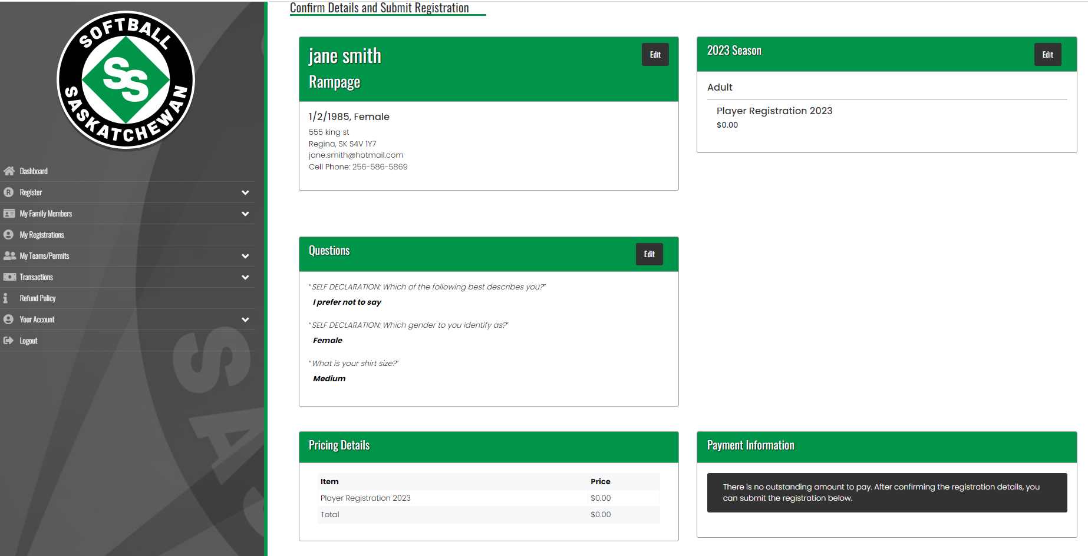

- Click on Submit Registration. The Registration Complete screen will appear.

- You will receive a confirmation email from Regina Ladies League with the subject ‘Regina Ladies League Registration Confirmation’. Check your Junk folder if the email is not in your Inbox.

