REGINA LADIES TEAM REGISTRATION PROCEDURES

- All teams are allowed to affiliate 20 players and 5 staff (coach/assistant coach/manager)
- Anyone listed as a coach, assistant coach or manager MUST have a Respect in Sport for Activity Leader number - https://sasksrc.respectgroupinc.com/koala_final/
- Players registered for a Regina Ladies League team must be turning 18 by the end of the current playing year (turning 18 by Dec 31/2022)

The following are instructions for you and your team for the affiliation process through RAMP, the new system Regina Ladies Softball & Softball Sask are now using.
- Coach or Manager to Register Team. If coach or manager does not have a RAMP account (ex. for another sport), an account will have to be created with this link for Regina Ladies Softball Association: https://www.rampregistrations.com/login?v3=7b80ef796d

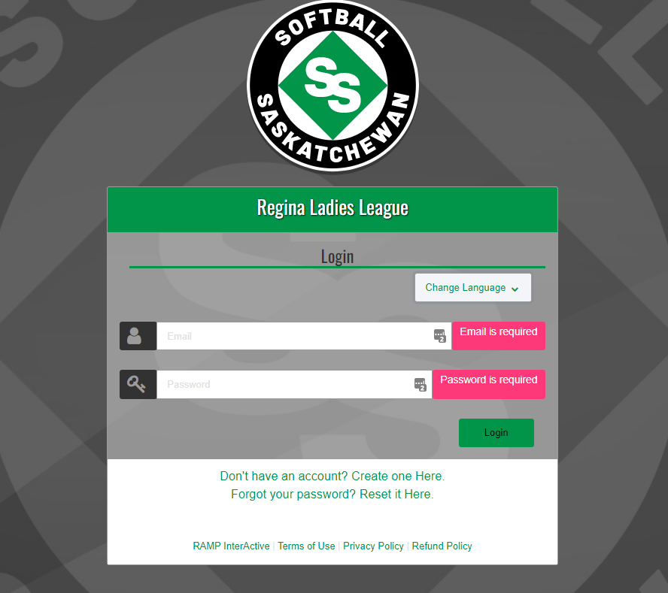

- Once account is created, login. The ‘Regina Ladies League’ screen will appear.
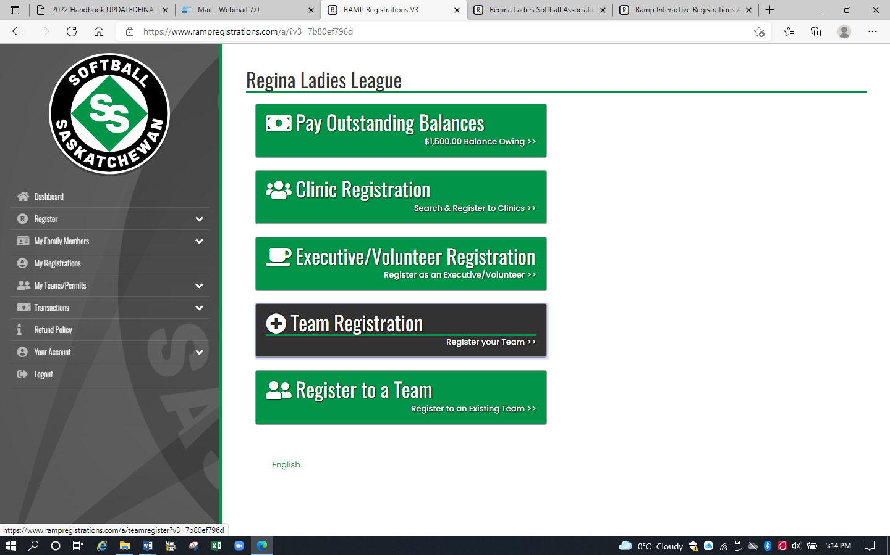

- Select ‘Team Registration’. The ‘Team Registration’ screen will appear.

- In the ‘Choose a Division’ field, click the down arrow. Select the appropriate category. There are age restrictions for each category. U19 – players born in 2003 or 2004; U23 – players born in 1999, 2000, 2001, 2002; Adult – must be 18 by December 31, 2022. If your team is made up of players in different categories, select Adult.

- In the ‘Choose a Team Contact’ field, click the down arrow. Select ‘Create New Team Contact’ if your name does not appear. Other contacts will be added later.

- In the ‘Team’ field, click the down arrow. Select ‘Create a New Team’. A ‘Team Name’ field will appear. Input team name.

- In the ‘Choose your Package’ field, select ‘2022 Team Registration’.

- Click ‘Continue’.

- The ‘Team Invites’ screen will appear. Enter player, coach, manager info. Emails will be queued until the team registration is activated by RLSA. 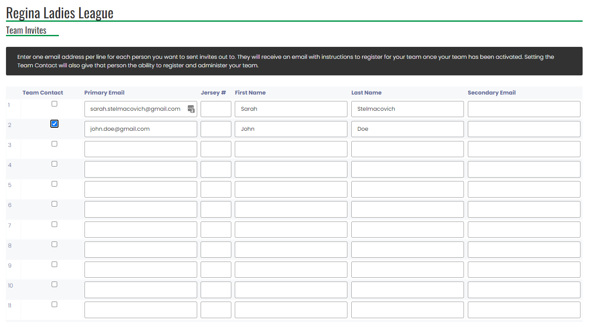

- Click ‘Continue’. The ‘Confirmation Details and Submit Registration’ screen will appear.
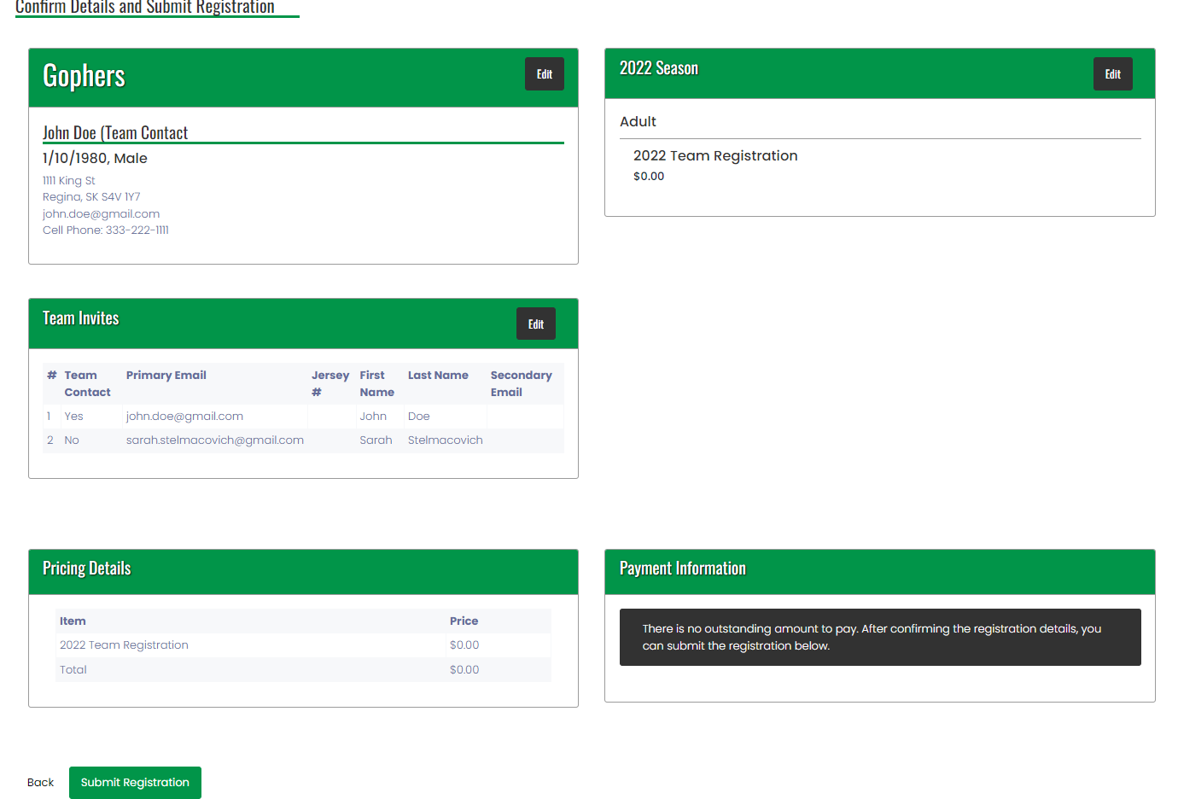

- Click ‘Submit Registration’ after confirming all info entered is correct.

- The ‘Team Registration Completed’ screen will appear.

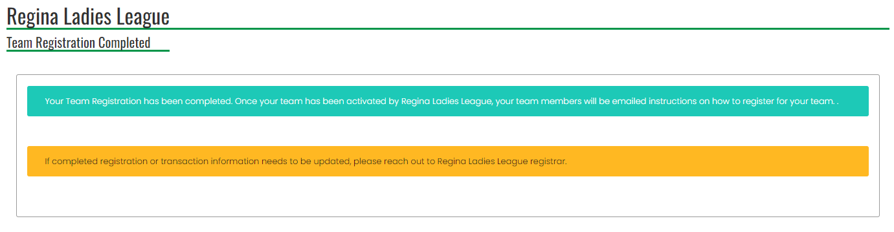

- You will get a confirmation email from Regina Ladies League stating your team registration confirmation is complete. Check your Junk folder if the email does not appear in your Inbox. This is an automated email from RAMP. Please do not reply to this email. If you have any questions about team or player registration, please contact Sarah Stelmacovich at 306-540-2009 or Brenda Anderson at 306-539-4943.
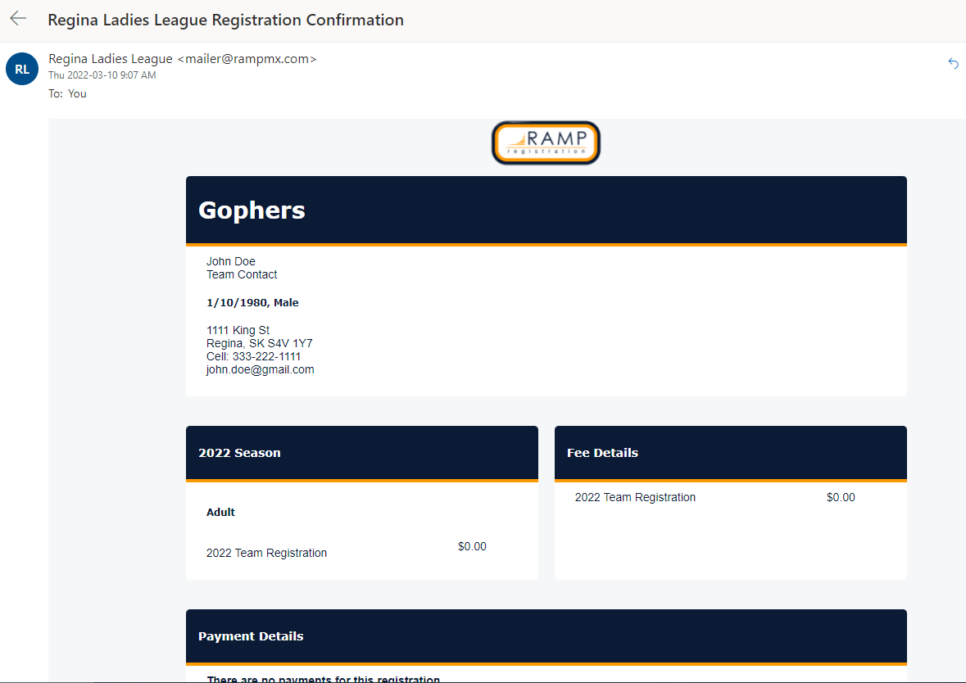
- RLSA will activate your team. Emails will be sent to everyone entered in the ‘Team Invites’ screen, inviting them to join the team. The email will be from Regina Ladies League. Have them check their Junk folder if the email does not appear in their Inbox.

All coaches and managers register as staff, even if you have already registered a team as the main team contact. Under the personal registration is where Respect in Sport numbers will be entered. If a person has already registered with RAMP for another sport, they can still use that account, they just have to use the invite code for your team.
- A player can only register with one team in the league.
- There is no cost per player as RLSA only has fees per team

- To Manage the team (ex. send more invites), login to the Regina Ladies League registration system. Refer to step 1.

- Click on ‘My Teams/Permits’ found on the left side of the screen.

- Click on ‘My Teams’. Your team name will appear on the right side of the screen.

- Click on ‘Manage’. Your team registration will appear on the right side of the screen.

- Click on ‘Manage’. Make required updates. When done, click on ‘Logout’ on left side of screen.

