RLSA TEAM REGISTRATION HELP SHEET/ AFFILIATION INFORMATION

- All teams are allowed to affiliate 20 players and 5 staff(coach/manager)
- Anyone listed as a coach, assistant coach or manager MUST have a Respect in Sport for Activity Leader - https://sasksrc.respectgroupinc.com/koala_final/
  - NOTE* SOFTBALL SASK DOES NOT ACCEPT RESPECT IN SPORTS FROM HOCKEY TAKEN BEFORE 2014.
- Players registered for a Regina Ladies League team must be turning 18 by the end of the current playing year (turning 18 by Dec 31/2024)
- If you have any difficulties with registering, please let Brenda or Sarah know when you are registering and we can provide you with assistance.
- Sarah Stelmacovich at 306-540-2009 or Brenda Anderson at 306-539-4943.

The following are instructions for you and your team for the affiliation process through RAMP, the new system Softball Sask is now using.
- All coaches, managers and players will have to create an account with ramp with this link for Regina Ladies Softball Association: https://www.rampregistrations.com/login?v3=7b80ef796d

- If you have a RAMP account from a previous sport (or prior RLSA team), please use that one.
- Please enter your Respect in Sport number when you register as a staff member.
- For those coaches or managers who are also players, you will have to register as both a STAFF and a PLAYER.
- A player can only be registered on one team.

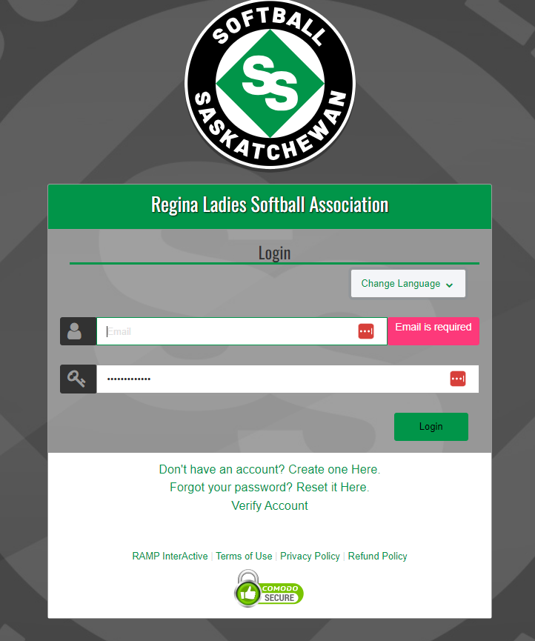

- Once account is created (you may be prompted to log in again), select Team Registration. Please select the age division for your team under division.
  - If you have U19, U23 players and adult players on the team – Please select ADULT as your division.

- If registering a new team:
  - create a Team Contact and Team name as prompted in the drop-down boxes.

- If reregistering a previous team:
  - Team name and Team contact should appear in the drop-down menus.

- Please select team package listed as $0 to continue with the team registration process. Fees will not be collected through RAMP.

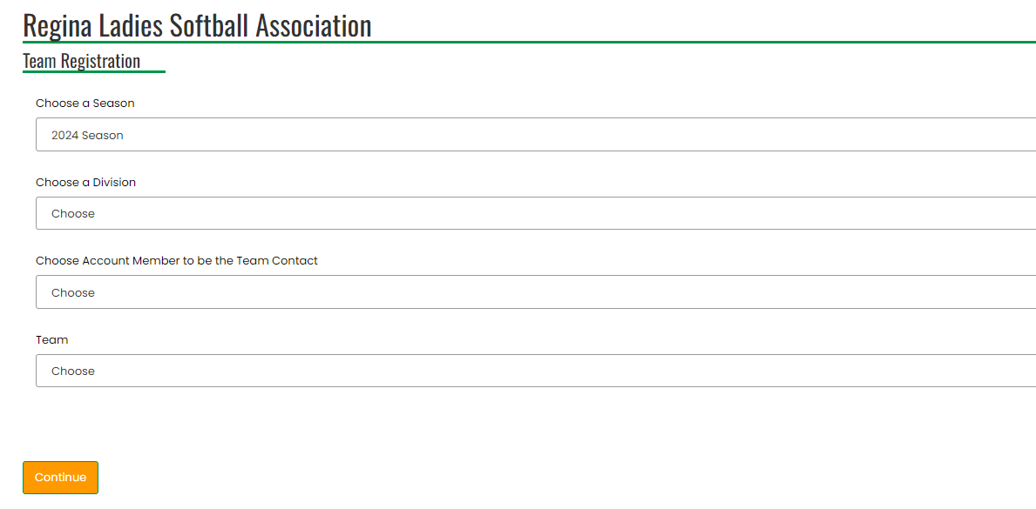

- The next page of the team registration will ask for team invites.
  - Here you can also choose who your main team contacts if you want more than one.

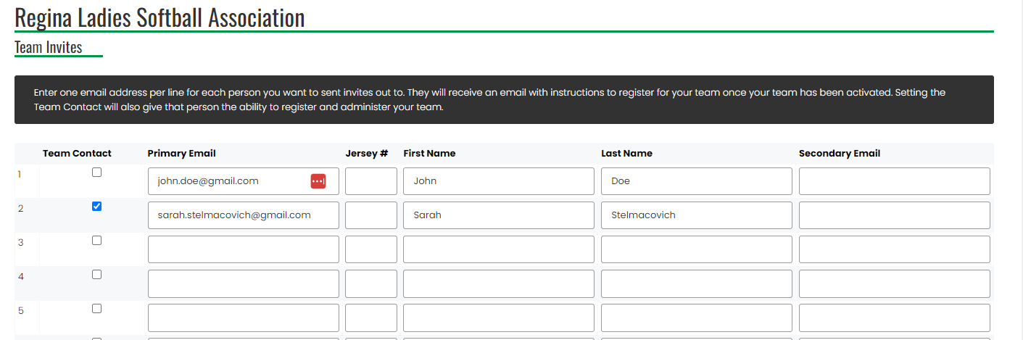

- The final Team Registration page should look like this, please hit submit registration.

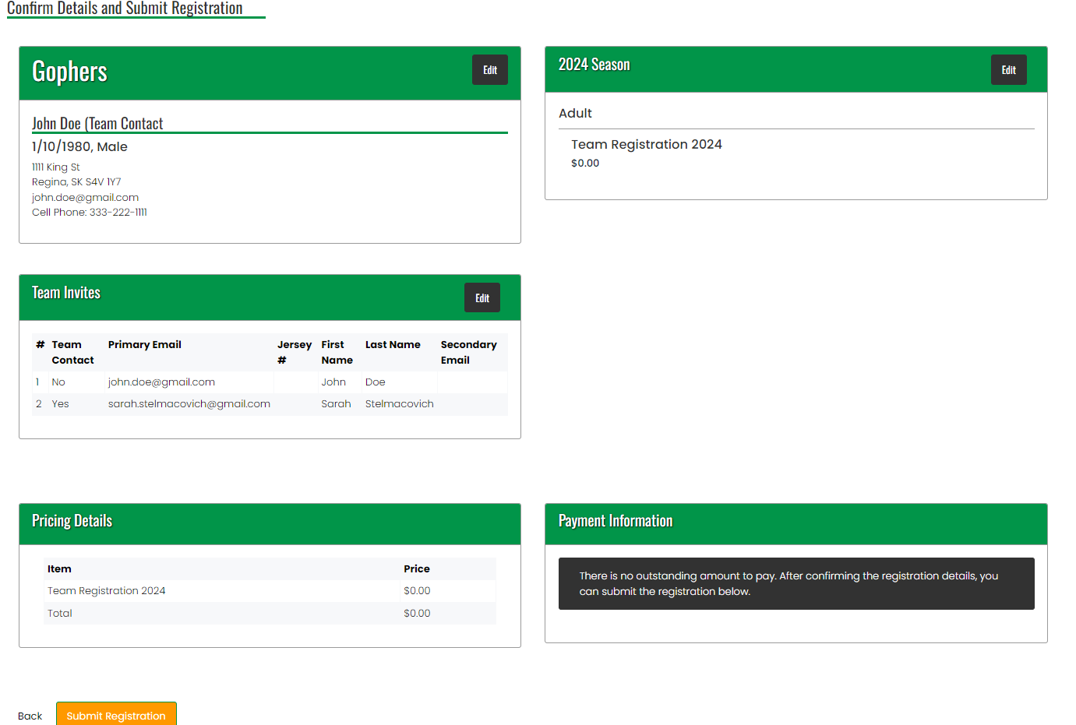

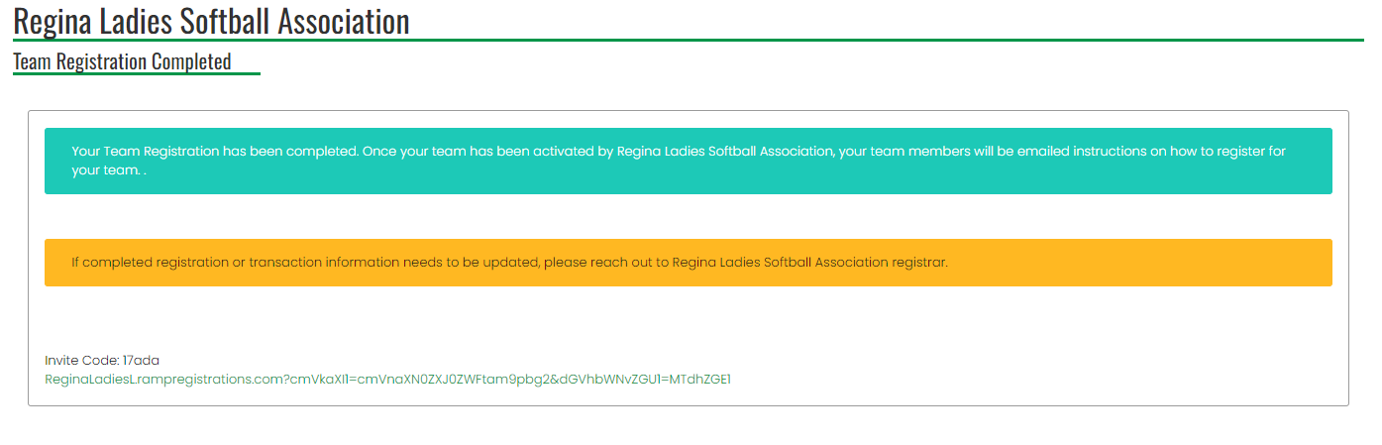

- You will get a confirmation email from RAMP stating your registration is complete.
  - Please let Sarah or Brenda know so we can then activate your team.

- Once the team is activated, you can then send out the individual emails for the team invites for their personal registrations.

  - To send out team invites, log back into the Regina Ladies Softball Association account created in step 1
  - Go to my teams, under my teams/permits tab.
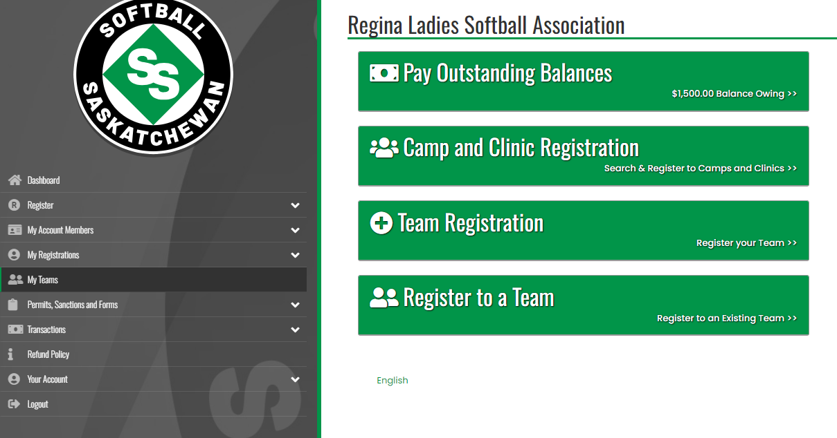

- Then go to manage teams. Here you can add the rest of your team invites to other players, coaches managers, etc.
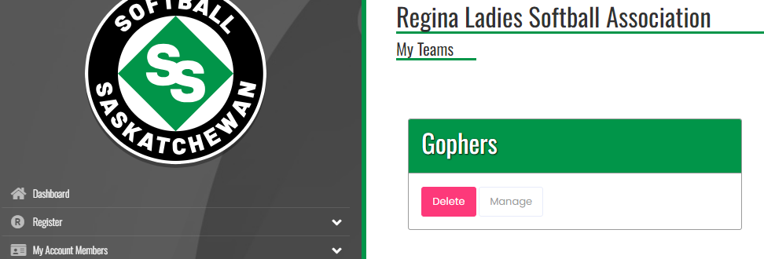

  - Be sure to select the current season (2024).

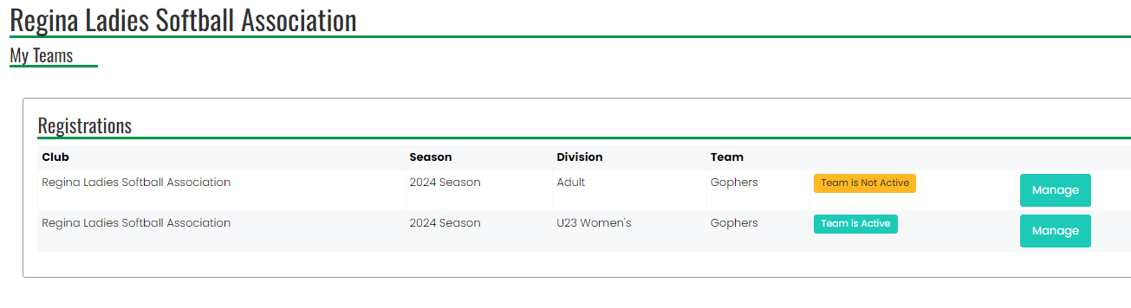

  - Click on send invites instead of update team invites when sending out the team invites to other players/coaches.
  - A confirmation message will pop up briefly saying emails will be sent out shortly.
  - Remind people to check spam/junk folders for team invites as the email will be from Regina Ladies Softball Association.

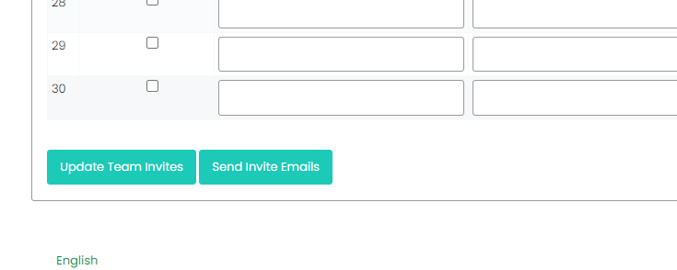

- A registration code will be sent out to each person on your team list, allowing them to register with that team.

