RLSA TEAM REGISTRATION HELP SHEET/ AFFILIATION INFORMATION 2026
- All teams are allowed to affiliate 20 players and 5 staff(coach/manager)
- Anyone listed as a coach, assistant coach or manager MUST have a Respect in Sport for Activity Leader - https://sasksrc.respectgroupinc.com/koala_final/
  - NOTE* SOFTBALL SASK DOES NOT ACCEPT RESPECT IN SPORTS FROM HOCKEY TAKEN BEFORE 2014.
- Per the 2026 season, Softball Sask now requires all coaches and staff who have players under the age of 18 on their team to have a valid criminal record and vulnerable sector act check.
- Players registered for a Regina Ladies League team must be turning 17 by the end of the current playing year (turning 17 by Dec 31/2026)
- If you have any difficulties with registering, please let Sarah or Brenda know when you are registering and we can provide you with assistance.
- Sarah Stelmacovich at 306-540-2009 or Brenda Anderson at 306-539-4943.
- Reminder to let Registrar know when team is registered so your team account can be activated before team invites are sent out to the rest of your players & staff.

The following are instructions for you and your team for the affiliation process through RAMP, the system Softball Sask is now using.
- All coaches, managers and players will have to create an account with ramp with this link for Regina Ladies Softball Association: https://www.rampregistrations.com/login?v3=7b80ef796d

- If you have a RAMP account from a previous sport (or prior RLSA team), please use that one.
- Please enter your Respect in Sport number when you register as a staff member.
- For those coaches or managers who are also players, you will have to register as both a STAFF and a PLAYER.
- A player can only be registered on one team in the Regina Ladies League.

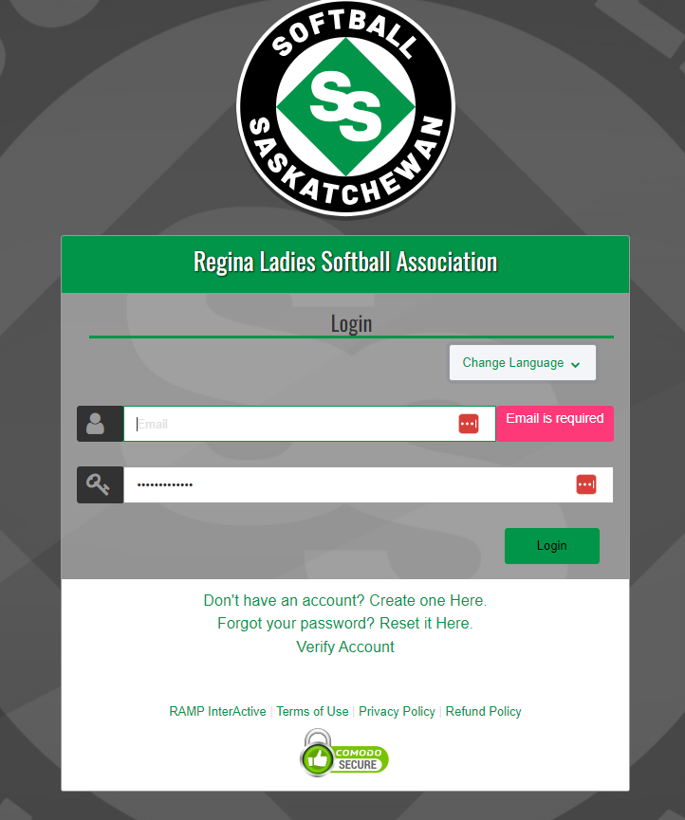

- Once account is created (you may be prompted to log in again), select Team Registration. Please select the age division for your team under division.
  - If you have U19 and adult players on the team – Please select ADULT as your division.
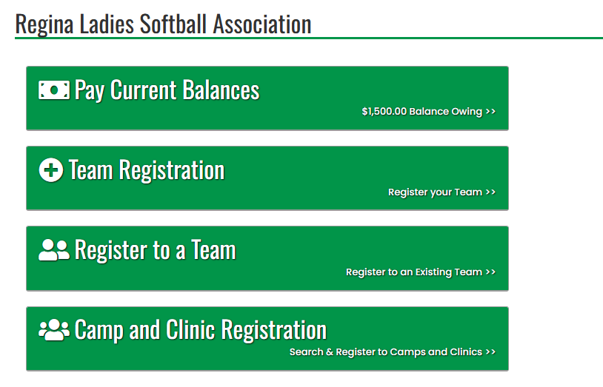
- If registering a new team:
  - create a Team Contact and Team name as prompted in the drop-down boxes.

- If reregistering a previous team:
  - Team name and Team contact should appear in the drop-down menus.

- Please select team package listed as $0 to continue with the team registration process. Fees will not be collected through RAMP.
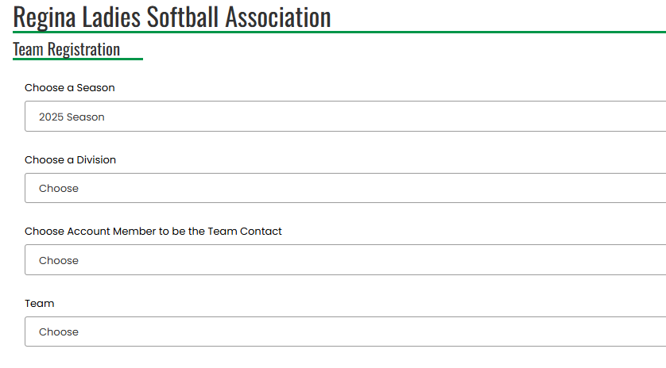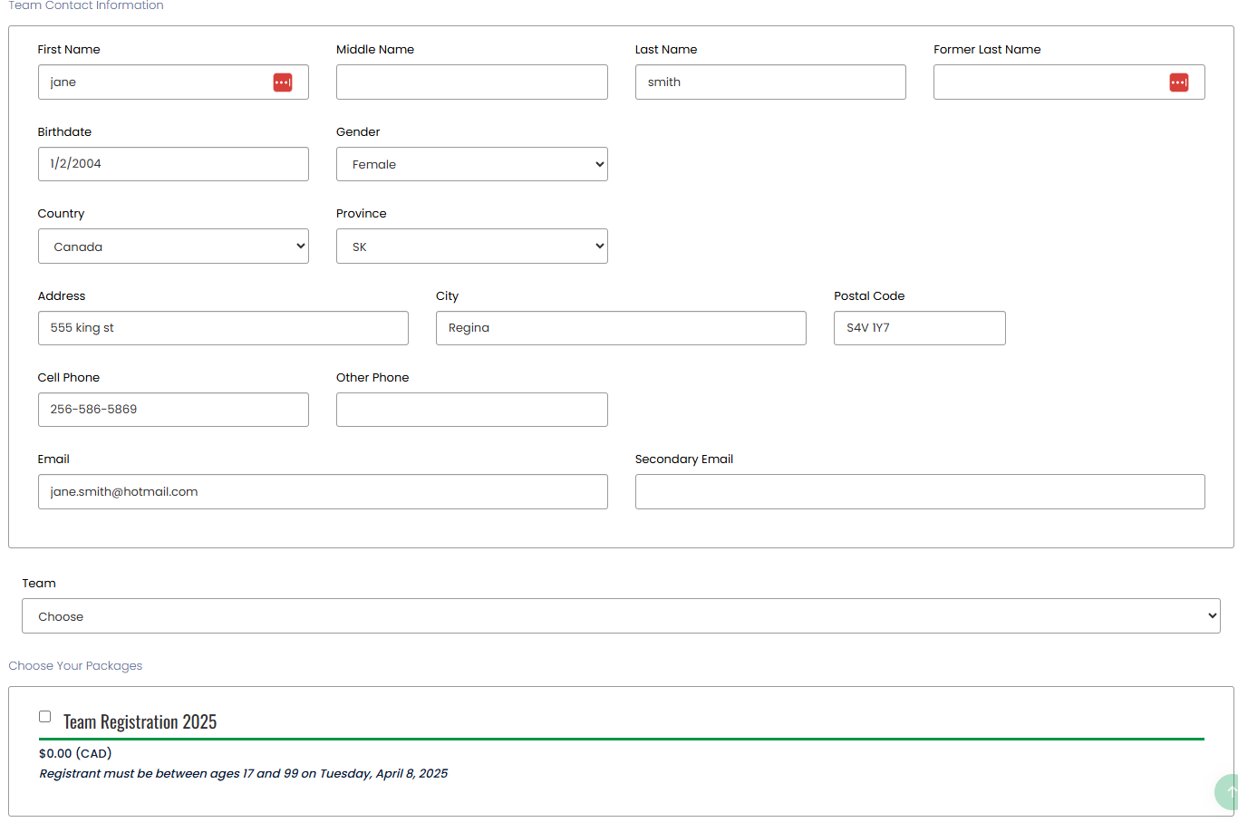
- Respect in sport numbers can be entered into secondary email for this year.

- The next page of the team registration will ask for team invites.
  - Here you can also choose who your main team contacts if you want more than one. Do not send out entire list of emails at this time, wait for confirmation of team registration.
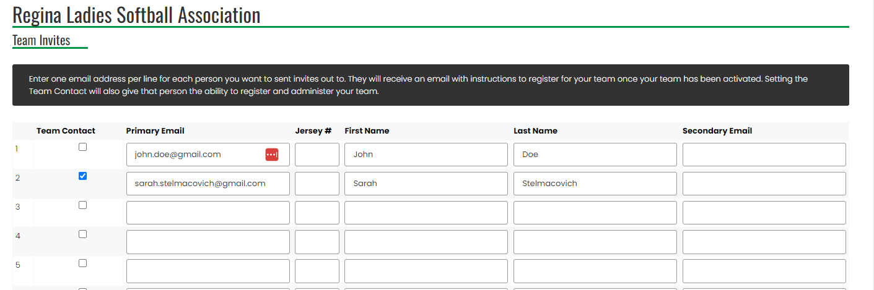
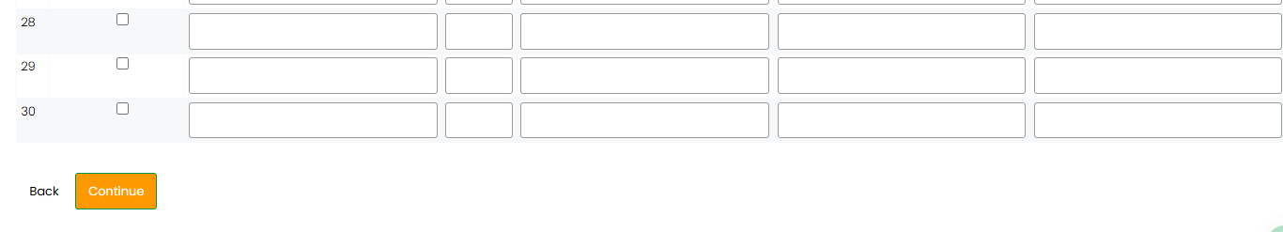
- The final Team Registration page should look like this, please hit submit registration.

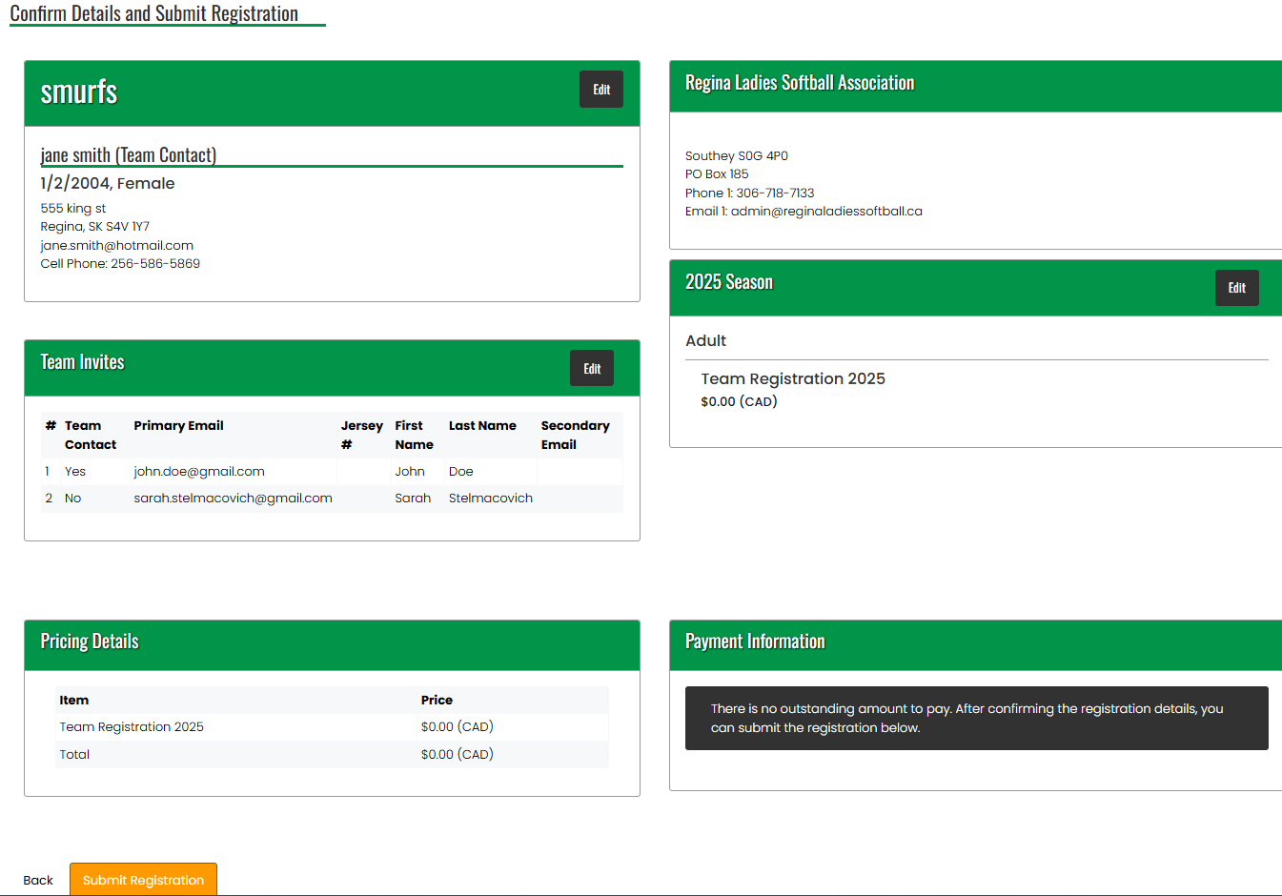

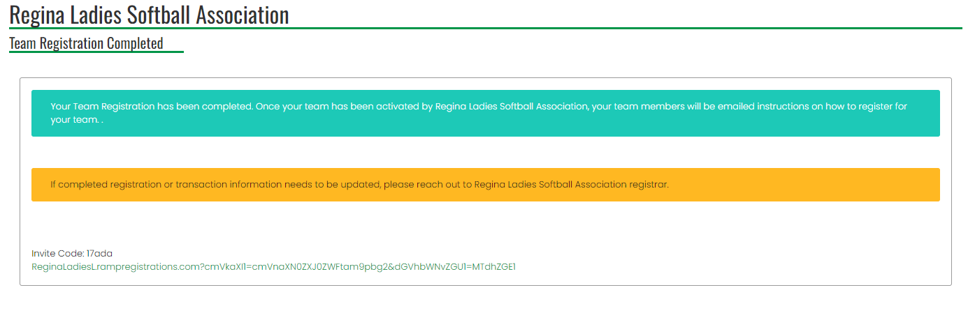
- You will get a confirmation email from RAMP stating your registration is complete.
  - Please let Sarah or Brenda know so we can then activate your team.
  - Sarah (306-540-2009) or Brenda (306-539-4943)

- Once the team is activated, you can then send out the individual emails for the team invites for their personal registrations.

  - To send out team invites, log back into the Regina Ladies Softball Association account created in step 1
  - Select my teams from side menu.
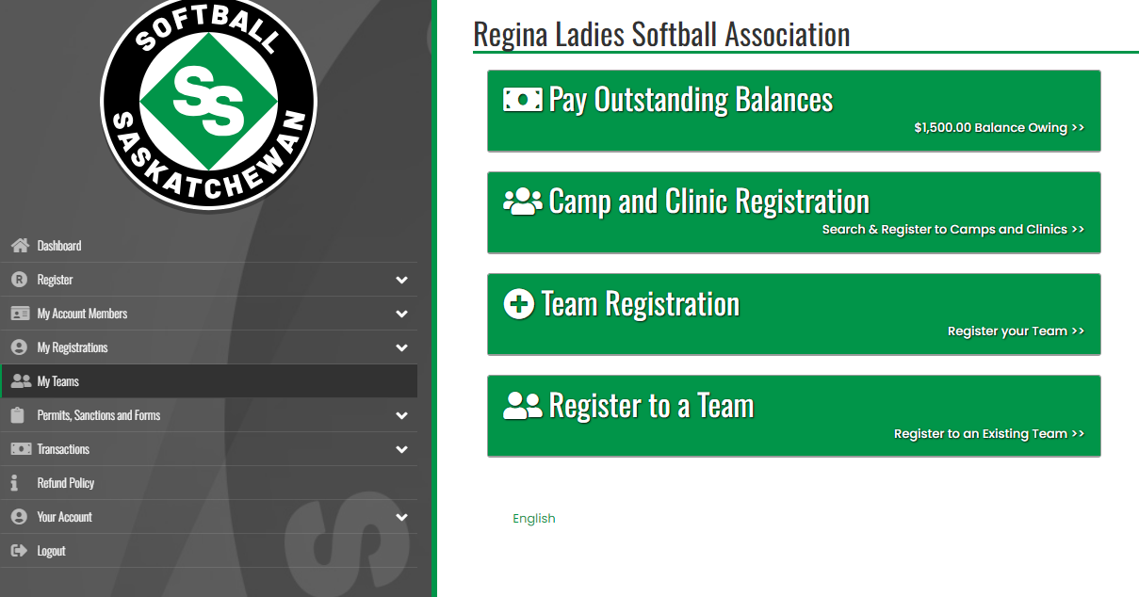

- Then go to manage teams. Here you can add the rest of your team invites to other players, coaches managers, etc.
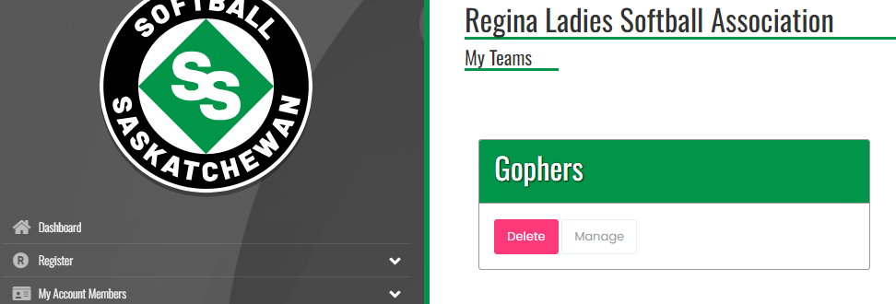

  - Be sure to select the current season (2026).
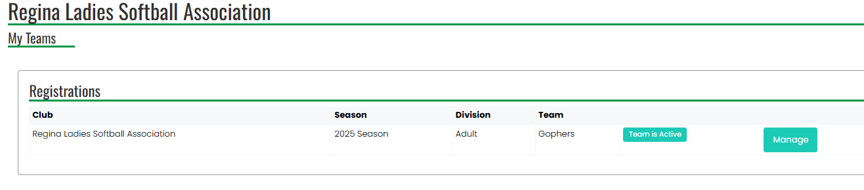
  - Click on send invites instead of update team invites when sending out the team invites to other players/coaches.
  - A confirmation message will pop up briefly saying emails will be sent out shortly.
  - Remind people to check spam/junk folders for team invites as the email will be from Regina Ladies Softball Association.

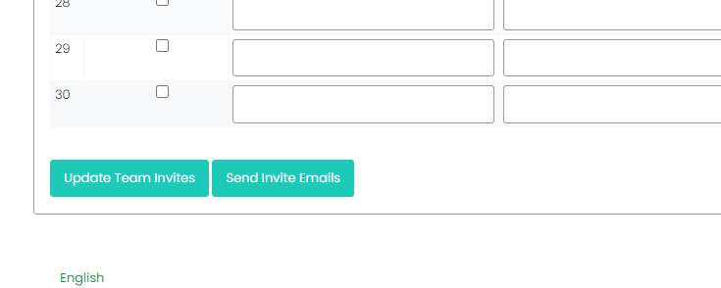

- A registration code will be sent out to each person on your team list, allowing them to register with that team.
  - Players and coaches must have their online registrations completed before being eligible to play/coach.

