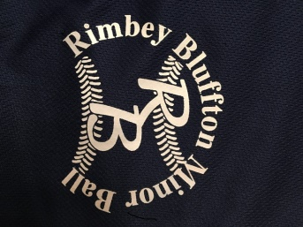
February 14, 2018
Thank you for your consideration of supporting Minor Ball in Rimbey/Bluffton. To continue the programs we are able to provide to the youth of Rimbey/Bluffton, we rely on continued corporate support. Rimbey/Bluffton Minor Ball has provided organized sport for children and youth within our community for numerous years.
This season we are expected to have almost 150 players register within our programs and we once again are seeking support through team sponsorship.
We do hope that this is something you might be willing to consider. Your sponsorship of Minor Ball will go a long way to supporting the health of youth in our community. We can provide you with further details and I would welcome the opportunity to speak with you further about this. I can be reached by email rimbeyblufftonminorball@gmail.com. Thank you for your time and consideration.

Yours in Sport,
Rimbey Bluffton Minor Ball

Rally Cap & Rookie $200
Community House Leagues: Mosquito, Peewee, Bantam & Midget $200
Competitive, AA Rays: Mosquito, Peewee, Bantam, Midget $300

