2025 Annual General Meeting for Rimbey Minor Soccer

DATE: April 15 2025 

***Current Rimbey Minor Soccer Board:***

| * President Christine Beermann) * Vice President - Vacant * Secretary/Registrar (Kim Rode) * Treasurer (Emily Peacock) * Equipment coordinator (Terri Gesselman) * Field Maintenance coordinator - Vacant * Technical coordinator (Leeann Cross) | * House league coordinator (Rachel Murray) * Ref Coordinator: (Rieki Solberg) * Competitive League coordinators (Maria Lee). * Website/Social Media Coordinator: (Vivian Goetz) |
| --- | --- |

**Board Positions still needing to be filled:**

| Vice President | Field Maintenance Coordinator |
| --- | --- |

***Agenda***

1. Welcome and Introduction of current board members and special guests
2. Review of the Past Year
   1. Indoor Soccer Update
   2. Team Success
   3. Ref Courses & Development
3. Financial Report
4. Update from CASA Director of Soccer Operations & Development, Jason Blake
5. Call for board members
   1. Field Maintenance Coordinator
   2. Succession planning
6. Upcoming Events & Plans for the Next Year
   1. Coach and Player development plans
   2. Technical Development May 10 U9-U13, house league coaches optional
   3. May 24/25 U11 tournament
   4. TBD for highway cleanup
   5. 2025 Indoor soccer registration
   6. Holly’s Greenhouse Fundraiser
7. Q&A and Member Input
8. Voting of specific adjustments to dissolution bylaw (see below) 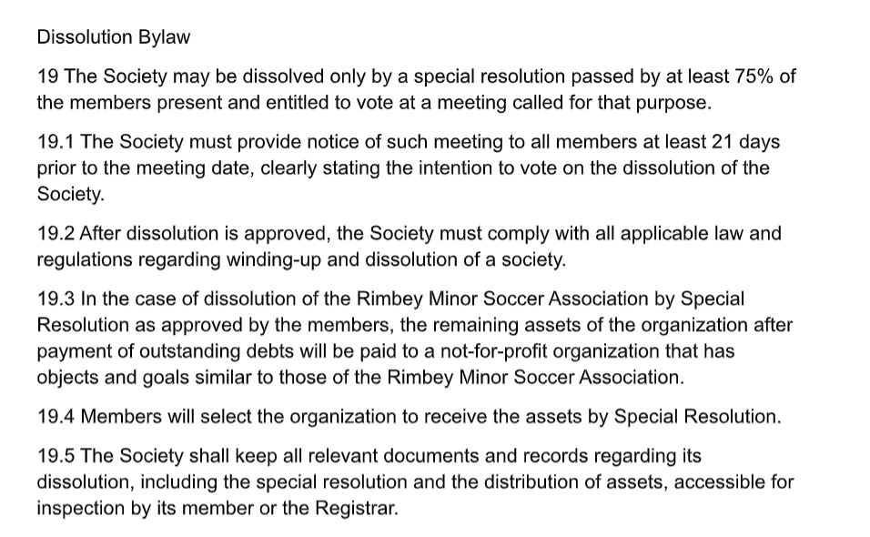
9. Closing Remarks