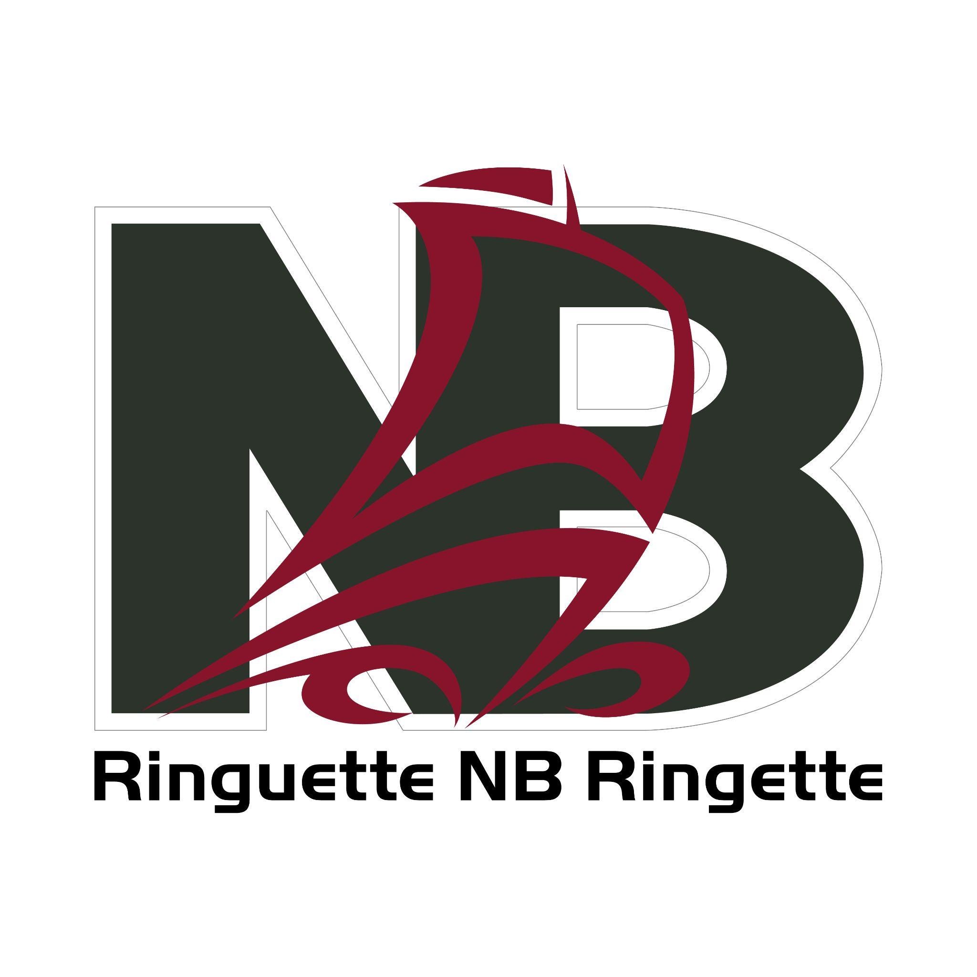
Form 13A

RNB COMPETITIVE TEAMS CODE OF CONDUCT

This Code of Conduct shall be received and signed as understood by every member (team staff and athletes) of a team representing NB at any Atlantic, Eastern or Canadian Ringette Championships or Canada Winter Games. It shall be co-signed by a parent or guardian in the case of a minor. Signed copies are to be returned to RNB prior to the competition and kept on file. Violations of this Code of Conduct are to be considered serious and shall be dealt with accordingly. In the case of a minor, an athlete may be returned home at the expense of the parent or guardian. Violations must be reported by team staff to RNB upon the team’s arrival home.
All individuals involved with a team representing NB will show leadership, responsibility and good character and abide by the following Code of Conduct:
- It is considered unethical for athletes, coaches, team managers and organizers to speak disparagingly about others involved in the Atlantic, Eastern or Canadian Ringette Championships or Canada Winter Games or activities associated with those tournaments.
- All team staff and athletes are expected to show respect for their opposing teams, officials and colleagues and shall avoid blatant humiliation of an opponent.
- Team staff and athletes are expected to aid in the orderly conduct of the competitions by respecting the authority of the officials on the ice and relating to them in a positive and respectful manner both on and off the ice.
- The use or possession of alcoholic beverages and non-prescription drugs while in attendance at competition or ceremonial functions is prohibited. Any violation shall be dealt with in a strict and serious manner.
- Any malicious damage to accommodation sites, transportation vehicles, etc. or personal misconduct causing harassment to participants or audience during games will not be tolerated. In all cases, damage to property will be the responsibility of the individuals at fault. (In the case of minors, it shall be the responsibility of the parents or guardians).
- Any misconduct of the nature mentioned above at Canadian Ringette Championships will be dealt with by Ringette Canada. Results of misconduct could be one or more of the following:
  - Disqualification from Nationals for one year.
  - Further suspension by RNB.
  - Fine.
  - In the case of illegal drug use, suspension or banishment from Ringette
- RNB reserves the right to return an athlete home, at its own expense, if the violation of any of the above code’s warrants.
By signing, I acknowledge that I have read the above and agree to abide.

Date ____________________________ Team Staff ____________________________________
PRINT NAME & SIGNATURE

Athlete ___________________________ Parent/Guardian _________________________________
PRINT NAME
PRINT NAME
___________________________ _________________________________
SIGNATURE
SIGNATURE

