Coaches attending: __________________________________ # athletes [x skaters] [x goalies]

Equipment: ________________________________________ [period & competition phase]

Practice Objectives: non-goalies | Practice Objectives: goalies

Practice Part/Timing | Description/Teaching Points | Diagram/Location
Introduction  7:00-7:05 | Objectives of the practice/reminders/ questions for athletes | Dressing room before practice

Practice Part/Timing | Description/Teaching Points | Diagram
Warm-up  7:30-7:35  [drill title] | Drill description  - Key teaching points  - Key execution points  Goalie information  [switch out full ice and half ice diagrams as needed] | 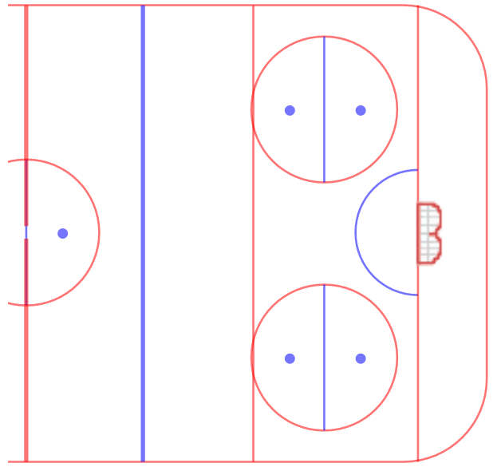

Practice Part/Timing | Description/Teaching Points | Diagram
Warm-up  7:35-7:40  [drill title] | Drill description  - Key teaching points  - Key execution points  - Goalie information | 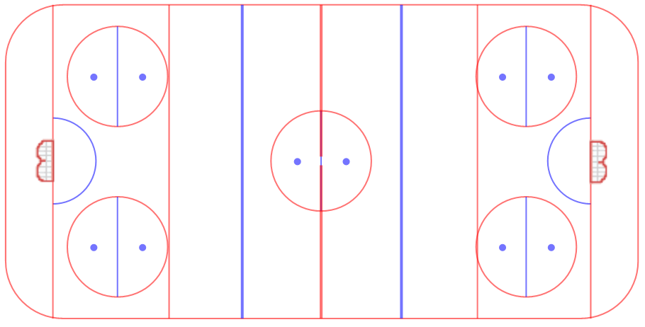

DON’T FORGET TO ADD HYDRATION BREAKS/STRETCHING

Practice Part/Timing | Description/Teaching Points | Diagram
Main Part  7:40-7:55  [drill title] | Drill description  - Key teaching points  - Key execution points  - Goalie information | 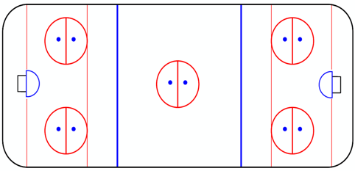

Practice Part/Timing | Description/Teaching Points | Diagram
Main Part  7:55-8:10  [drill title] | Drill description  - Key teaching points  - Key execution points  - Goalie information

Practice Part/Timing | Description/Teaching Points | Diagram
Cool-Down  8:25-8:30  [drill title] | Drill description  - Key teaching points  - Key execution points  - Goalie information

Practice Part/Timing | Description/Teaching Points | Diagram/Location
Conclusion  8:30-8:35 | Recap of practice/notice of upcoming events | Dressing room after practice

