Universal Athlete Assessment
Skills Testing Protocol

Learning to Train (L2T) & Train to Train (T2T)
Developmental Stages

Updated August 2015
Introduction
The following Skills Testing Protocol (STP) is based on the Ringette Technical Skills Matrix for the Learn to Train and Train to Train stages in the Ringette Long-Term Athlete Development (LTAD) Framework.
The protocol can be easily applied by any association in a timely fashion to objectively and consistently assess athlete’s core ringette skills.
There are no evaluators required. All measurement is conducted objectively by either measuring “how fast?” or “how many?” therefore those running the testing sessions are not “evaluating” skill but rather simply recording results. There is less experience required of those running the test session and little room for real or perceived bias.
Why?
The data is being collected, using this protocol, for the following reasons:
1. The measures are objective and the tests can be accurately replicated. The data will help assess current state and show progress from skill introduction, acquisition, consolidation and refinement over time. Measuring will reinforce the critical impact of quality practice.
2. The data collected and indications of change over time will be one tool associations may use to measure coaching effectiveness.
3. The data will give Ringette Alberta and local associations valuable information on how to support coaches in their efforts to improve the skills of their players over each season.
4. The data will help minimize the reliance on chronological age in these stages (where growth is rapid) to place athletes in programs that are best suited to their development at any given moment in time
5. Collecting the averages and norms for all athletes across the province can be used to help establish competitive equity among teams.

When to Test
It is strongly recommended that the STP be conducted three (3) times over the course of a year: at the start of the season (to act as a benchmark); at mid-season; and near the end of the competitive season. This will allow coaches and players to evaluate progress over the course of an entire season. It is important to resist the urge to skip the mid-season testing as this assessment will provide data that can be acted upon during the second half of the season. Failing to do this mid-season test can leave gaps in skill development unaddressed.
Skills testing at the start of the season is best conducted association-wide. The mid season and end of season tests can be done on a team by team basis and even be done with only one or two stations per practice session.
Measuring Growth
Included in the skill development testing is also a simple measurement of the athlete’s height. When a coach is developing any type of physical training for an athlete, the developmental age must be accommodated. The coach and parents will need to work collaboratively to ensure growth is accurately tracked on a quarterly basis; therefore, Ringette Alberta strongly recommends that parents measure their child’s growth during the off-season to ensure data are being collected on a three-month basis. Standing height, seated height and arm span are the three most important measurements as they are indicators of different stages of growth.
Generally, legs will grow fastest first, followed by the arms and then the torso. When evaluating an athlete’s skills test scores it is important to consider the athlete’s rate of growth as this will have an impact on the athlete’s body awareness and coordination. This may reduce her ability to perform the tests and may result in lower scores relative to earlier testing. This is important information to tell the athlete to ensure she is not discouraged and for the coach to know when selecting particular drills to develop skills. Most importantly, the growth rate will indicate to coaches necessary changes in training to take advantage of windows of opportunity to train different systems such as speed, suppleness and strength. Missing these windows of opportunity will permanently limit an athlete’s ability to reach her full potential. Coaches must adapt training programs for each individual athlete based on individual athlete growth measurements.
For further information regarding this topic and how to conduct proper growth measurements, visit Canada’s Sport for Life website
http://www.canadiansportforlife.ca/resources/role-monitoring-growth-ltad

Testing Stations
Station 1: Forward & Backward Speed Skate
Station 2: Agility Weave with a Ring
Station 3: Parallel Start & Stop
Station 4: Butterfly Transitional Skate

Materials & Equipment Required

- Stopwatches
- Whistles
- Clipboards & Pens
- Spray Paint
- Measuring Tape (for back up only)
- Small Cones
- Rings
- Athlete Score Sheet
- Pre-Measured Station Ropes
- Snow Shovel

Master Rink Diagram
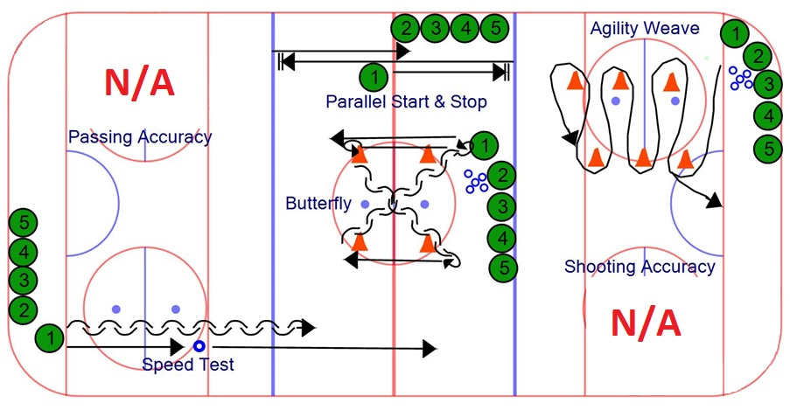
Safe Zones

The shaded areas represent the safe zones within which the athletes at each station must remain. This is particularly important for the athletes participating in the Speed Test, Parallel Stop and Start, and Butterfly.

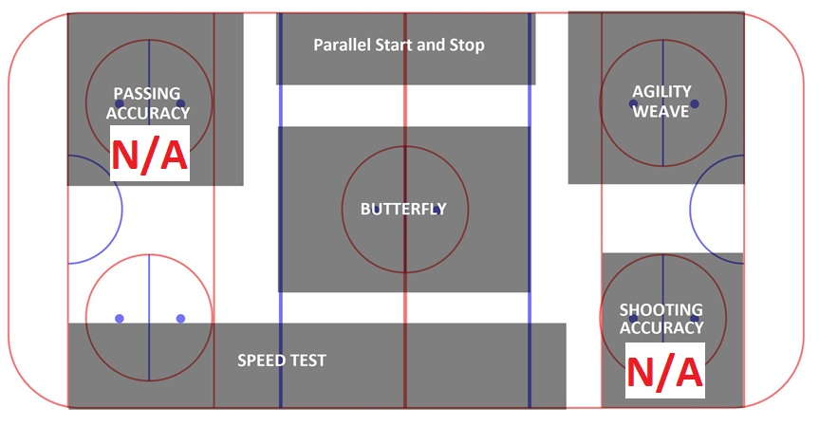
Station 1
SET UP - Forward & Backward Speed Test
- Step 1 – Mark the Distance
  - Volunteer 1 – hold one end of the pre-measured rope provided on the goal line approximately 15’ from the side boards. This is the starting line.
  - Volunteer 2 – extend the rope so that it is taut and parallel to the side boards. The rope provided is marked at 50’ and 100’. Keep the rope taut and on the ice.
  - Volunteer 3 – ONLY when the rope is parallel to the side boards and taut, with the spray paint, make a “dot” at the 50’ and a line at the 100’ mark perpendicular to the rope. The 50’ dot will be used for Step 2 below and need not be any larger than about the size of the ring. The line for the 100’ mark should be approximately 10’ in length
- Step 2 – Placement of the rings
  - Volunteer 1 – place one ring aligned with the line of travel on the white ice on the dot at the 50’ mark. Place four other rings against the boards beside this dot for quick set-up between trials.

Equipment Required:
- Stopwatch
- Spray paint
- Pre-Measured rope (100’ long)
- Athlete score sheet

TIME  8 min | Description  Reaction Time, Forward Acceleration & Sprint Speed & Backward Acceleration & Sprint Speed
Execution:
- The assistant on the starting goal line will loudly and clearly announce the countdown: “three, two, one, go” and simultaneously concisely drive one straightened arm from above the head towards the hip on each numerical count to ensure the timer at the finishing line is clear as to when to start the stopwatch.
- With the stopwatch in hand, the timer/recorder stands next to the finish line and will start the stopwatch when s/he hears the word “go” and sees the arm finishing the last vertical drive of the hand towards the hip.
- The athlete stands behind the goal line (toes cannot cross the line) and faces in the direction of travel (i.e. down the length of the ice for forwards or towards the end boards for backwards).
- The athlete must not start any movement until the word “go” has been vocalized.
- On the word “go” the athlete will sprint forward, spear the ring at the 50’ mark and then continue to sprint past the finishing line at the 100’ mark.
- The timer/recorder at the finish line will stop the watch when the first skate makes contact with the finish line.
- Record time rounded up to the nearest 1/10th of a second.
- The athlete will complete the test twice skating forwards and twice skating backwards (no ring for backward trials).
- The fastest time between the two trials (i.e., one forward, one backward) will be the official times.
Key Points:
- The assistant commanding the start must project loudly, clearly and consistently to ensure the athlete and timer are starting at the exact same time.
- If the athlete has a false start she will be given one (1) extra trial. Further false starts on subsequent trials will result in no time being recorded for that trial marked as “FS” (“False Start”).
- Encourage the athlete to skate as hard as possible through the finish line and to not slow down prematurely at or before the marked line.
- Athletes must respect the ‘safe zone’ upon their completion of each trial and return to the starting line without entering another test’s zone.
- An athlete needs sufficient rest. Have the athletes follow a specified order to ensure adequate recovery time.

Station 1
Forward & Backward Speed Test

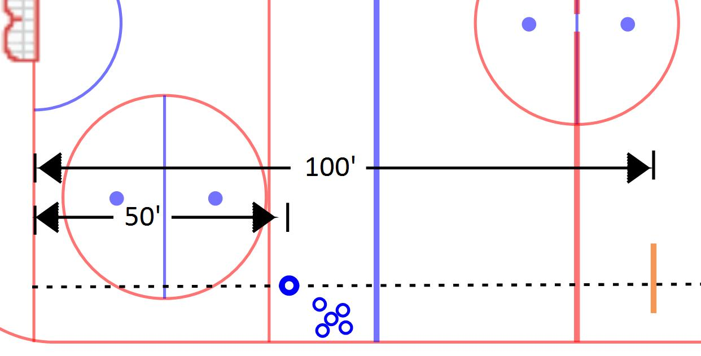

Station 2
Agility Weave with a Ring
SET UP
- Orientation – as viewed from the perspective of the goaltender standing in the crease facing centre ice

- Step 1 – Build the left side column of pylons
  - Volunteer 1 –find the exact intersection of the goal line and the location where the right side goal post would be (the net should not be in place)
  - Volunteer 1 – place the “start” end of the rope on the ice at the intersection of the goal line and location of the right side goal post
  - Volunteer 2 – extend the rope down the ice so that the rope creates a straight line that is perpendicular to the goal line. Hold the rope on the ice taut while volunteer 3 marks the appropriate pylon locations. Volunteer 4 can help “eyeball” the rope to ensure it is perpendicular to the goal line
  - Volunteer 3 - with the spray paint provided, spray a small dot approximately the size of a tennis ball on the ice to indicate the location where each (of the three) pylons will be placed. Tape has been wrapped around the rope in the locations where the pylons for the left side column of the layout are to be positioned.
  - Volunteer 3 –place the pylons on the ice where marked with the spray paint

- Step 2 – Build the right side column of pylons
  - Volunteer 2 – with volunteer 1 still holding the start end of the rope in its original location, extend the rope along the goal line towards the right side boards
  - Volunteer 3 – place a finger on the ice to indicate the start location for the right side column. This mark will be 15’ from the right side goal post on the goal line and is indicated by the tape at the 15’ mark on the rope.
  - Volunteer 1 – move to place the start end of the rope on the ice at the location indicated by volunteer 2
  - Volunteer 2 – extend the rope down the ice so that the rope creates a straight line that is perpendicular to the goal line. Hold the rope taught on the ice. Volunteer 3 can help “eyeball “ the rope to ensure it is perpendicular to the goal line
  - Volunteer 3 - with the spray paint, spray a small dot approximately the size of a tennis ball on the ice to indicate the location where each (of the three) pylons will be placed. Tape has been wrapped around the rope in the locations where the pylons for the right side column of the layout are to be positioned.
  - Volunteer (all) – place the pylons on the ice where marked with the spray paint

- Step 3 – Mark the start line
  - Using the spray paint, mark a line that is perpendicular to the goal line. The line will extend from the start location of the right side column (where volunteer 1 held the rope to build the right side column) back to the boards behind the goal line. Be careful not to spray the boards.

- Step 4 – Mark the finish line

Equipment Required:
- One (1) stopwatch
- Six (6) cones
- Spray paint
- Two (2) rings
- Pre-Measured rope
- Athlete score sheet

TIME  8 min | Description  Agility Weave While Carrying the Ring
Execution:
- The assistant/recorder will announce: “Three, two, one, go.” On the word “go” the athlete skates forward in a weave pattern around the cones while carrying a ring.
- The athlete will do a tight turn around the sixth (6th) cone until she is facing in the direction she just came from and then continue to skate the same weaving pattern back through the cones to the finish line.
- The assistant/recorder will stop the watch when the athlete’s first skate makes contact with the finish line.
- The athlete is to skate around the cone first with the ring following behind her.
- The assistant/timer will record the time rounded up to the nearest 1/10th of a second.
- Each athlete will perform two (2) trials with the fastest trial being the official time.
Key Points:
- The athlete wants to complete the drill as quickly as possible.
- If the athlete has a false start she will be given one (1) extra trial. Any false starts on subsequent trials will result in no time being recorded for that trial (mark “False Start”).
- The athlete should be protecting the ring by always having her skates pass each cone before the ring does (i.e. cone, body, ring). The athlete cannot lead with the ring. If the ring goes around the cone before the athlete’s skates, the athlete needs to go back and repeat the turn around that particular cone.
- If the athlete misses a cone she must go back and go around the cone.
- If the athlete accidentally drops the ring during the trial encourage her/him to go back and pick it up and continue to complete the trial as quickly as possible to receive a time.
- The athlete should be doing tight turns around each cone utilizing her inside and outside edges on both feet and wants to be accelerating out of each turn with the use of crossovers.
- An athlete needs sufficient rest in between each trial. Have the athletes follow a specified order to ensure adequate recovery time.

Station 2
Agility Weave with a Ring

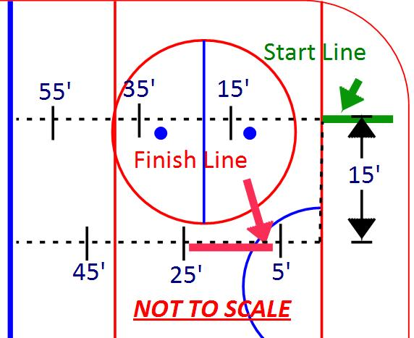

Station 3
Parallel Stop & Sprint Test
SET UP
- Orientation – on the side of the ice surface between the agility weave and the passing accuracy stations
- Step 1 – Mark the Distance
  - Volunteer 1 – Approximately 15’ from the side boards hold the middle of the rope provided on the centre ice red line. The middle of the rope will be indicated by a band of red tape.
  - Volunteer 2 and 3 – extend the rope towards opposite blue lines so that the rope is parallel to the side boards. Locate the bands of tape around the rope which represents 25’ from the centre line (in some ice rinks these bands of tape will be found to intersect the blue lines). Keep the rope taut and on the ice. Do not move the rope!
  - Volunteer 1 – ONLY when volunteer 2 and 3 have located their marks and the rope is taut and parallel to the side boards, proceed to the location of volunteer 2 and spray paint a line parallel to the blue line. The spray painted line should be approximately 10’ long as the athletes will be repeatedly stopping on this line so the centre of it will eventually disappear; therefore, it must be long enough to not to be “erased” during the test
  - Volunteer 1 – repeat for the other end of the rope
- Step 2 – Mark the “no go” zone
  - Volunteer 1 – Spray paint a line between the two blue lines that is approximately halfway between the side boards and the centre ice face-off circle to indicate where the athletes must stay with-in

Equipment Required:
- One (1) stopwatch
- Spray Paint
- Pre-Marked rope
- Athlete score sheet
- Shovel (if running testing sessions back to back)

TIME  8 min | Description  Forward Starts, Acceleration, Lateral Movement, Deceleration and Parallel Stops
Execution:
- The timer stands next to the boards facing the athlete and will count down: “Three, two, one, go.”
- Two assistants should be standing by a blue line (or painted line) next to the boards to ensure the athlete makes full contact with the line and comes to a complete stop.
- On the word “go” the athlete skates as fast as she can to the blue line on her right. Both feet must make contact with the line and she must come to a complete stop facing the sideboards (i.e. facing the same direction as she started). The athlete then skates as fast as she can to the far blue line, both feet must make contact and she must come to a complete stop facing the sideboards. The athlete finishes the test by sprinting back over the centre line.
- The timer will stop the time when the first foot makes contact with the centre line.
- The timer will record the time rounded up to the nearest 1/10th of a second.
- Each athlete will perform the test three (3) times with the top two times counting. The first two trials shall be started in different directions (left/right). The athlete may decide which way to start for the third trial.
Key Points:
- The athlete wants to complete the drill as quickly as possible.
- The athlete may use crossing over at the takeoff or turning and performing an open pivot to start.
- Encourage the athlete to sprint over the centre line to complete the test and to not begin decelerating until after she has crossed the line.
- The timer should be facing the athlete to ensure she is starting directly over top of the line and can clearly hear the instructions.
- If the athlete has a false start she will be given one (1) extra trial. Any false starts on subsequent trials will result in no time being recorded for that trial (mark “False Start”).
- An athlete needs sufficient rest in between each trial. Have the athletes follow a specified order to ensure adequate recovery time.

Station 3
Parallel Stop & Start Test

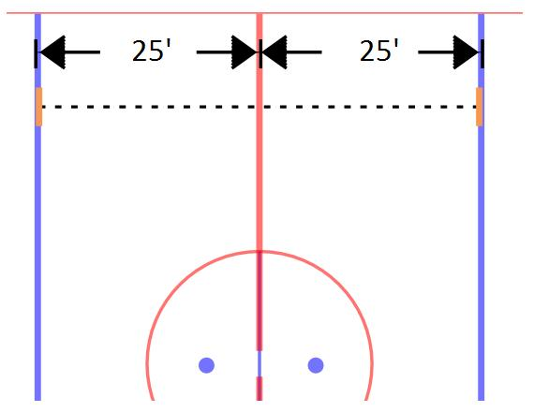

Station 4
SET UP - Butterfly Transitional Skate
- Orientation – as viewed from the perspective of a goaltender standing in the crease facing centre ice
- Step 1 – Obtain the rope from the speed test volunteers after they complete their set up
- Step 2 – Determine the location of the first two cones
  - Volunteer 1 and Volunteer 2 each take an end of the rope provided
  - Volunteer 1 – proceed to the right side hockey face-off dot located outside of the far blue line
  - Volunteer 2 – proceed to the left side hockey face-off dot located outside of the near blue line
  - Volunteer 1 and 2 – extend the rope so that it bisects volunteer 1’s and volunteer 2’s face off dots.
  - Volunteer 3 – using the spray paint, spray a small dot, approximately the size of a tennis ball, on the ice in the two locations where the rope intersects the centre ice free pass circle
- Step 3 – Determine the location of the second two cones
  - Volunteer 1 – proceed to the left side hockey face-off dot located outside of the far blue line
  - Volunteer 2 – proceed to the right side hockey face-off dot located outside of the near blue line
  - Volunteer 1 and 2 – extend the rope so that it bisects volunteer 1’s and volunteer 2’s face off dots.
  - Volunteer 3 – using the spray paint provided, spray a small dot, approximately the size of a tennis ball, on the ice in the two locations where the rope intersects the centre ice free pass circle
- Step 4 – Placement of the cones
- Volunteer 1 and 2 - place a cone on each of the four dots that are now marked on the centre ice free pass circle
- Step 5 – Marking the start and finish lines
  - Volunteer 3 – using the spray paint, make a start/finish line of approximately 3’ in length starting at each cone on the circle and moving outwards towards the side boards. Each line must be parallel to the centre red line.
Equipment Required:
- One (1) stopwatch
- Four (4) cones
- Rope from the speed test
- Spray paint
- Athlete score sheet

TIME  8 min | Description  Agility & Transitional Speed Within a Confined Space
Execution:
- The athlete starts behind the start line at the bottom right cone facing forward (i.e. in the direction of travel) in athletic stance.
- The assistant/recorder will announce: “three, two, one, go”. On the word “go” the athlete skates forward to the top-right cone, pivots and then skates backwards to the bottom–left cone, pivots and skates forwards to the top left cone, pivots and skates backwards to the bottom-right cone, pivots and skates (sprints) past spray painted line drawn next to the top right-cone to finish the drill.
- After the assistant/recorder has started the drill, s/he will skate up to the finish line to ensure accurate timing. The time is to be stopped when the first skate makes contact with the finishing line.
- The assistant/timer will record the time rounded up to the nearest 1/10th of a second.
- After all the athletes complete one trial from the bottom right, repeat the sequence starting from the bottom-left.
Key Points:
- Each athlete must complete two (2) trials: once clockwise and once counter clockwise with the average being the official time. (Note: should an athlete fall during a trial, the faster time of the two trials will be used – the fall should be recorded on the scoring template as an “F”).
- A cue to help the athletes follow the correct pattern is to remind them to always face the same direction (i.e., “always face the clock” or “stay square to the end boards”).
- An athlete must transition from forwards to backwards and backwards to forwards around the cone and not in between the cones.
- Should the athlete accidentally fall, encourage the athlete to get up as quickly as possible and continue to complete the trial to receive a time. Only record the time if it is the faster of the two trials, otherwise record an “F” on the scoring template.
- If the athlete has a false start she will be given one (1) extra trial. Any false starts on subsequent trials will result in no time being recorded for that trial (mark “False Start”).
- An athlete needs sufficient rest in between each trial. Have the athletes follow a specified order to ensure adequate recovery time.
Station 4
Butterfly Transitional Skate
