Notes:

Need pylons, rings, 4 small nets

Shooter tutors (no goalies)

20-23 skaters

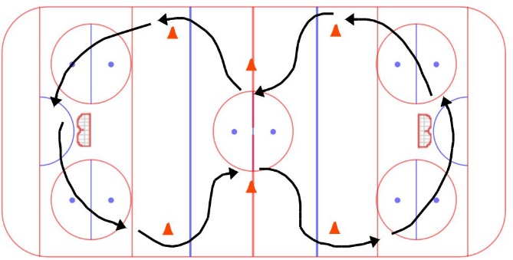4 on-ice coaches, 4 bench coaches, 1 timekeeper

# Warmup – 5-7 minutes

**Butterfly - wide:**

* Crossovers/cut towards the middle at pylons
* change direction part way through

STRETCH – coaches lead stretch, in motion, remove pylons

# Passing – 5-7 minutes

**Partner passing:**

* Coaches put out rings in a line so the partners can find them and start passing
* Facing your partner, not too far apart
* Forehand, backhand

**coaches can set up pylons for next drills during this time!

# Ring control & shoot – 10-12 minutes

**Ring control, pass, shoot:**

* Out of both ends same time. With no goalies, the next skater can go as soon as the player in front of them makes the pass to the coach
* Skater protects the ring around 2 pylons, passes to a coach over the blue line, then cuts in front of the coach for a return pass over the blue line.
* Shoot on net, and get back in line.
* Switch corners part way through.

# 1v1 Battle – 5-7 minutes

* Shape

  Description automatically generatedPinny colours can be the same or different at each circle
* Athletes line up outside the circle
* On the whistle the first two race for the ring and whoever doesn’t get it is the checker, the other one should protect the ring.
* They must stay inside the circle
* On the next whistle, the first two drop the ring and exit on the FAR SIDE of the circle, while the next two in line race for the ring
* Try to rearrange pairings so nobody goes against the same person twice.
* This can be tiring, so don’t leave it too long between whistles.
* 3-4 pairs per circle, use all 5 circles if need be. (6-8 athletes at each circle)

# Scrimmage – 20-25 minutes – half ice

* Small nets
* See setup diagram below, same for both ends. Pass over the ringette line.
* 90 second shifts, change on buzzer, whoever had the ring leaves it where it was
* All skaters must reach the bench before the next line can leave the bench
* Keep the bench organized – two teams on each bench
* Coaches acting as referees will get the ring and place it on one of the passing dots and start from there when everyone is on the ice. NO RING RACES.
* Coaches act as goalies, distribute rings after saves and goals
* No real penalties, but there may be a change of possession if an infraction occurs

