Notes:

Need pylons, rings, 4 regular nets

Shooter tutors (no goalies)

20-23 skaters

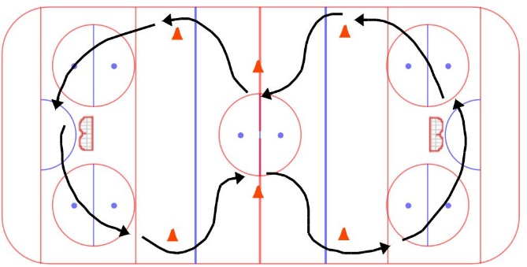4 on-ice coaches, 4 bench coaches, 1 timekeeper

# Warmup – 5-7 minutes

**Butterfly - wide:**

* crossovers at pylons
* change direction part way through

STRETCH – coaches lead stretch, in motion, remove pylons

# Passing – 5-7 minutes

**Partner passing:**

* Facing your partner
* Spaced out approx. from faceoff dot to faceoff dot
* Forehand, backhand, and moving back and forward

**coaches can set up pylons for next drills during this time!

# Ring control & shoot – 10-12 minutes

**Mini breakout:**

* Opposite corners go at the same time. With no goalies, the next skater can go as soon as the Coach returns the pass to the skater in front of them
* Skater protects the ring around 3 pylons, passes to a coach at centre, then breaks up the ice to get a return pass.
* Chart

  Description automatically generatedShoot on net, and get in line in the opposite corner. Change corners part way through.

# 1v1 from corner – 10 minutes

**1v1 from corner:**

* Divide groups by pinny colour, half at each end.
* Change corners part way through so they practice pivoting both directions
* F cuts around pylon and drives to the net for scoring change
* D defends F by challenging ring carrier and channeling wide or checking
* Skaters should change lines and coaches should try to have them up against different opponents each time
* Diagram

  Description automatically generatedMust stay on their half of the zone. The goal is to engage the defender.

# Scrimmage -25-35 minutes – half ice (or cross-ice)

* See setup diagram below, same for both ends. Pass over the ringette line.
* 90 second shifts, change on buzzer
* All skaters must reach the bench before the next line can leave the bench
* Keep the bench organized – two teams on each bench
* Coaches acting as referees will get the ring and place it on one of the passing dots and start from there when everyone is on the ice. NO RING RACES.
* Shooter tutors, but coaches nearby for ring distribution, or goalies if there are any
* After a goal, there can be a free pass or a coach/goalie can distribute the ring
* No real penalties, but there may be a change of possession if an infraction occurs

