Notes:

Need pylons, rings, 4 regular nets

Shooter tutors if there are no goalies

20-23 skaters

4 on-ice coaches, 4 bench coaches, 1 timekeeper

# Warmup – 5-7 minutes

**Butterfly - long:**

* Stretching down the middle
* Along the sides, can be “go hard”, “backwards”, etc.
* Should turn in a different direction each time

STRETCH – coaches lead stretch, in motion, remove pylons

# Passing – 5-7 minutes

**Partner passing:**

* Facing your partner
* Spaced out approx. from faceoff dot to faceoff dot
* Forehand, backhand, and moving back and forward

# Ring control & shoot – 10-12 minutes

**Cut the pie:**

* This can go out of all 4 corners
  + (if there aren’t enough coaches, you could do this out of one side for a while then switch to the other one)
* 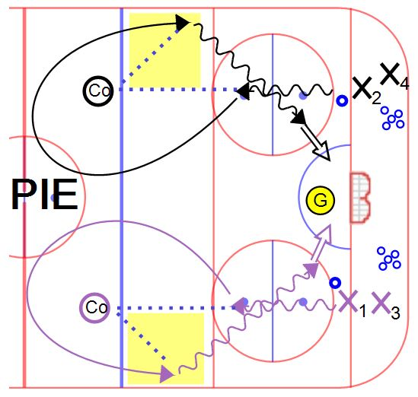A coach (or player) on the faceoff dot outside the blue line
* X1 takes a few hard strides then passes to the coach. X1 then cuts towards the centre circle and back to the boards just inside the blue line to receive a return pass from the coach (inside out pattern)
  + X1 then cuts through the faceoff dot and takes a hard shot on net.
* If there are goalies, watch the timing from both corners so the goalie isn’t getting two shots at once.
* Shoot on net, and get in line in the opposite corner

# 1v1 Battle – 5-7 minutes

* Shape

  Description automatically generatedPinny colours can be the same or different at each circle
* Athletes line up outside the circle
* On the whistle the first two race for the ring and whoever doesn’t get it is the checker, the other one should protect the ring.
* They must stay inside the circle
* On the next whistle, the first two drop the ring and exit on the FAR SIDE of the circle, while the next two in line race for the ring
* Try to rearrange pairings so nobody goes against the same person twice.
* This can be tiring, so don’t leave it too long between whistles.
* 3-4 pairs per circle, use all 5 circles if needed (6-8 athletes at each)

# Scrimmage -20-25 minutes – half ice

* See setup diagram below, same for both ends. Pass over the ringette line.
* 90 second shifts, change on buzzer
* All skaters must reach the bench before the next line can leave the bench
* Keep the bench organized – two teams on each bench
* Coaches acting as referees will get the ring and place it on one of the passing dots and start from there when everyone is on the ice. NO RING RACES.
* Shooter tutors, but coaches nearby for ring distribution, or goalies if there are any
* After a goal, there can be a free pass or a coach/goalie can distribute the ring
* No real penalties, but there may be a change of possession if an infraction occurs

