Notes:

Need pylons

Shooter tutors if there are no goalies

20-23 skaters

4 on-ice coaches, 2 bench coaches, 1 timekeeper

# Warmup – 5-7 minutes

**Butterfly - long:**

* Stretching down the middle
* Along the sides, can be “go hard”, “backwards”, etc.
* Should turn in a different direction each time

STRETCH – coaches lead stretch, in motion, remove pylons

# Passing – 5-7 minutes

**

* Facing your partner
* Spaced out approx. from faceoff dot to faceoff dot
* Forehand, backhand, and moving back and forward

**coaches can set up pylons for next drills during this time!

# Ring control & shoot – 10-12 minutes

**Cut the pie:**

* This can go out of all 4 corners, but if there aren’t enough coaches, you could do this out of one side for a while then switch to the other one
* A coach (or player) on the faceoff dot outside the blue line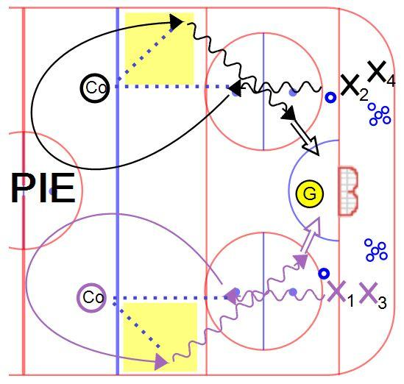
* X1 takes a few hard strides then passes to the coach. X1 then cuts towards the centre circle and back to the boards just inside the blue line to receive a return pass from the coach (inside out pattern)
  + X1 then cuts through the faceoff dot and takes a hard shot on net.
* If there are goalies, watch the timing from both corners so the goalie isn’t getting two shots at once.
* Shoot on net, and get in line in the opposite corner

# 1v1 from corner – 10-12 minutes

**

* Divide groups by pinny, half at each end.
* Only one pylon – for the F to go around
* F cuts around pylon and drives to the net for scoring change
* D defends F by challenging ring carrier and channeling wide or checking.
  + D decides how close to get – no pylon to guide them
* Skaters should change lines and coaches should try to have them up against different opponents each time
* Change corners part way through so they practice pivoting both directions

# Scrimmage -20-25 minutes (still recommend doing half- or cross-ice)

* 60 second shifts, change on buzzer, could graduate to change on the fly if well-organized
* All skaters must reach the bench before the next line can leave the bench
* Everyone comes in one door and out the other
* Coaches acting as referees will ensure the ring is not too close to the boards on a line change, skaters race to the ring and continue from there. If this becomes a safety concern, give the ring to the goalie if it’s in one end or the other, and a centre-ice free pass if it’s in the neutral zone.
* Shooter tutors/goalies, but coaches nearby for ring distribution
* After a goal, there will be a centre ice free pass OR a goalie ring
* No real penalties, but there may be a change of possession if an infraction occurs