Notes:

Need pylons

on-ice coaches, bench coaches, timekeeper

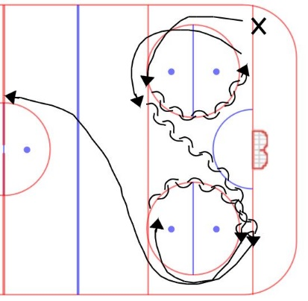

# Warmup/skating – 7-10 minutes

**Skating:** 5 circles backwards crossovers x 2 and pivots x 2.

* Twice backwards
* Twice with pivots so they always face the far end of the rink

STRETCH

# Chart Description automatically generatedPassing – 5 minutes

**Partner passing:**

* Facing your partner
* NOT TOO FAR APART
* Forehand, backhand, **one-touch** and moving back and forward
* **Don’t take too much time here! Have goalies say when they’re ready to face shots.**

Goalies do extra stretching as needed

# Diagram Description automatically generatedGoalie warmup – 7-10 minutes

**Half ice horseshoe:**

* Skate before passing
* Nice flat pass along the ringette line
  + No diagonal passes!!
  + Remind them to use their backhand for passes and shots
* Pick up ring & hard shot – no dekes/fakes

# 1v1 – 10-12 minutes

**1v1 from corner:**

* Diagram, schematic

  Description automatically generatedDivide groups by pinnie, half at each end.
* Run out of both corners, timed so there aren’t any collisions
* STAY ON HALF OF THE ICE (dotted line)
* Only use one pylon for the F to go around. Let the D decide when to pivot
* F cuts around pylon and drives to the net for scoring change
* D defends F by challenging ring carrier and channeling wide or checking
* Skaters should change lines (yes even for U16) and coaches should try to have them up against different opponents each time

# Scrimmage – 20-25 minutes

* 60-90 second shifts, change on buzzer or on the fly
* If changing on the fly, recommend someone sets the time clock to count down from 30 minutes (or however much time is left in the ice slot) so that athletes and coaches can get a sense of how long they’ve been on the ice
* If changing on the buzzer:
  + All skaters must reach the bench before the next line can leave the bench
  + Everyone comes in one door and out the other
  + Coaches acting as referees will ensure the ring is not too close to the boards on a line change, skaters race to the ring and continue from there. If this becomes a safety concern, give the ring to the goalie if it’s in one end or the other, and a centre-ice free pass if it’s in the neutral zone.
* After a goal, there will be a centre ice free pass or goalie ring
* No real penalties, but there may be a change of possession if an infraction occurs