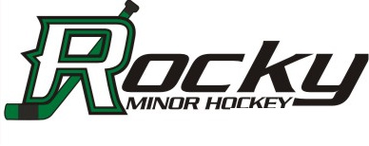

Box 1903 Rocky Mountain House, AB T4T 1B4

COACHES PHILOSOPHY
At Rocky Minor Hockey we believe in an athlete-centred approach to assist our athletes in learning and achieving in the game of hockey. All of our coaches endeavour to develop players to the best of their ability, both on and off the ice.
RMHA has two key objectives:
- To provide the maximum opportunity for all children in the Rocky Mountain House area, between 4 and 18 years of age to participate in hockey.
- To foster the development of hockey and life skills in a positive environment that encourages teamwork, sportsmanship and fair play. Respect for others and fair play are two key values within our association. The most important element in developing athletes is to provide them with qualified coaches who create a positive learning environment with lots of enthusiastic encouragement.
The following are additional objectives and goals of the RMHA and its members:
- To foster, promote and teach amateur hockey and to provide maximum opportunity for all eligible individuals on a team to participate as equitably as possible, both during the regular season and playoffs.
- To develop community spirit and encourage teamwork and sportsmanship and good fellowship amongst all participants to the betterment of their physical, mental and social well-being.
- To develop, organize and control team competition to the maximum of playing accommodation and financial resources.
- To sponsor and promote such athletic, social and other activity as may contribute to the financial resources of the organization.
- To carry on the RMHA without financial gain to or benefit of any of its members.
- To use all revenue solely for the promotion of these purposes and objectives.

