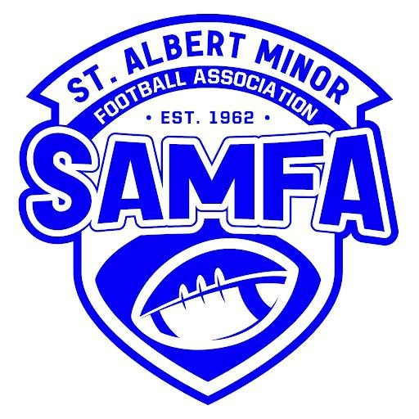
St. Albert Minor Football Association
P.O. Box 48056
St. Albert, AB
T8N 5V9

Season

Name of Volunteer:
Last Name: ____________________________________________________
First Name: ____________________________________________________
Volunteer Position Held: __________________________________________
St. Albert Minor Football Association requests that the holder of this letter, as named above, have a Criminal Record Check (including Vulnerable Sector) completed in order to fulfill their position as outlined above. The age group of children involved is between 6–18 years old. The bearer of this letter is a volunteer and is not paid or compensated in any way by the St. Albert Minor Football Association.
To all Executive, Head Coaches, Assistant Coaches, Team Managers, and Team Trainers:
The mandate for the St. Albert Minor Football Association is to provide a youth-oriented program. As such, we must practice due diligence to provide a safe environment, including safe space and mentorship, for the youth within the St. Albert Minor Football Association football program. All individuals within the St. Albert Minor Football Association that are directly involved with youth must provide a
Criminal Record Check (including Vulnerable Sector) prior to working with youth. Fully realizing that these are volunteer positions, we are requesting your full cooperation.

The St. Albert RCMP detachment is located at:
96 Bellerose Drive
St. Albert, AB T8N 7A4

Their office hours of operation are:
- Monday – Friday: 8:00 AM – 6:30 PM
- Closed Saturday and Sunday

You must bring two (2) pieces of identification, one of which must be photo ID.

Please provide this letter to the St. Albert RCMP detachment to receive your Criminal Record Check free of charge. You must be a resident of St. Albert. If you are not a resident of St. Albert, or if you are aware of an offence on your record, you must attend the Edmonton Police Service for a more detailed Criminal
Record Check.
Thank you for your attention to this important matter.

St. Albert Minor Football Association
(Pres or VP name, position, and signature)

