2023 PSL Game Results Submission

1. Go to www.sasksoccer.com
2. Click on Admin Login (Top Left corner)
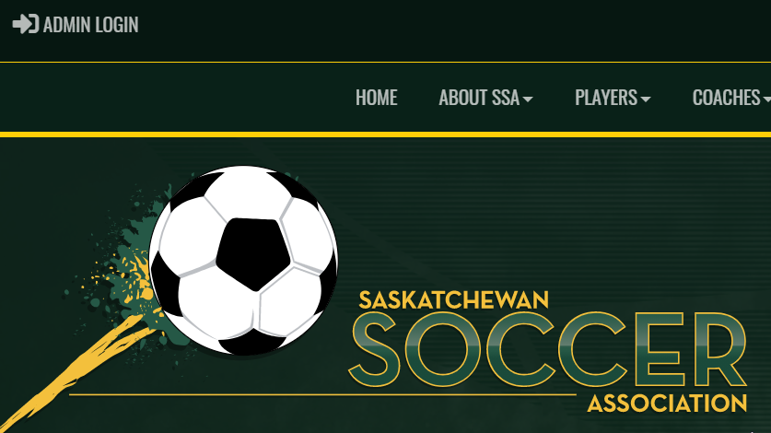
3. Enter your username/password (contact your MO contact if not sure)
4. Once logged in, click on League Games (left side of screen).
5. Select the appropriate game from the list

6. Click the Green Icon – Gamesheet
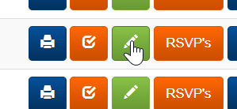

7. Enter the score of the game (home team only). Click Game is Finished.
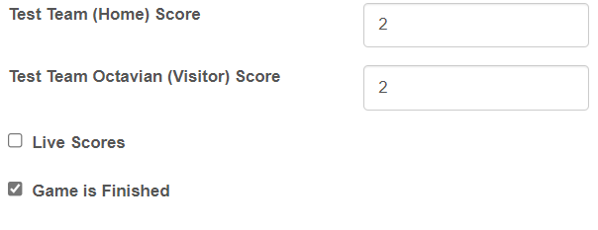
*NOTE: There should be NO game score OR individual goal scorers inputted for any U13 matches*

8. Select your players/staff who attended the game
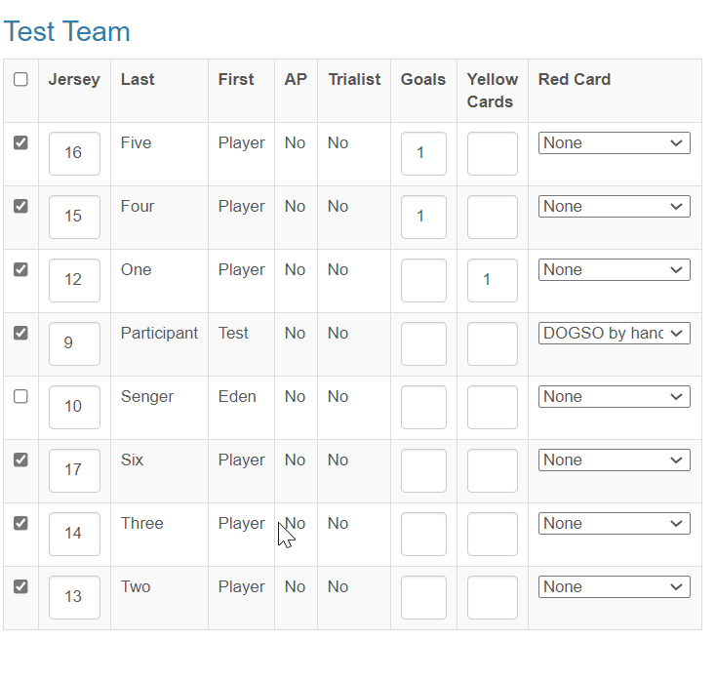
9. After entering all details for your team, click Update Roster/ Update Staff
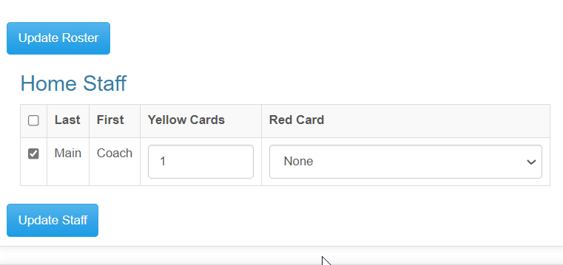

10. Scroll down the gamesheet page – Game files. Select a picture of your game sheet and upload it.
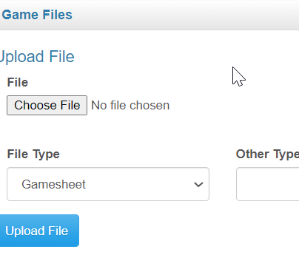
11. Visitor Team Only – Return to League Games. Click on the Orange Icon – Verify (check mark)

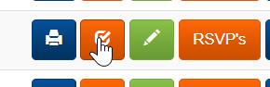

12. Select the appropriate choice and click Update Verification Status
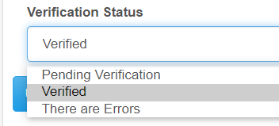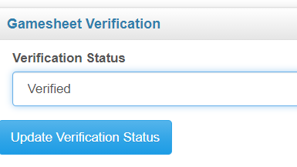

Should you have any questions – or issues through the process, please feel free to email Kellin Enslev, Coordinator of Competitions (k.enslev@sasksoccer.com)

Thank you for your contribution to the 2023 PSL!

