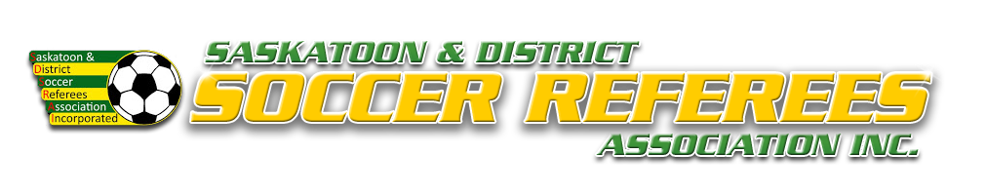
SDSRAI Misconduct Report – Adult
Game Date: Time: Field:
Home: Away: Division:
Player/Shirt #: Team:
Check one (or more) of the following violations to accurately describe the actions of the ejected player.
At the minute of the half, the player was ejected for:
MINOR INFRACTIONS
☐ Received Two Cautions in the Match (1st Yellow / 2nd Yellow )
☐ Denies Obvious Goal Scoring Opportunity – Hand ball
☐ Denies Obvious Goal Scoring Opportunity – Other than Hand ball
☐ Spitting on the field
VIOLENT CONDUCT
☐ Physical Confrontation I – Contact & Attempt to Contact (choke, ☐ Physical Confrontation II – Contact & Attempt to Contact (push,
elbow, headbutt, punch, kick, knee, etc.) slap, trip, chop, hair pull, step on another player, throw/kick
☐ Running the keeper (no attempt to avoid) object at person, chasing, etc.)
☐ Boarding (excessive force; no ball) ☐ Fighting – punches thrown (2+ players involved)
☐ Boarding (excessive force; attempt to play ball)
☐ Any other violent conduct not listed (describe on back)

SERIOUS FOUL PLAY
☐ Running the keeper (attempt to avoid) ☐ Charging
☐ Dangerous tackle ☐ Any other serious foul play not listed (describe on back)

FOUL & ABUSIVE LANGUAGE/GESTURES
☐ Uses offensive, insulting, and/or abusive language NOT ☐ Threatening a person verbally or physically
directed at a person
☐ Uses offensive, insulting, and/or abusive language directed ☐ Uses offensive, insulting, and/or abusive language directed AT an
AT a person official or Organizer
☐ Uses minorly offensive gestures directed at a person ☐ Uses minorly offensive gestures directed at an official
(i.e the finger) (i.e the finger)
☐ Uses seriously offensive gestures directed at a person ☐ Uses seriously offensive gestures directed at an official
(i.e moon, genital grab, etc.) (i.e moon, genital grab, etc.)
☐ Failing to leave the field of play after dismissal, ☐ Entering the match official change room/personal space
and/or delaying the restart of play due to negative reaction without invitation to engage in discussion in a threatening
to referee sanctions, and/or refusing to comply with or unwarranted manner.
the directives of the match official.

EXTREMELY OFFENSIVE CONDUCT
☐ Discriminatory remarks (i.e race, gender, colour, etc.) ☐ Spitting at an opponent or other person

For the section below, please check all that apply:
UNSPORTING/UNETHICAL CONDUCT
☐ Did not leave field immediately after being ejected ☐ After being ejected, re-entered the field of play
☐ After being ejected, slammed gate, kicked door, threw ball, ☐ After being ejected, continued to use insulting, offensive, or
kicked garbage at no one, etc. abusive language/gestures
☐ After being ejected, significantly delayed the restart of play ☐ Continuing physical altercation off the field
☐ Suspected intoxication ☐ Intentionally damages property of SAS, SSCI, or City
☐ Instigator in Physical Confrontation ☐ Any other activity not listed
☐ 3rd Person/Additional Person(s) involved by way of this schedule
(i.e. Violent Conduct, Serious Foul Play, Foul & Abusive Language
or Gestures, Unethical Conduct, etc.)

Description of Events in Detail

Referee: Signed: Date:

