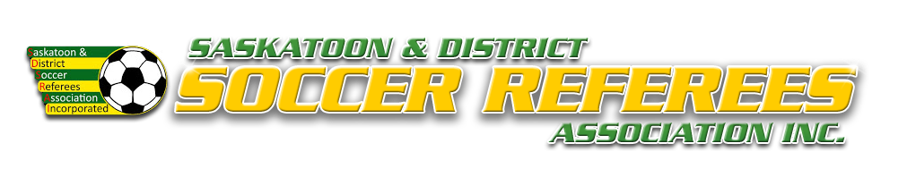
SDSRAI Misconduct Report – Adult
Game Date: Time: Field:
Home: Away: Division:
Player/Shirt #: ID #: Team:
Check one (or more) of the following violations to accurately describe the actions of the ejected player.
At the minute of the half, the player was ejected for:
MINOR INFRACTIONS
☐ Received Two Cautions in the Match (1st Yellow / 2nd Yellow )
☐ Denies Obvious Goal Scoring Opportunity – Hand ball
☐ Denies Obvious Goal Scoring Opportunity – Other than Hand ball
☐ Spitting on the field
VIOLENT CONDUCT
☐ Physical Confrontation I – NO intent to injure (i.e choke, elbow, ☐ Physical Confrontation I – intent to injure (i.e choke, elbow
headbutt, punch, kick, knee, etc) headbutt, punch, kick, knee, etc)
☐ Physical Confrontation II – NO intent to injure (i.e throw/kick ☐ Physical Confrontation II – intent to injure (i.e throw/kick
object at person, push, slap, trip, chop, hair pull, step on, etc) object at person, push, slap, trip, chop, hair pull, step on, etc)
☐ Running the keeper (no attempt to avoid) ☐ Boarding (attempt to injure)
☐ Fighting – punches thrown (2+ players involved) ☐ Any other violent conduct not listed (describe on back)
SERIOUS FOUL PLAY
☐ Boarding (attempt to play ball, no intent to injure) ☐ Running the keeper (attempt to avoid)
☐ Dangerous tackle ☐ Charging
☐ Any other serious foul play not listed (describe on back)
FOUL & ABUSIVE LANGUAGE/GESTURES
☐ Uses offensive, insulting, and/or abusive language NOT ☐ Threatening a person verbally or physically
directed at a player/spectator/official
☐ Uses offensive, insulting, and/or abusive language directed ☐ Uses offensive, insulting, and/or abusive language directed AT an
AT a player/spectator official
☐ Uses minorly offensive gestures directed at a player/spectator ☐ Uses minorly offensive gestures directed at an official
(i.e the finger) (i.e the finger)
☐ Uses seriously offensive gestures directed at a player/spectator ☐ Uses seriously offensive gestures directed at an official
(i.e moon, genital grab, etc.) (i.e moon, genital grab, etc.)
EXTREMELY OFFENSIVE CONDUCT
☐ Discriminatory remarks (i.e race, gender, colour, etc.) ☐ Spitting at an opponent or other person
For the section below, please check all that apply:
UNSPORTING/UNETHICAL CONDUCT
☐ Did not leave field immediately after being ejected ☐ After being ejected, re-entered the field of play
☐ After being ejected, slammed gate, kicked door, threw ball, ☐ After being ejected, continued to use insulting, offensive, or
kicked garbage at no one, etc. abusive language/gestures
☐ After being ejected, significantly delayed the restart of play ☐ Continuing physical altercation off the field
☐ Suspected intoxication ☐ Intentionally damages property of SAS, SSCI, or City
☐ Instigator in Physical Confrontation ☐ 3rd Person involved (escalation but NO contact)
☐ 3rd Person involved (escalation AND contact) ☐ Any other activity not listed

Description of Events in Detail

Referee: Signed: Date:

