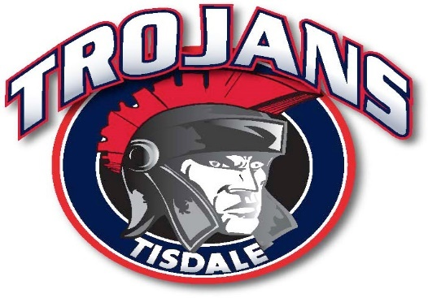

The Tisdale Trojans AAA Midget Hockey Club of the Saskatchewan AAA Midget Hockey League is accepting applications for the position of Head Coach.

JOB RESPONSIBILITIES:
- Scout and recruit players
- Organize season plan and progression for on and off ice
- On ice coaching and player development
- Administration duties as assigned by the Board of Directors
- Required to follow and honor the Bylaws and Policies of the Organization
QUALIFICATIONS:
- Playing experience at the Junior level preferred
- High Performance 1 certification, Respect in Sport & Checking
- Recruiting experience
- Effective organizational and time management skills
- Excellent communication skills – both written & verbal
- Provide a criminal record check
- Ability & desire to work long hours, evenings, weekends & holidays as necessary

Salary commensurate with experience, knowledge & ability.

Qualified candidates shall submit a resume by May 10, 2019 to:
Greg McShannock – President Tisdale Trojans
g.mcshannock@sasktel.net

