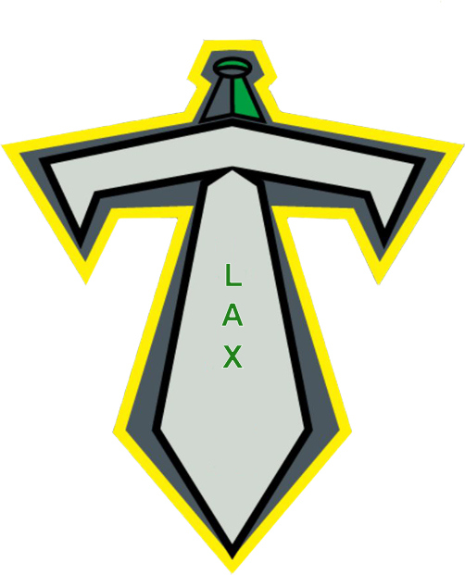

Titans (Mini Tyke & Tyke)

Mini Tyke (6 under)

LTAD:

-Introduce Skills
-Basic Rules (how to use/hold stick, body positioning/no contact, crease)
-Fair Play
-Physical Activity
-Play Agility Games (tag, red rover)

Technical Skills:

-Cradling (top hand cradles, bottom guides, up at shoulder/not at hip)
-Loose Ball Retrieval (trap and scoop, two hands in motion)
-Catching (proper technique)
-Passing (overhand, hand positioning)
-Shooting (overhand, hand positioning)
-Defensive Body Position (stance, holding/using/stick positioning)

Tactical Skills:

-Cutting
-Give n’ Go
Tyke (7-8)

LTAD:

-Introduce Skills
-Basic Rules (place and push, crease)
-Fair Play
-Physical Activity
-ABC’s

Technical Skills:

-Cradling (top hand, up at shoulder, don’t over cradle, only protect)
-Scoop (on the run, attack the ball)
-Overhand Pass
-Overhand Shot
-Defensive Body Position (stance, 2 hands, place and push, stick check, etc)
-Creating Space (engage defender, pop out, cuts)

Tactical Skills:

-Give n’ Go
-Cutting
-Floor Positioning (*right side of the floor, offence, defence, face-off)

Goalies:

-Stance
-Angles
-Passing
-Stopping Shots

FOCUS SHOULD BE PLACED ON FUNDAMENTAL SKILL DEVELOPMENT; FORMING GOOD HABITS, BASIC TECHNICAL ABILITY

HABITS:

Fun vs. Competitive (Score, Winning)
Team Play vs. Individual Play
Movement (Running) vs. Stationary (Standing)

Correcting technical skills; side-arms, over cradling, cradling at hip, hand positioning on stick

PRACTICES:

High Reps, Little Standing Around
Fun (Keep Players Engaged)

GAMES:

Fun, Fair Play
Co- Operation, Correction
New, Positive Experience

Glossary:

https://laxlife.ca/appendix/

