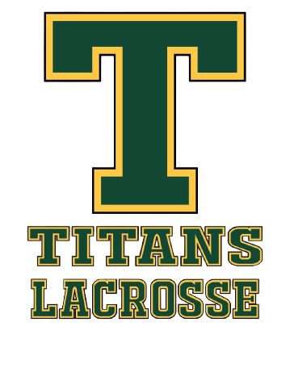
Sherwood Park Titans Lacrosse Parent
and Spectator Code of Conduct
(Updated 2026)

It is the intention of this Code of Conduct to promote proper behavior, respect, sportsmanship, and a safe environment for all participants within the Sherwood Park Titans Lacrosse Association (SPTLA).
This Code of Conduct applies to all parents/guardians, family members, and spectators attending or participating in SPTLA sanctioned activities, including, but not limited to: games, practices, tournaments, meetings, and team events.
Parents/guardians are responsible for ensuring that any guests or spectators attending on their behalf conduct themselves in accordance with this Code of Conduct.
Governance Acknowledgment
As a participant with Sherwood Park Titans Lacrosse Association (SPTLA), I acknowledge and agree to comply with:
- SPTLA Bylaws and all SPTLA Policies & Procedures
- All applicable GELC, ALA, and Lacrosse Canada regulations
- The Alberta Universal Code of Conduct (AB UCC)
- Alberta Safe Sport requirements
As they apply to my participation, and as amended from time to time.
Electronic acknowledgment of this Code of Conduct through the SPTLA registration platform constitutes binding agreement to abide by this Code of Conduct and all governing policies referenced above.

Parent Responsibilities

- I will remember that athletes participate for their enjoyment and development.
- I will support all players by encouraging effort, respect, and good sportsmanship.
- I will demonstrate respect toward players, coaches, officials, volunteers, board members, and other spectators.
- I will not engage in harassment, bullying, intimidation, discrimination, abuse, or retaliation, including through electronic or social media platforms.
- I will not question officials’ decisions in a public or disruptive manner.
- I will address concerns through the appropriate communication channels outlined in SPTLA policies.
- I will support efforts to maintain a Safe Sport environment free from verbal, physical, or emotional abuse.
- I will ensure that any family members or guests attending SPTLA activities on my behalf adhere to this Code of Conduct.

Failure to comply with this Code of Conduct may result in disciplinary action, up to and including suspension, removal, or expulsion, in accordance with the SPTLA Discipline & Complaints Policy and applicable governing body policies. Certain conduct matters may be referred to the Alberta Lacrosse Association Safe Sport processes where required.

