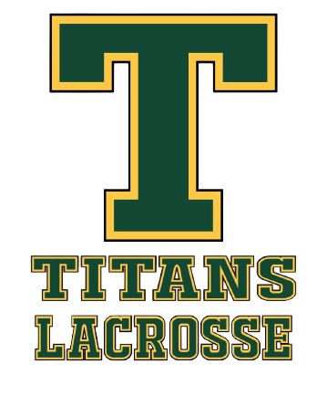
Sherwood Park Titans Lacrosse
Player Code of Conduct (Updated 2026)

All players must comply with this Code of Conduct as a condition of participation with SPTLA.

Governance Acknowledgment
As a participant with Sherwood Park Titans Lacrosse Association (SPTLA), I acknowledge and agree to comply with:
- SPTLA Bylaws and all SPTLA Policies & Procedures
- All applicable GELC, ALA, and Lacrosse Canada regulations
- The Alberta Universal Code of Conduct (AB UCC)
- Alberta Safe Sport requirements
As they apply to my participation, and as amended from time to time.
Electronic acknowledgment of this Code of Conduct through the SPTLA registration platform constitutes agreement to abide by this Code of Conduct and all governing policies referenced above.

Player Responsibilities
- I will respect my teammates, coaches, officials, opponents, and volunteers.
- I will follow team rules, game rules, and coaching directions.
- I will demonstrate sportsmanship in both victory and defeat.
- I will not engage in bullying, harassment, intimidation, discrimination, abuse, or retaliation.
- I will use social media and other electronic platforms responsibly and will not post content that harms or disrespects others.

Failure to comply with this Code of Conduct may result in disciplinary action, up to and including suspension, removal, or expulsion, in accordance with the SPTLA Discipline & Complaints Policy and applicable governing body policies, and certain conduct matters may be referred to the Alberta Lacrosse Association Safe Sport processes where required.

