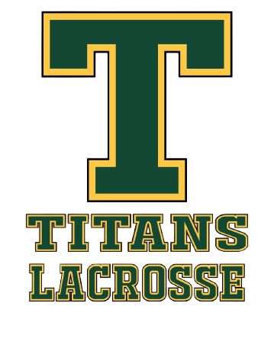
Sherwood Park Titans Lacrosse
Coach Code of Conduct (Updated 2026)

All coaches and bench staff must comply with this Code of Conduct as a condition of participation with SPTLA.

Governance Acknowledgment
As a participant with Sherwood Park Titans Lacrosse Association (SPTLA), I acknowledge and agree to comply with:
- SPTLA Bylaws and all SPTLA Policies & Procedures
- All applicable GELC, ALA, and Lacrosse Canada regulations
- The Alberta Universal Code of Conduct (AB UCC)
- Alberta Safe Sport requirements
As they apply to my participation, and as amended from time to time.
Electronic acknowledgment of this Code of Conduct through the SPTLA registration platform constitutes binding agreement to abide by this Code of Conduct and all governing policies referenced above.

Coach Responsibilities
- I will promote athlete development, enjoyment, safety, and respect.
- I will maintain required certifications, screening, and training requirements.
- I will adhere to Safe Sport principles, including the Rule of Two.
- I will provide equitable instruction, discipline, and support.
- I will model professionalism and respect toward players, parents, officials, volunteers, and fellow coaches.
- I will not engage in abuse, harassment, discrimination, retaliation, or inappropriate conduct.
- I understand that serious conduct matters may fall under ALA and/or ABSSCM jurisdiction.
- I understand that SPTLA may impose interim measures, including suspension or removal, pending review of conduct concerns.
Failure to comply with this Code of Conduct may result in disciplinary action, up to and including suspension, removal, or expulsion, in accordance with the SPTLA Discipline & Complaints Policy and applicable governing body policies, and certain conduct matters may be referred to the Alberta Lacrosse Association Safe Sport processes where required.

