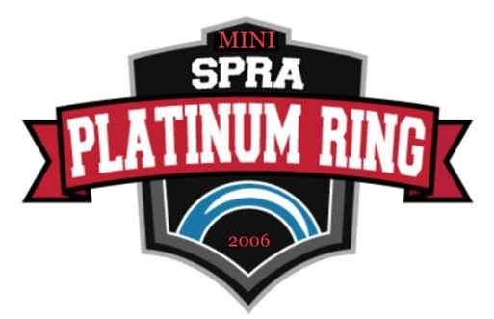

MINI PLATINUM RING JAMBOREE
Division | Fee
AS1 | $50
AS2 | $200
U10S1 | $400
U10S2 | $400
U10S3 | $625

PAYMENT MUST BE RECEIVED TO ACCEPT YOUR APPLICATION
Deadline for application is December 6th. Teams will be notified of acceptance by January 9th.
Cancellation/Refunds: Refunds will be given if cancelled before December 5th. If cancelled on or after December 5th, the full registration fee will be charged unless we are able to find a replacement team to fill the spot.

Stay To Play Policy
SPRA Platinum Ring Tournament has instituted a Stay to Play policy to ensure availability of accommodations for all participants while better managing competition costs.
All travelling teams (100kms+/one way) are required to book hotel rooms through Hudson Travel Group (HTG Sports) to be eligible to play in the tournament.
- The Manager’s mailing address will be used to determine kms to Sherwood Park, AB.
- A team will be issued a booking code upon acceptance, that will need to be used when booking through HTG Sports.
- SPRA Platinum Ring Tournament offers exemptions from the Stay to Play policy for both teams and individuals under the following categories:
  - Proximity Exemption Request: If the team/athlete is based within the specified proximity distance from the competition venue or the team/athlete plans to stay with family or friends that resides within the proximity distance, the team/athlete may be eligible for an exemption from the policy.
  - Special Exemption Request: A Special Exemption Request will need to be completed for all other exemption requests. Requests will be considered on a case-by-case basis and will be reviewed by the Stay to Play Review Committee. This policy has been put in place to benefit teams, local event organizers and Sherwood Park Ringette alike. To request an exemption please complete the Stay to Play Exemption Form
  - Note: If your Club falls within 100kms of Sherwood Park, AB, you do not have to stay in the event hotels as you do not fall within the Stay and Play policy range. However, if your Club Team decides to book accommodations, the bookings must be made through Hudson Travel Group (HTG) to use the Toronto Tourism Hotel members. Hudson Travel Group holds all blocks at the hotels and will work with your Team to ensure your needs are met.

