Manager’s Information Package

Welcome to another season of ringette and thank you for your role as manager!

This manual is a quick reference for you to help guide you through a successful season. Please note that the SPRA website has additional information and links to address your questions and concerns.

Manager’s Roles:

The Team Manager is a key role on your Ringette Team. You help the Coaches by acting as the liaison between the parents and the coaching staff, organize and oversee the team’s parent volunteers and deal with issues or concerns as they arise. Specific duties of the Team manager include:

Deal with all off-ice team items

Communicate SPRA information and requirements to Coaches

Communicate SPRA information to the parents

Ensure that all parents are involved in the Ringette Team (assigning of roles/duties)

Ensure all coaching staff complete security clearance checks and submit the completed forms (required by December 15)

Advise all coaching staff complete necessary certification requirements for their level

Complete team hard card information for the registrar

Communication of ice Schedules to the Team

Communication of other SPRA events (i.e. photo’s)

Arrange scorekeeper, timekeeper for games Some teams assign this as a role to schedule.(This can be a role assigned)

Report game scores to BGL

Work with coaches to deal with issues, concerns or complaints from parents or athletes

Encouraged to attend monthly executive meetings as you are the parents’ connection to the association

Manager Certification
There is a Manager Certification Program offered by Ringette Canada. Managers do not have to be certified, but certification is required to be on the hard card (Official Team list with players and team staff). Information is available on Ringette Canada’s website under the Coaches tab (Managers Certification Program) and you can take the online certification course offered there.
Managers Certification Program (Ringette Canada)
This managerial "course" has been designed specifically for those who may not wish to coach yet wish to contribute and be involved in a team’s organization. The information contained in the Managers
Certification is valuable and beneficial for any individual in the "team sport" setting. It is highly recommended that those people who are currently in a coaching role obtain this manual to help increase their knowledge in the area of team administration. This program is intended to prepare an individual for a managerial or an administrative position on any Ringette team.

- Once complete, a certificate of achievement will be generated, but you are not required to print this as you will receive a wallet card accrediting you as a Certified Manager by Ringette Canada.These individuals will be registered with their provincial/territorial association and with Ringette Canada as certified managers.
- You will have the ability to review the Manager’s Certification Program by logging onto the system at any point in the future.
- All certified managers will be added to the Manager’s database and will have the ability to receive emails regarding updates or professional development opportunities. All provinces will be provided with a master list of all certified managers in their province.
- Certification Deadlines: Certification deadlines for tournaments or provincial/territorial championships vary across Canada. It is your responsibility to check with your provincial/territorial association regarding deadlines affecting your certification. Don’t make assumptions – check and be sure!

Lines of Communication:

- Your division director is available for assistance throughout the season in dealing with team staff, player and parent personalities or any other issues or questions you may have. SPRA is here to help so please contact your division director who can help you find the answers and solutions you need.
- Questions or concerns about the Black Gold and League Games: contact the BGL Rep at: bglrep@sherwoodparkringette.ca
- Vice President is also available to assist managers throughout the season and can be reached at vp@sherwoodparkringette.ca

Lines of Communication to the BGL
(Taken from BGL Operations Manual §1.1 - 04.2010)

SPRA Philosophy:

We do NOT support:
- benching players
- shortening the bench
- yelling negative comments at players
- disrespect towards players, officials, and parents
- punishment practices

We expect all players to have an opportunity to play on the power play, to play when short-handed, to play first shift of a period and the last shift of a period in a close game. A coach’s job is to develop players who believe in themselves and this cannot be done if they do not get opportunity to succeed and fail. The end of a close game is not designed for only what would be considered the top players.

Parent Message:

The Manager should reinforce the following message to the parents.

SPRA is committed to the growth and development of its players. The following document outlines what SPRA expects from parents and coaches throughout the Ringette season to optimize the experience for the players. If these expectations are not met, the individuals will be dealt with according to the policies and guidelines of SPRA.

Parent to Parent: It is important that you as parents are positive with each other. The parent to parent message is critical. Positive comments about the team, the coaches, your child and other parent’s children create a positive environment for everyone to exist in! Remember every position is important in a team sport, not one more than another.

Parent in the Stands: Behavior in the stands generates the type of team you will be known as. The association and coaches expect all parents to cheer for their own team and not against another team. We expect positive comments towards both teams. We will also expect parents to control their emotions when it comes to the officials in the game. Yelling at officials will not be tolerated. Officials will only be addressed by the coaches and there are protocols for coaches to follow if there are official issues.

Parents with Coaches: We expect parents to treat their coaches with respect. They have volunteered their time and they have committed to the roles and responsibilities of a coach as laid out by the association. If you have a serious concern or question for the coach, email the coach and request a face to face meeting and include your division coordinator in the email. Please never discuss issues in front of the players, before games and after games. These are not appropriate times to have a meeting and will be less likely to result in a positive outcome. When you wait 24 hours before having the discussion with the coach, it allows you to determine if your child has the same perception as you do! If you do not feel comfortable discussing the issue with the coach, contact your manager.

Parents to Player: First understand your child’s strengths then compliment them on the things they do well. Try to limit what you tell them they need to do- that is the coach’s responsibility. Ensure that your child comes to the games well nourished, well rested, properly equipped and in good spirits. Encourage them to work hard and to listen to their coach, as you are getting them to the rink. Do not contradict the coach with instructions as this confuses the players. Be positive and understand that a big part of your child’s enjoyment this season will be based on your comments and behavior.

Please take the time to fill out the coach evaluation forms as compliments and constructive criticism are necessary for a great season!!!

Possible Team Roles to fill:

Here is a list of possible positions that you may want to consider having to make your team run smoothly:

- Manager
- Treasurer
- Tournament Coordinator
- Minor Official scheduler
- Jersey Parent (Home) Teams may choose to have players be responsible for their own jerseys this season
- Jersey Parent (Away)
- Social Committee (2-3 parents) Special attention should be given to what team events are appropriate at this point in time
- Music person for dressing room
- First Aid person
- Stats
- BGL Spectator Liaison
- Social Media – If teams have their own social media accounts, SPRA policies still apply.

Criminal Record Checks

Anyone on the Executive or on a team Hardcard must have a Criminal Record Check every two years. This information has been provided through the Directors/Coordinators to the coaches. There is a letter from the SPRA Secretary that is required to be taken to the RCMP station to get your criminal record check done
- The hours are 7:30am to 4:30pm - Monday to Friday. They will not process you at 4:30pm.
- Make sure you bring your driver's license.
- Take a number when you arrive and then fill out the form on the front and back.
- The CRC should be dropped off at GARC in the SPRA box.
- CRC’s must be completed before our tournament in December

Pictures

You will be provided a picture time by the picture coordinator with the schedule for Team Pictures. Pictures are usually done in October.

Ice Schedules

- Schedules will be sent by the Ice Allocator to the Coaches and the Managers.
- Either the Coach or the Manager should communicate the team schedule to all team members.
- Schedules include:
  - All League Games
  - Practice Times
  - Power Skating (U12, U10, U14,U16)
  - Goalie Clinics

Power Skating and Goalie Clinics
Coaches are expected to be in attendance and on the ice during the power skating sessions as well as U10 goalie clinics. These technical instruction opportunities are designed for both player development and coach development.

Cancelling Ice

Important Information re: Cancelling Ice
Ice times scheduled between September and March are considered Regular Season and require a minimum of 96 business hours’ notice to cancel ice. Ice times scheduled other than "Regular Season" above are considered Off Season and require a minimum of 2 full weeks’ notice to cancel ice.
During Regular Season - if you wish to cancel a weekend, Saturday, Sunday (or Monday) practice, you must notify the ice allocator by the previous Tuesday 8:00 pm. Tuesday practice needs to be canceled by the previous Wednesday night and so on. If you need to reschedule a game the Coach or Assistant Coach must provide the opposing team a minimum of 72 hours’ notice. Please contact the ice allocator as soon as possible to reschedule the game.
Games requiring re-scheduling will be done so based on available ice times agreed to between the ice allocators. Coaches are not to reschedule games. Game cancellation for reasons other than road closures may result in a fine being assessed to the individual team.
Failure to provide adequate notice will result in charges being assessed to cover the associated costs incurred.
The SPRA ice allocator is to be contacted by email only at: icespra@gmail.com

Road Report
This season Zone 5 will use the AMA Road Report as the official standard as to whether a road is safe for winter travel.

Black Out Dates
Provide the Ice Allocator with all blackout dates for session 2 including tournaments. No black outs are allowed for session 1, you must follow the reschedule policy.

Equipment Policy

Equipment Deposit Policy – Coaches
- A $500.00 Equipment Deposit is due from coaches upon receiving jerseys/equipment from SPRA.

- No jerseys/equipment will be issued without a team cheque or personal cheque made payable to Sherwood Park Ringette Association. The coach is responsible for all jerseys/equipment loaned to them for use by their respective team.

Equipment Deposit Policy – Individual Use
- A $500.00 Equipment Deposit is due upon receiving equipment from SPRA.

- No equipment will be issued without a personal cheque made payable to Sherwood Park Ringette Association. The borrower is responsible for all equipment loaned to them.

Returns under Review
To address jerseys/equipment lost and/or damages that require replacement - the deposit will be returned in full, less:
- $250 - goalie pads
- $130 – chest protector
- $100 – trapper
- $60 – blocker
- $50 – ring bags
- $70 – goalie equipment bag
- $50 - per jersey
- $500 - per set of jerseys

To address jerseys requiring laundering:
- $50 per set of jerseys

Hard Cards
Emailed by Registrar and to be completed and sent back.

Concussion Policy

All resources and information can be found on the SPRA website. All decisions must be made with the athlete’s well-being at the forefront of any decisions and actions. Resources include:

- Concussion Policy
- Return to Play Policy
- Return to Play Form

- Concussion assessment and recognition tools
- Making Headway Online Module (http://www.coach.ca/concussion-elearning-modules-p153487&language=en)

Shot Clocks
Shot clocks will be used at all divisions U12 and above. The home team is responsible for providing the shot clocks.

Fundraising

Fundraising is decided by the individual teams and must comply with any legislation that pertains to it. E.g. Alberta Liquor and Gaming Commission

First Aid Certification
All teams U12 and up must have a member of the team staff with first aid certification.

Injury Claims
Reference the Ringette Alberta website for claim forms and information when same is needed. Claims need to be made immediately. Information can be found in the clubs tab. https://ringettealberta.com/injuries-reporting-preventing/

Player and Coaches Awards
Refer to the Ringette Alberta website for nomination forms.

Game Sheets
How to fill out an Official Game Sheet
Pre-game Coaches/Teams:
The home team will start filling out the game sheet, they will hand this off to the visiting team for them to complete their side.

Teams will need to make sure certain information is filled in properly, these are:
  - Division, Level, Location, Times, Game Number, League/Tournament, Date (the entire top row of the Ringette Alberta Official Game Sheet
  - Team, Team Staff, and any Junior Coaches - Colour of jersey - Numbers and Player names (must have the last names in full at the least)
  - Goalies (G), Captains (C), Assistant Captains (AC), Affiliate Players (AP), Injured Players (INJ) - Only cross out players when using an affiliate (AP)
Officials during warm-up:
Officials will check the Officials Game Sheet against the players are on the ice. They count the players on the ice, and as long as there are more on the Officials Game Sheet than on the ice, that is good. They are also checking for the Coaches, Junior Coaches, Goalies, Captains, Assistant Captains, Affiliate Players, Injured Players are filled in and marked. If the officials notice the AP, then other (non-AP) players MUST be crossed off.
During the game Score-Keepers:
Score-keepers are inputting the data that the officials are communicating to them; Goals and Penalties. They are also doing the Goaltenders Record. Everything on the sheet needs to be recorded top down, with all boxes used.
Inputting Goals:
  - Always start at the top and fill in top down
  - Listen to the official for 1, 2, or 3 numbers, then list them across the line, finishing with the time of the goal
  - There should never be ticks or checkmarks denoting goals
  - Put a line after the first period (this will help you count at the bottom)
  - Once the game is done, put another line to show that is the end of regulation time (if there is OT, you continue this process)
  - Tally the goals at the bottom in the black, do not forget the total

Inputting Penalties:
  - Always start at the top and fill in top down
  - Reasons for penalties are listed in the Penalty Codes section at the bottom of the sheet
  - Input all boxes, as some can be different o If the player that is serving is different than that who got the penalty.

- This is why are two spaces called No. and Served By o Min might be 2 or 4, please listen to the official for that prompt
- Time off of the ice is the time that player came to the box
- Pen start time is when the penalty actually started ♣ This usually is different when there is a third penalty and the player comes off the ice, but their penalty does not actually start until the first penalty ends. Otherwise, they are typically the same most of the time.
- Pen finish time is when the penalty ends
- Time onto the ice is when that player is allowed to step onto the ice ♣ Again, this is typically the same, but when there are 3 penalties, a penalty might expire, but that player is not allowed on the ice because there are still 2 players serving active penalties. In that situation, these last two boxes will be different
- Between periods and at the end of the game, place a line.
- This line does NOT have to be in the same spot at the line between periods in the goals section - At the end of the game, it is helpful to tally the penalty minutes
Time-outs:
- There is a small square for each team at the bottom of their section o Fill in the period, time and check if used
- If there is one in OT, just add to this with a comma
Goaltenders Record:
- Please try to fill this out for U19 and below - If you have a separate sheet, just keep a tally going there, or use a space on the Official Game Sheet that isn`t being used
Post-game
- After the last whistle, the second top row must be filled out by the Minor Officials and Officials. Score Keeper, Time Keeper, Shot Clock Operator, and Referees must sign the Official Game Sheet
- Officials will check over the Official Game Sheet after the handshake, after that you can take the Official Game Sheet and distribute. In League player, use the bottom legend to see who gets what copy. In tournaments, you might do different.
**Please consult the example version of an Official Game Sheet

Refer to the sample game sheet: 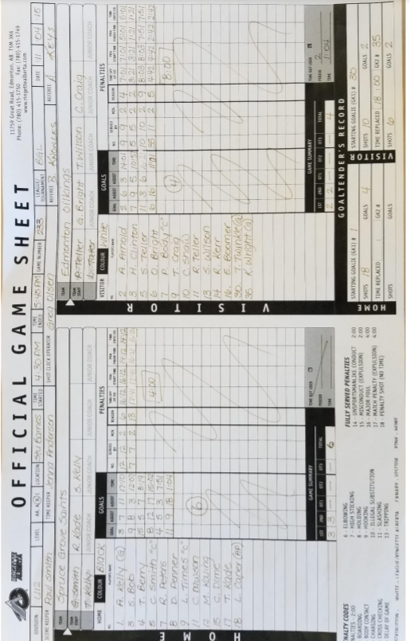

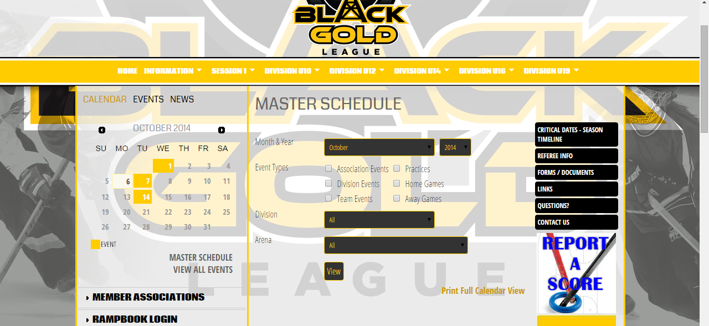

Black Gold League Calendar
You are able to access information about schedules and standings by session or division.
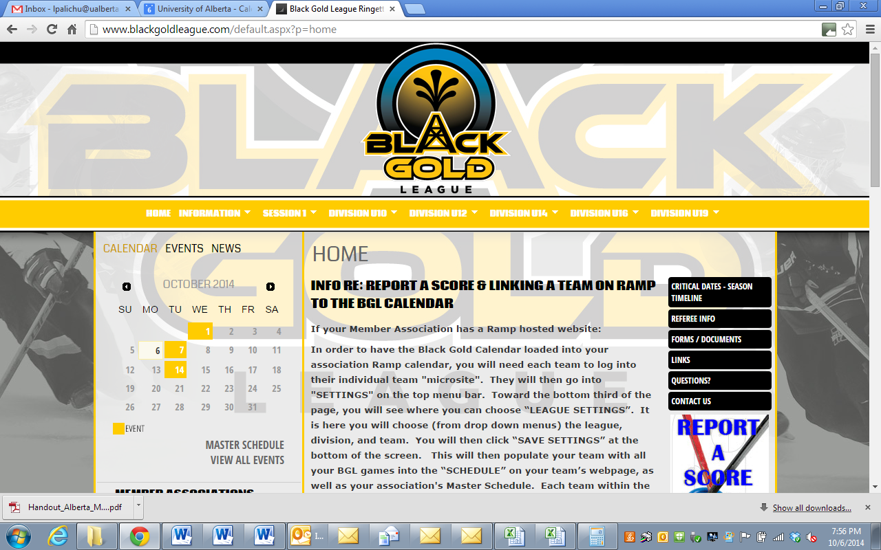

Black Gold Critical Dates
These can be found on the BGL website by selecting the calendar found on the homepage. Choose the Master schedule and then the information that you require.

We know that this is a lot of information to absorb, but hopefully, by providing all this information in one document, you can refer to it as need. Please, however, do not be afraid to reach out. There are several individuals within SPRA who are happy to help you if needed.

