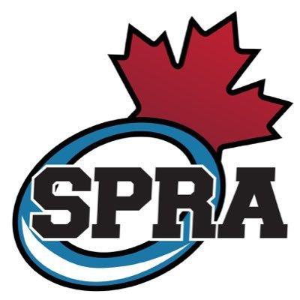

Code of Conduct for Players & Families
SPRA is committed to providing an environment in which all individuals are treated with respect. Furthermore, SPRA supports equal opportunity and prohibits discriminatory practices. Members are expected to conduct themselves at all times in a manner consistent with the values of SPRA. Members will be subject to sanctions according to SPRA's Discipline Policy for non-compliance of the following:
- I will not abuse or harass any official, opposing team member, team mates, parents, member of the coaching staff or SPRA Executive.
- I will not show disrespect to the officials, including the use of foul language and obscene or offensive gestures.
- I will comply with the rules, regulations and policies of SPRA.
- I will follow the public health guidelines of the day.
- I will ensure any behavior on or off the ice shows integrity to the event and SPRA, this includes dressing room and practice behavior.
- I will adhere to the highest standards of fair and respectful game play. I will not engage in conduct that is disrespectful and does not demonstrate fair play (e.g. any excess of penalties, major penalties on the ice against other players, coaches and officials, etc.)
- I will not deliberately disregard the Ringette Alberta or SPRA Rules.
- I will not engage in any conduct detrimental to the game of ringette, including but not limited to, abusive use of alcohol and/or cannabis,non-medical use of drugs, tobacco or vaping products by minors.
- I will represent SPRA with pride and will not use Social Media (such as but not limited to Facebook, Twitter, Instagram) to disrespect, harass, or intimidate others.
- I will only post appropriate, positive social media content which is consistent with the values of SPRA.
- I will not take photographs or videos in the locker room.
- The SPRA Code of Conduct shall govern all disciplinary matters within our association to the extent that it conflicts with or augments the Code of Conduct of the Alberta Ringette Association or Ringette Canada, but shall not supersede or replace elements of the Zone bylaws or Ringette Alberta By-Laws.
- My family and I agree to this code of conduct, and will follow it.
My family and I agree to this code of conduct, and will follow it.
Athlete:__________________________________ Signature:_________________________________
Family Representative Signature:_____________________________Date:______________________

All information on SPRA’s Policies, Values and Code of Conduct can be found on our website under the About Us tab*

