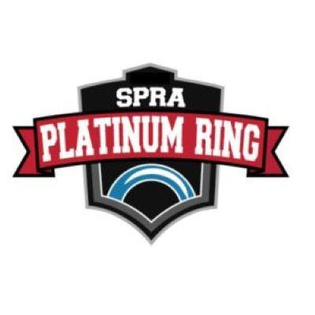

Platinum Ring Tournament
November 7-9th, 2025
Division | Fee
U12 A / B / C | $950.00
U14 A / B / C | $950.00
U16 A / B / C | $950.00
U19 A / B | $950.00
U14 AA | $950.00
U16 AA | $1,500.00
U19 AA | $1,500.00

Registration is now open for Divisions above.

Deadline for application is October 6th. Teams will be notified of acceptance by October 8th.

Cancellation/Refunds: Refunds will be given if cancelled before October 5th. If cancelled on or after October 5th, the full registration fee will be charged unless we are able to find a replacement team to fill the spot.

Stay To Play Policy

SPRA Platinum Ring Tournament has instituted a Stay to Play policy to ensure availability of accommodations for all participants while better managing competition costs.

All travelling teams (100kms+/one way) are required to book hotel rooms through HTG Sports to be eligible to play in the tournament.
- The Manager’s mailing address will be used to determine kms to Sherwood Park, AB.
- A team will be issued a booking code upon acceptance, that will need to be used when booking through HTG Sports.
- SPRA Platinum Ring Tournament offers exemptions from the Stay to Play policy for both teams and individuals under the following categories:
  - Proximity Exemption Request: If the team/athlete is based within the specified proximity distance from the competition venue or the team/athlete plans to stay with family or friends that resides within the proximity distance, the team/athlete may be eligible for an exemption from the policy.
  - Special Exemption Request: A Special Exemption Request will need to be completed for all other exemption requests. Requests will be considered on a case-by-case basis and will be reviewed by the Stay to Play Review Committee. This policy has been put in place to benefit teams, local event organizers and Sherwood Park Ringette alike. To request an exemption please complete the Stay to Play Exemption Form
  - Note: If your Club falls within 100kms of Sherwood Park, AB, you do not have to stay in the event hotels as you do not fall within the Stay and Play policy range.

HOTEL ACCOMMODATIONS ARE PROVIDED BY HTG SPORTS
⬇️
🔗 Event Profile: SPR Platinum Ring Tournament 2025

Tournament Arenas
Millennium Place: MLNM-CH (Chevy Arena) and MLNM-SP (Sprite Arena)
2000 Premier Way, Sherwood Park, AB. Phone: 780-416-3300
Ardrossan Recreation Complex: ARRC-E (East) and ARRC-W (West)
80 – 1 Avenue, Ardrossan, AB. Phone: 780-922-3377
Glen Allen Recreation Complex: GARC
199 Georgian Way, Sherwood Park, AB. Phone: 780-467-4404
Strathcona Olympiette Centre: SOC
52029 Range Road 224, Sherwood Park, AB. Phone: 780-400-3805
Moyer Recreation Centre: MOYR
4, 54569 Range Road 215, Josephburg, AB. Phone: 780-998-7022
Sherwood Park Arena/Shell Arena: SPKA and SPKS
2015 Oak St, Sherwood Park, AB. Phone: 780-467-2202
Questions? Send them to: tournament@sherwoodparkringette.ca

