John Losty u14director@sherwoodparkringette.ca
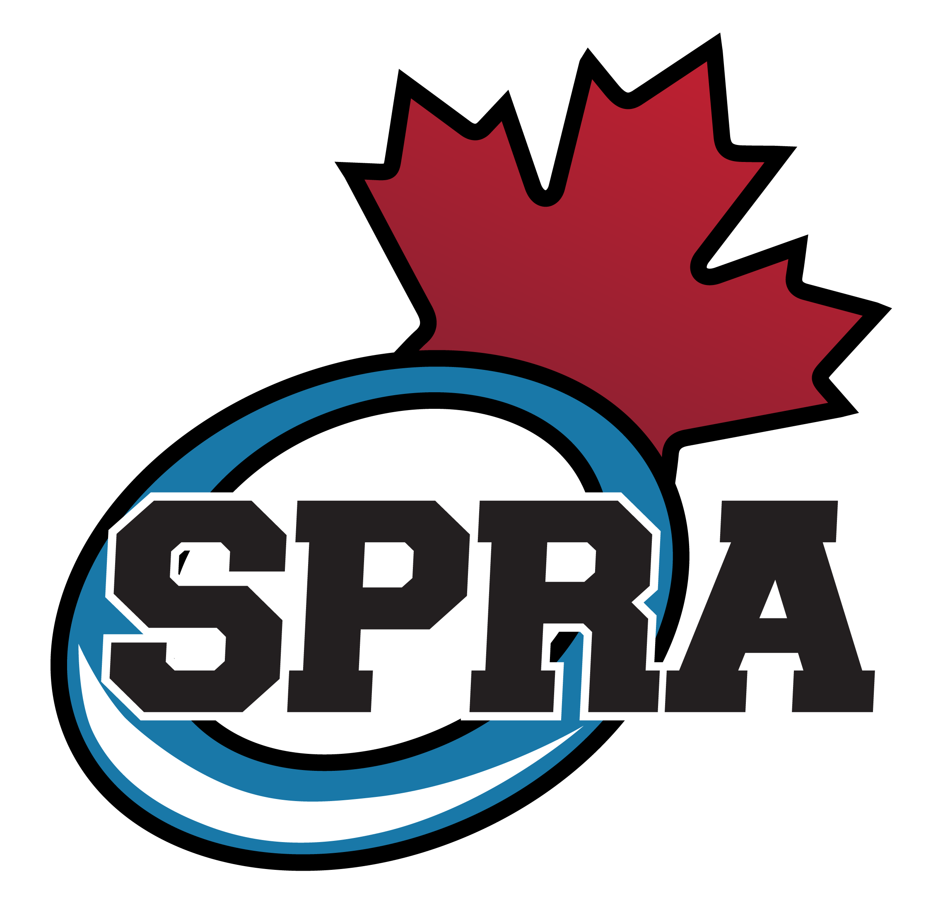

U14 Update June 2021
SPRA has been and continues to review all of the guidelines and return to play information released by Ringette Canada, Ringette Alberta, Alberta Health Services, and Strathcona County, and we are committed as an Executive to ensuring that our Association follows all of the recommendations put forward, which as we have learned, means making adjustments as we proceed forward.
We don’t know yet what our evaluation process and schedule will look like yet. We will keep you apprised as the season gets closer.

In the meantime, REGISTER NOW – CLICK HERE
U14 Birth Years: 2008-2009: $150 (fundraising fee) + 775 (registration) = $925.00
We are in the process of setting dates for the warm-up/Pre-skate (not mandatory), as well as the UAAs and evaluation dates. You should know that, same as other years, there will be skates on the September long weekend and we will try to get these out to you ASAP.
PowerAA Tryouts are tentatively set for August 29, 31 and Sept 2, 2021.Keep an eye on the AA Program information on the SPRA website: CLICK HERE

COACHING

Every team needs to have a coach and at least one assistant coach. Ringette requires at least one certified female to be on the bench or ice at all times. All coaches/bench staff need the appropriate certification based on the division/level they are coaching and their role.

The cost of coaching clinics is reimbursed by SPRA. Check the website for upcoming courses and get certified! http://www.coachingringette.ca/c/ Please contact Kari Sadoway, Director of Coach Development at Coach@SherwoodParkRingette.ca if you have any questions.

PLAYER REQUESTS

You are NOT able to submit a player request for U12, U14, U16, U19.
IMPORTANT TO READ!
ALSO CHECK OUT the SPRA Parent Handbook:
http://sherwoodparkringette.ca/wp-content/uploads/2016/07/SPRAParentHandbook.pdf

PLEASE ensure you read the Parent Handbook as noted above as it outlines and answers many questions you may have. If you still have questions or concerns, please don’t hesitate to contact us.

Looking forward to another fun season! See you at the rink!

John Losty
u14director@sherwoodparkringette.ca

