SLO-PITCH - (ALL)
Acceptable Certification Stamps:
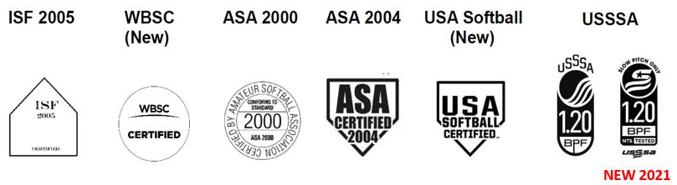
All other bats are not approved for use. Non-approved Bats shall be removed from competition and visibly marked (e.g. tape). Teams should be advised that attempted use during the game will, by rule, result in ejection.
Updated November 2020
- Any bat that appears on the WBSC approved bat list and has a current ISF certification stamp (2005 only) will be accepted for play in Softball Canada competition or,
- Any bat that appears on the USA Softball Approved Bat List and has an ASA 2000 or ASA 2004 certification stamp will also be accepted for play in Softball Canada competition (the ASA 2013 certification stamp is no longer accepted for endorsement in Slo-Pitch competition) or,
- Any bat that has a new USSSA certification stamp and is not on the USSSA withdrawn/non-compliant list will also be accepted for play in Softball Canada competition.
- The bat must meet the compression standards outlined by the certifying organization and may be tested to ensure that they are in the proper range.
- The bat must still pass a visual inspection per the current Softball Canada rulebook.
Note: Bats with an ASA 2013 certification stamp may still be eligible for use in Slo-Pitch competition if they are eligible under WBSC (ISF) or USSSA certification.
New: USSSA has recently adopted a new certification stamp (NTS Stamp shown above) that will begin appearing on new bats in 2021. Bats with the former stamp will continue to be accepted as well. USSSA certification is accepted for Slo-Pitch competition only.

