Softball New Brunswick Injury Report Form
(please complete as soon as possible after injury)

SECTION A: PERSONAL INFORMATION
First Name: |  |  |  |  | Last Name:
Team Name: |  |  |  |  | Date of injury:  Time of injury:
Age: | Sex: M F |  | Email: |  |  |  | Phone number:
Address: |  |  |  | City: |  |  |  | Province: | Postal  Code:
Event: |  |  |  |  | Location of Event:
WITNESS INFORMATION
First Name: |  |  |  | Last Name: |  |  |  | Role:
Email: |  |  |  |  |  |  |  | Phone Number:
SECTION B: INJURY DETAILS
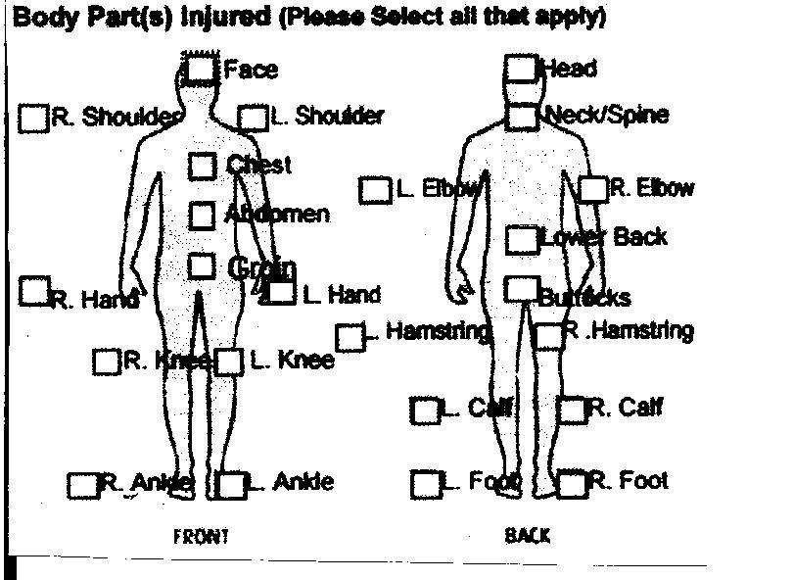 |  |  |  |  |  | NATURE OF INJURY:  Dislocation _____ Skin injury _____  Sprain/Strain _____ Swelling _____  Fracture _____ Bruising _____  Head injury _____  Other _____ (describe here)  ---------------------------------------------------------------------------------------  NOTE: that any injury involving loss of consciousness or a possible concussion requires immediate medical consultation  ---------------------------------------------------------------------------------------  CARE:  Trainer _____ Hospital _____ EMS _____ Doctor _____  INITIAL TREATMENT:  RICE (Rest, Immobile, Cold, Elevate) _____  Wrapping _____ Stretch/Exercise _____  Sling/splint _____ Manual Therapy _____  Dressing _____ None _____
Please indicate here what caused the injury and whether it could have been avoided:

Name of individual completing form: Signature:
(please print)
Completed form must be sent to executivedirector@softballnb.ca as soon as possible.

