
UMPIRE REGISTRATION HOW TO
Step 1: Log in to your PERSONAL Softball Saskatchewan RAMP account. Not your association/league account. If you do not have one, then you will need to create one.
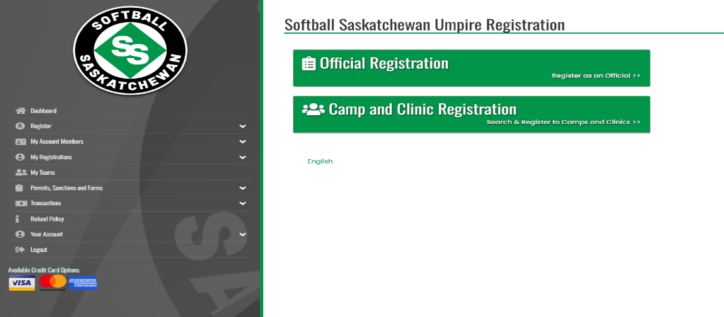
Step 2: Choose “Official Registration.”

Step 3: Review the IMPORTANT 2026 Umpire Registration Requirements
Step 4: Choose the account member and input any necessary information
Step 5: Choose your Officiating Level from the drop-down menu
Step 6: Choose the appropriate package, for example, “18 and Over”
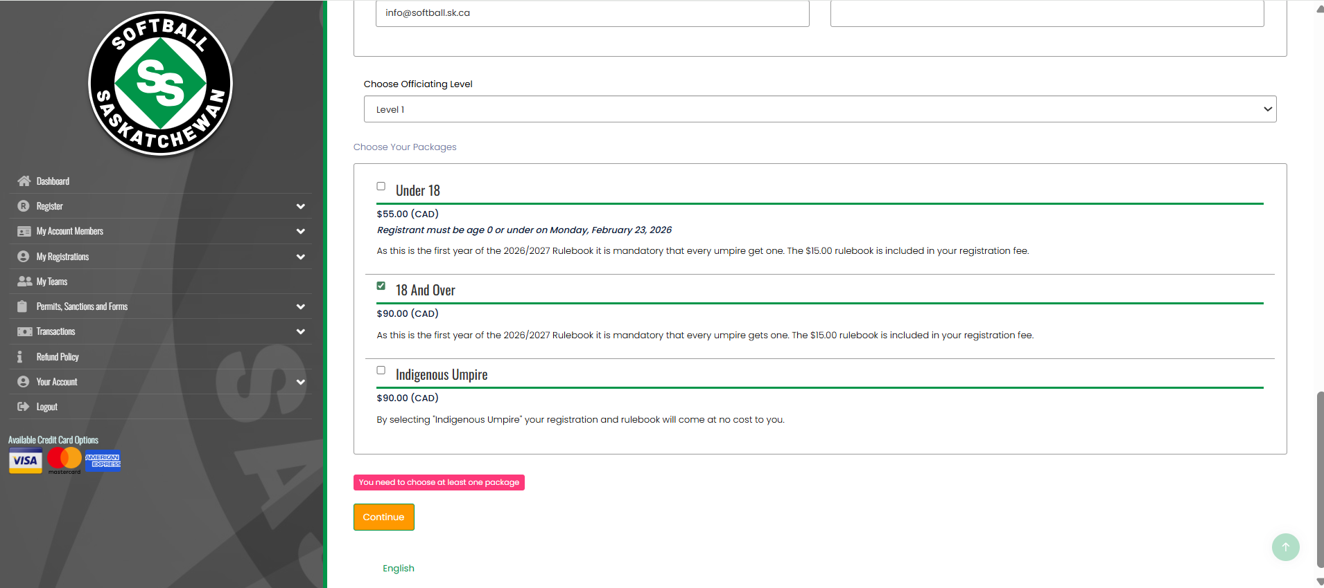
Step 7: Enter an Emergency Contact

Step 8: Answer ALL questions that appear on the next page (we need these for reporting purposes)
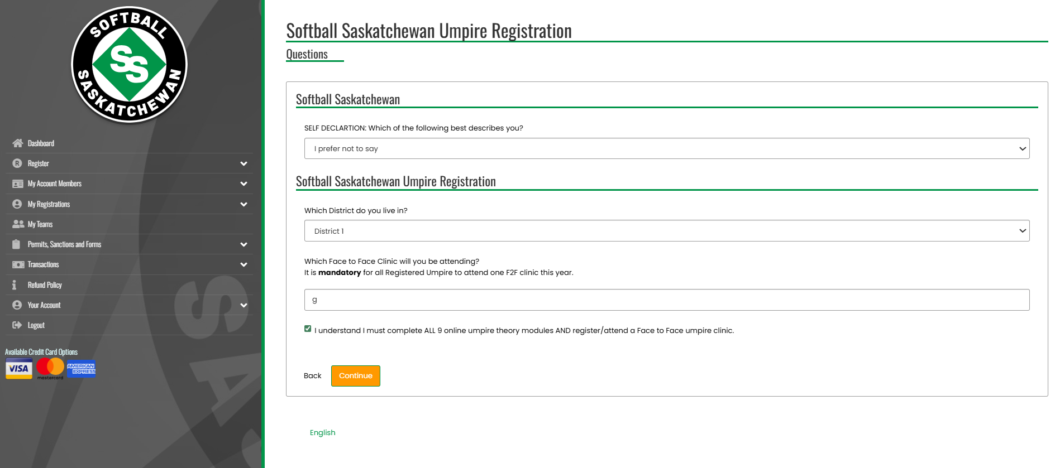
Step 9: Review your information.
Step 10: Choose the payment method. We will accept the following payment methods:
- Credit card through your RAMP registration.
- E-transfer to info@softball.sk.ca. Please include your name
- Step 11: Click “Submit Registration.” If there are any issues with your registration, we will contact you.
Step 11: Choose “Camp and Clinic Registration”
Step 12: Scroll to find the Clinic you would like to attend and click “register for camp and clinic.”
Step 13: Choose the account member.
Step 14: Input Emergency Contact information.
Step 15: Review your information.
Step 16: Submit Registration.
Step 17: Complete the 2026 Softball Canada National Education Online course at this link: https://softball.ca/programs/umpires/toolbox/instructor/online
Step 18: Attend a face-to-face Umpire Clinic

