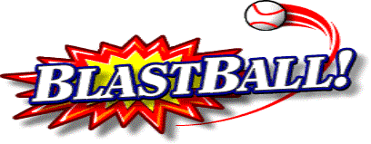 Active 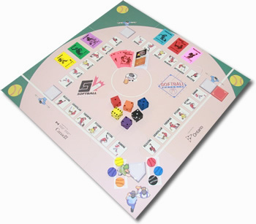

and Softball

Attention Elementary School Teachers:

SOFTBALL SASKATCHEWAN’S BLASTBALL AND ACTIVE SOFTBALL
PROGRAMS ARE BACK!

Softball Saskatchewan’s BlastBall & Active Softball Program is available to elementary schools around the province.

This program includes:
- A BlastBall loaner kit to provide schools the opportunity to participate in the sport of Softball by having access to proper equipment. Included in these kits are: 2 blast bases, 2 foam bats, 2 tees, 6 cones, 12 whiffle balls, 12 foam balls and 10 rubber bases.
- An Active Softball kit includes: game board (4’ x 4’), set of Activity Cards (72), Rules & Skills Guide, 6 playing pieces (sponge softball pucks), 6 sponge dice, 2 foam bats.
- A comprehensive teacher’s package designed to demonstrate how BlastBall could benefit your Physical Education program. This package includes curricular links and lesson plans.
- A trained instructor may be available to come into any class and deliver practical lessons directly to your students.

BLASTBALL is a softball/baseball type game specifically designed for children who have no experience playing softball i.e. Kindergarten to Grade 2. Physical and Health Education Canada has officially launched the SOFTBALL resource!! It’s available here http://www.phecanada.ca/resources/move-think-learn. BlastBall is very flexible and can be incorporated into the Physical Education Curriculum in a variety of ways. It can fit into a unit teachers are presently teaching on the basic movement patterns of sending and receiving, or it can be used as the main method of introducing these key movement patterns. ACTIVE SOFTBALL is designed for Grades 3-8, to teach students movement skills and concepts through the sport of Softball. Active Softball introduces combinations of loco-motor movements using different drills and applies a variety of tactical solutions while developing interpersonal skills during the different physical activities.

The game is ideally suited for the Physical Education Program at your school because:
1. It’s fun and easy to play as players have instant success.
2. The player needs no gloves or special equipment and it does not cost a great deal.
3. It allows efficient use of facilities (can be done in the gym or outside) and minimal special equipment required.
4. Minimal instruction is required for teachers
Softball Saskatchewan will be offering this program to elementary schools throughout the province starting in early January until the end of April. Please pass this information to the appropriate people in your school. For more information or to book a BlastBall kit for your school contact Melissa Hersche at 306-780-9235.

BLASTBALL & ACTIVE SOFTBALL LOANER KIT REQUEST FORM

Phone: (306) 780-9235 Fax: (306) 780-9483
info@softball.sk.ca
www.softball.sk.ca

Contact: _______________________________ Position: ___________________________________
School: ________________________________ Phone: ____________________________________
Mailing Address: _________________________ Physical Address*: ____________________________
City: ___________________________________ Postal Code: ________________________________
Email: ______________________________________________________________________________
__________________________________________________________________________________
*if different from mailing address. Kit will be sent via Purolator and will not ship to Box address
LOANER KIT REQUEST
(Requests are usually for 2 weeks to 1 month, depending on requests received for the kits.) This program only runs from January to April.
First Choice of Date: ________________________________________
Second Choice of Date: ________________________________________
Length of time requested: ________________________________________
Will this Kit be used indoors: or outdoors:
Would you like an ACTIVE SOFTBALL KIT included (good for grades 3-8): yes: no:
Grade Using Kit: ________ # of Girls: # of Boys: (we need the #’s
Grade Using Kit: _____ # of Girls: # of Boys: in order to provide
Grade Using Kit: ________ # of Girls: # of Boys: free giveaways)
Grade Using Kit: ________ # of Girls: # of Boys:
Grade Using Kit: ________ # of Girls: # of Boys:

PROGRAM POLICIES
The BlastBall loaner kit program exists to provide schools/groups the opportunity to participate in the sport of Softball by having access to proper equipment. Included in these kits are: 2 blast bases, 2 foam bats, 2 tees, 6 cones, 12 whiffle balls, 12 foam balls, 10 rubber bases, and 1 teacher’s guide. The Active Softball kit is comprised of: game board (4’ x 4’), set of Activity Cards (72), rules & skills guide, 6 playing pieces (sponge softball pucks), 6 sponge dice, 2 foam bats.

LOANER KITS

- In order to be eligible to receive a loaner kit, schools must complete all forms requested by Softball Saskatchewan.
- In all cases we anticipate full usage of this equipment for a number of different grades and classes within a school.

Policies:
- Schools will receive the equipment for their requested period of time;
- Each group must forward the equipment to the next user group or office on time;
- All forms must be completed properly and sent into the Softball Saskatchewan office on time;
- Groups will be charged for loss or damage to equipment.

Follow the steps below to access & use the loaner kit program:
- Complete the Softball Saskatchewan request form and submit it to the office
- You will receive a confirmation indicating the dates and details of your loaner period.
- Sign a Release Form and fax/email to the Softball Saskatchewan office when you receive it with the kit.
- Complete inventory of equipment as soon as kit is received – fax/email this form to the Softball Saskatchewan office.
- Complete inventory of equipment before it is sent to the next group or office and fax/email these forms to the Softball Saskatchewan office.
- Send the Loaner Kit to the next group or the office on the shipping date stated in your confirmation letter.

