- Entering referees and linesmen after the game has started and without any wifi. You will be required to enter their first and last name plus their certification level. By entering an incorrect level it may alter how it is listed on the game sheet. Do not end the game until you are hooked into wifi and can verify they have been entered correctly.
- Clearing a penalty as a result of a power play goal. When a goal is scored on a power play below on the same screen it will ask if this ends a penalty. It will show the jersey number. Click on the appropriate jersey number and proceed to the next screen. You will notice on the game sheet screen his jersey has disappeared. The time will automatically be adjusted.
- In the event of a double minor where the first 2:00 was cleared for a power play goal, you will have to go in and adjust the end time of the second half of the double minor.
- Signatures at the end. The people may print initials or write full name etc. You have their typed name and for verification later the score keep will be able to say they signed. If one fails to sign make a note of it in game notes.
- Misconducts penalties. When entering them only click on misconduct. Ignore the bottom section that shows “game misconduct”. You would only click on that if it was the player’s second misconduct in a game. It shows up as a misconduct on the screen and also a misconduct on the game sheet.
- The electronic game sheet only allows for 5 bench staff and no more. If you need to drop someone, then drop the manager. HC regulations only require you to have a head coach and safety for the team to be legal. In the event that you have to drop the manager, they can still do everything but sign the game sheet. They would not be eligible to be on the bench either.
- Clearing penalties on the main screen. When a penalty occurs it shows up on the main screen as a jersey number. When that penalty has expired and the player has returned to the ice then click on the jersey number and end the penalty. It will help you to know if you still have current penalties being served.
WEEK 2
- We can’t emphasize the use of the cheat sheet enough. It is absolutely necessary if you wish to be accurate. This is the only thing you have to check against at the end of the game. It virtually replaces the paper game sheet and scratch pad that you normally carry into the time box.
- End Game time. We have been noticing that almost all the games are listing as time played out with 0:00 left on the clock. If you have time left on the game clock this is where you enter it. This become important for penalties in the last 10 minutes.
- Clear Penalties. As penalties expire and players leave the penalty box clear their jersey off the game sheet. Click on the jersey and end the penalty. It will help you to keep straight who still has time left to serve and what order they come out in. It also makes it easier to see coincidental penalties. 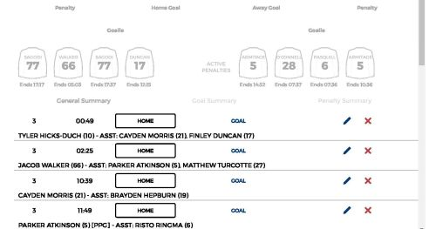
- Head Contact. We have been using check to the head but the official name is Head Contact.
- Penalty Shot. When a penalty shot is awarded and scored make sure to check the penalty shot circle. When you enter the player number who got the penalty scroll down to “Penalty Shot” and click on that. Do not click on the infraction. That way it will show up on the game sheet as Penalty shot under penalties whether or not a goal was scored.

