Winner’s Bracket

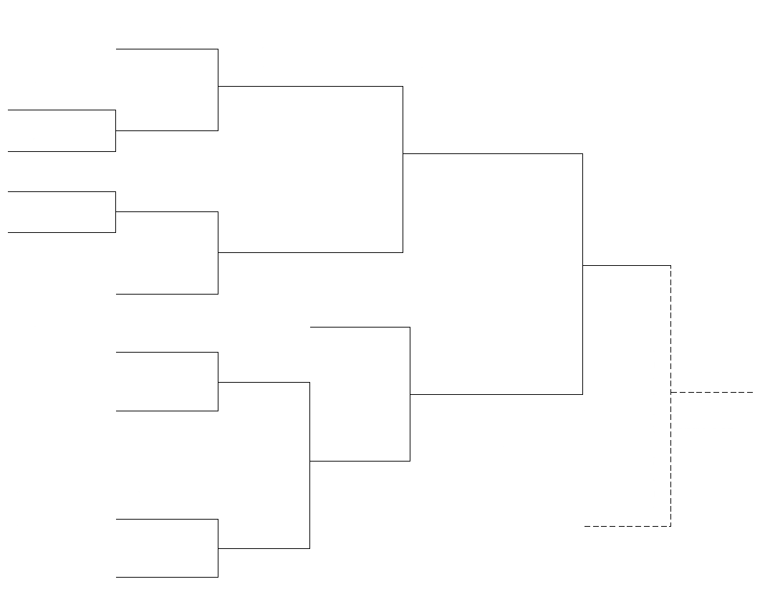
65+ Mixed Doubles
Matthew Halton High School
Friday July 5, 2019
Registration: 8:30 a.m.
Games Start: 9:00 a.m.
Fitzpatrick/Huebner

(3

Reeder/Ridley

(1
Dussault
(7

Jacobs

(2

Furukwa/McInnis
(4
(10

Guenter

L7

Loser’s Bracket
L2

(5
(9 (11
L3

(8

L1
L10 If First Loss
(6

L4

