Winner’s Bracket

65+ Womens
Matthew Halton High School
Saturday July 6, 2019
Registration: 8:30 a.m.
Games Start: 9:00 a.m.

Baker/Huebner
1

(2

Jacobs/Reeder
2

(1 (4

Watson/McInnes
3

Loser’s Bracket

L1

(5
(3

L2

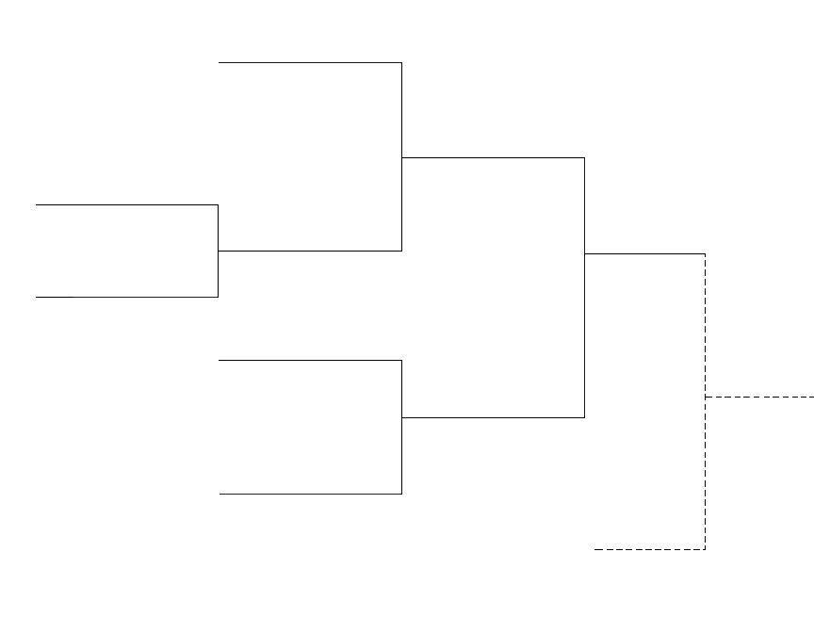

L4 If First Loss

